

BIOLOGY

**Welcome!**

This course will introduce you to the new advances being made in modern Biology, including the influence of genes on our development, environmental issues and some of the ethical and technological aspects of the subject. As Biology is a practical subject you will develop experimental skills and gain an understanding of how to plan, analyse and evaluate experimental procedures.

Watch this [video](https://www.youtube.com/watch?v=eipFN4WwXVg) as a taster of how you could make a difference.

**FAQ**

**What specification will I study?**

You’ll be covering the OCR A specification – you can find it [here.](https://www.ocr.org.uk/qualifications/as-and-a-level/biology-a-h020-h420-from-2015/)

**How many lessons will I have a week?**

You’ll have 5 hours of contact time each week. In addition, you are expected to complete a minimum of five hours homework to include: independent study, consolidation of class work and past paper practice.

**Who will my teacher be?**

The biology team include Andrew Edwards, Harry Minhinnick, Elizabeth Parfitt, Sarah Marshall and Alison Owen – you’ll find out which of us are teaching you when you get your timetable.

**What subjects go well with Biology?**

It’s a challenging science subject so we strongly encourage students to take other science A Levels alongside this course in order to strengthen the skills needed to be successful in Biology. It goes very well with Chemistry and Maths and there is also some overlap with Psychology, P.E. Environmental Science and Geography.

**What grades should I have?**

5 GCSEs at grade 4 or above, including English at grade 5 or above, and Mathematics and Biology (Science) at grade 6 or above. If you have got less than a 7 in Maths, then we suggest you also take Core maths as this will support your problem-solving.

**What will I study?**

In Year 1, you will study the following topics:

* Biological Molecules
* Cell Structure
* Nucleotides and Nucleic Acids
* Enzymes
* Biological Membranes
* Cell Division and Organisation
* Gas Exchange
* Transport in Animals
* Transport in Plants
* Disease and the Immune System
* Biodiversity
* Classification and Evolution

**Getting ready…**

You will be issued with one of the textbook specific for your exam board from the library (LC). However, you may prefer to but your own. We sell the following books at the IT helpdesk…

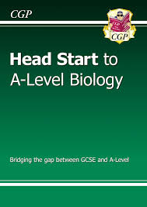 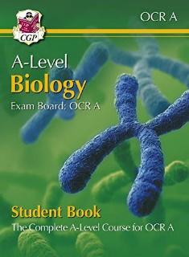 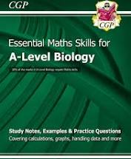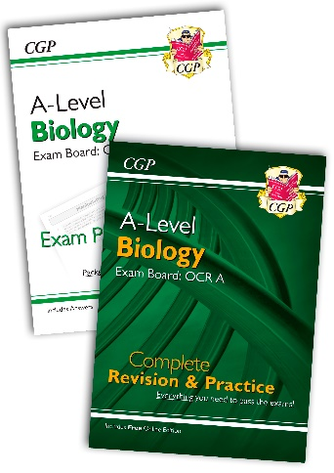

If you receive a bursary, you can use this to buy a book.

These additional books are also available to borrow from the LC:

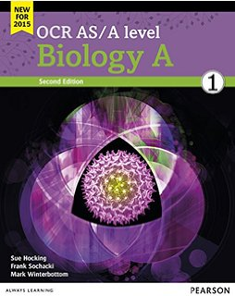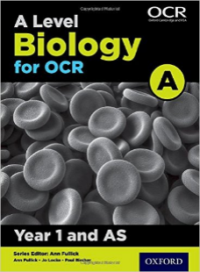 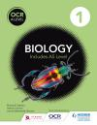 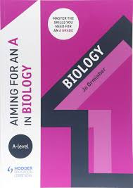

**You will also need:**

* A scientific calculator
* A4 Ring binders with dividers
* Lined paper
* Pens and pencils
* Highlighters
* A ruler

**Students also find it useful to have:**

* Blank flashcards
* A whiteboard and whiteboard pens to use at home
* Plastic wallets

This booklet contains activities that will help you recap your GCSE knowledge and prepare for A-level biology. All these topics will be developed in Year 1 of your studies. Some sections you will mark yourself, and some we will mark together during your first few classes.

**Bring your completed, marked, booklet into your first Biology lesson.**

|  |  |  |
| --- | --- | --- |
| **Approximate time** | **Activity** | **Page** |
| ½ hr | **Question on practical skills** | 4 |
| 1 hr | **Biological Molecules** | 6 |
| 1 hr | **Maths Skills** | 7 |
| ½ hr | **Cell Structure** | 11 |
| 1 hr | **Practical Investigations** | 12 |
| ½ hr | **Natural Selection and Evolution** | 15 |
| ½ hr | **Find out more….** | 18 |

**Activity 1: Question on practical skills**

*Please complete this question, including the graph which you can draw on the graph paper provided. We will mark and discuss this together during the Biology induction which focusses upon your experimental technique and developing practical skills.*

Q1. The effect of temperature on diffusion rate in cells was investigated, using agar jelly as a model of cell cytoplasm. Pink agar jelly, prepared with a dye called phenolphthalein and dilute sodium hydroxide, was cut into four equal-sized cubes. Each cube was laced into a test tube of hydrochloric acid at a different temperature and the time taken for the cube to become colourless was recorded. The experiment was repeated three times at each temperature. Table 1.1 show the results.

**Table 1.1**

|  |  |  |  |  |
| --- | --- | --- | --- | --- |
| **Temperature (0C)** | **Time taken for cube to become colourless (s)** | | | |
| **Repeat 1** | **Repeat 2** | **Repeat 3** | **Mean** |
| 10 | 728 | 414 | 425 |  |
| 20 | 343 | 330 | 351 |  |
| 30 | 240 | 231 | 228 |  |
| 40 | 187 | 166 | 172 |  |

1. Calculate the mean figure for each temperature, giving your answer to the nearest **whole number.** *(2 marks)*
2. i) Give two benefits of repeating the experiment at each temperature *(2 marks)*

ii) Draw a graph on graph paper of these results, including a line of best fit *(3 marks)*

1. Describe any correlation shown by the graph *(1 mark)*
2. Write a simple conclusion for this investigation based on the results shown in the graph *(2 marks)*
3. Hydrochloric acid is an irritant and can cause damage if it comes into contact with skin or eyes. Suggest two precautions that could be taken to reduce the risk from hydrochloric acid in this experiment. *(2 marks)*
4. A student wants to repeat this experiment. Suggest two pieces of additional information that could be added to the method above, so that these are more likely to be reproducible. *(2 marks)*

**Activity 2: Biological Molecules**

1. Revise your chemistry.   
   Make sure that you the difference between an atom, element molecule and ion. This [video](https://www.khanacademy.org/science/high-school-biology/hs-biology-foundations/hs-biological-macromolecules/v/elements-and-atoms) will help you recap.
2. Watch this [video](https://www.youtube.com/watch?v=FgfknBZaVTI) on the main biological molecules.
3. Now produce a summary table of the main biological molecules. Include: the key elements that make up the molecule; why is it important to living organisms; where in the body would you find it and if you can, give named examples.

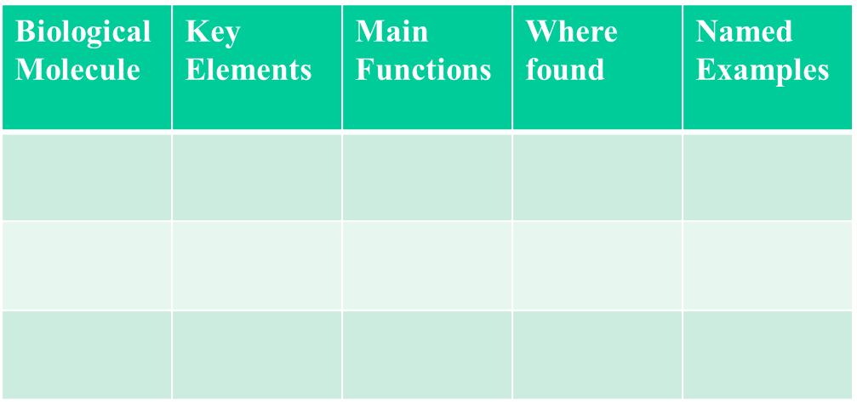

**When you’re ready complete the quick** [**quiz**](https://www.khanacademy.org/science/high-school-biology/hs-biology-foundations/hs-biological-macromolecules/e/biological-macromolecules) **to test yourself….**

1. If I am the Answer, what is the Question?   
   Complete the table by writing a question for which these would be the answer

|  |  |
| --- | --- |
| **Word** | **Question** |
| Atom |  |
| Bond |  |
| Element |  |
| Function |  |
| Glucose |  |
| Lipid |  |
| Peptide |  |
| Property |  |
| State of Matter (e.g. gas/liquid/solid) |  |
| Structure |  |

1. Complete the following sentences:

* Carbohydrates are made up of sugar units and have the general formula ______________________. ______________________ are the simplest carbohydrates, with only one sugar unit. Examples are ______________________, fructose and galactose.
* Starch and glycogen are formed from many ______________________ units joined by ________________. They are good _________________ storage molecules because they are compact, _________________________ in water and can be readily broken down.
* Cellulose has a __________________ function and is found in the cell wall of _____________ cells.
* Water is made up of 3 ____________ from ______________ different elements.
* _____________ have both ___________ and functional roles e.g. reinforcing connective tissue or catalysing cellular reactions.

**Activity 3: Math Skills**

You will continue to develop your Math Skills throughout your A Level Biology course.20% of the marks at A-level Biology are testing maths skills. Please bring your answers to your first lesson.

You need to be confident at the following:

* Significant figures and decimal places
* Using standard form
* Calculating percentages, magnification and rates of reaction
* Drawing graphs
* Calculating areas and volumes
* Statistical tests etc. etc.

As we consider Biology on a scale from molecules to ecosystems, the ability of converting between units becomes very important. Answers to all of these questions should use standard form e.g. use 5.6 x 103 rather than 5600, use 4.2 x 10-2 rather than 0.042.

1. How many?

| mm in a m |  |  | µm in a mm |  |
| --- | --- | --- | --- | --- |
| µm in a m |  |  | nm in a µm |  |
| mm in a µm |  |  | m in a µm |  |
| µm in a nm |  |  | mm in a nm |  |
| µl in a litre |  |  | ml in a litre |  |
| µl in a ml |  |  | ms in a s |  |

1. Convert each of the following into metres.

| (a) | 5 µm |  |
| --- | --- | --- |
| (b) | 1 mm |  |

1. Convert each of the following into µm.

| (a) | 4 m |  |
| --- | --- | --- |
| (b) | 17 mm |  |

1. Areas and Volumes. How many?

| (a) | μm2 in a mm2 |  |
| --- | --- | --- |
| (b) | mm3 in a cm3 |  |

1. Convert each of these into more sensible units.

| (a) | 0.0003 μm |  |
| --- | --- | --- |
| (b) | 4500000 nm |  |
| (d) | 0.0007 s |  |

1. How would you express the following in numbers and units?
2. A woodlouse crawled 5 cm in 10 min.

|  |
| --- |

1. A patient’s drip flowed with 10 drips every 30 s.

|  |
| --- |

1. The growth of a slime mould colony was 40 cells per millimetre cubed per hour.

|  |
| --- |

1. A breathing rate of 20 breaths in 30 s.

|  |
| --- |

1. A change in temperature of 1.2 degrees over three years.

|  |
| --- |

1. Here are some more resources you could use to practise your basic skills…

* Significant figures and decimal places [quiz](https://quizizz.com/admin/quiz/5cdb5e03c04112001bf9b9ae/decimal-places-significant-figures)
* [Video](https://www.khanacademy.org/math/arithmetic-home/arith-review-decimals/arithmetic-significant-figures-tutorial/e/significant_figures_1) on significant figures
* [Video](https://www.khanacademy.org/math/arithmetic/arith-decimals/arith-review-decimals-intro/v/place-value-with-decimals) on decimal places
* [Quiz](https://www.tutor2u.net/maths/reference/gcse-maths-revision-quizzes-standard-form) on standard form
* [Video](https://www.youtube.com/watch?v=WwqMObx5oDU) on standard form

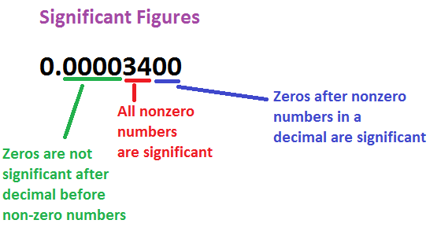

1. You will also develop your English skills to enable you to use specialist scientific terminology correctly. The following table is muddled. Draw lines to match the command word with what you are expected to do in your answer.

|  |  |
| --- | --- |
| **Command Word** | **What to do** |
| Calculate | Give a brief one or two word answer or a short answer. |
| Describe | Pick out information or say what something is. |
| Evaluate | Write about what something is like, e.g. a narrative giving and account of the structure of the heart. |
| Explain | Write about the main points of a topic |
| Give/Name/State | Give reasons for something |
| Identify | Use you scientific knowledge to work out what the answer might be. |
| Justify | Show or prove something is right |
| Outline | Work out the solution to a mathematical problem. |
| Suggest | Give the arguments both for and against and issue, or the advantages and disadvantages of something. You also need to give and overall judgement. |

**Activity 4: Cell Structure**

1. A matter of scale! Below is a logarithmic scale bar ranging from 0.1nm to 1mm. Try to find an example of a cell or structure that would be the approximate size of each of the nine divisions. One has already been completed for you.

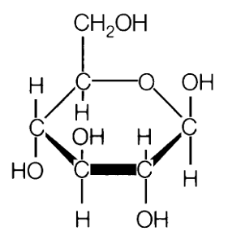

Glucose

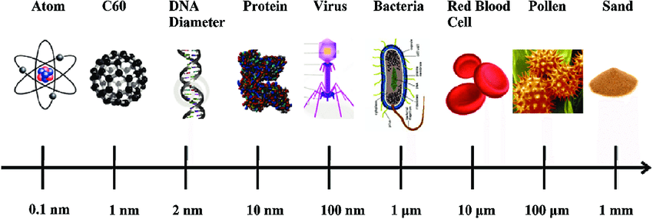  
This [video](https://www.khanacademy.org/science/high-school-biology/hs-cells/hs-introduction-to-cells/v/scale-of-cells) may help give you some ideas.

1. Complete the following worksheet to remind you of your basic cell structure.

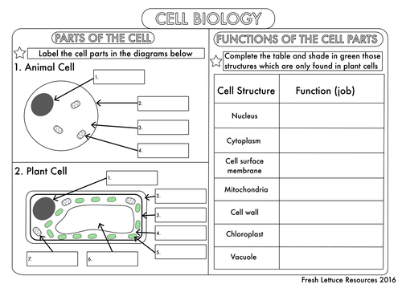

If this feels a bit hazy you may want to have a quick revision session to freshen your knowledge. Try the BBC [bitesize](https://www.bbc.co.uk/bitesize/guides/zsgfv4j/revision/1) sessions.

**Activity 4: Practical Investigations**

During your Biology A-level, you will keep a portfolio of your practical investigations in a lab book. This will be used as evidence of your experimental skills in order to be awarded the Practical Endorsement. This is a separate pass/fail certificate that runs alongside your A Level. You have to show competence in:

* + Following instructions
  + Planning and implementing experiments
  + Health and safety
  + Making observations
  + Presenting data
  + Recording data
  + Drawing conclusions and evaluating
  + Using software, and online and offline sources of researching

1. Making observations and Sampling  
   Study the cartoon area of interest below.   
   Write down as many observations as you can about the plants growing in the area



1. A picture containing screenshot, colorfulness, circle, child art

   Description automatically generatedWhich of these observations could you investigate? There is an example given in the table below. Can you copy out the table and think of a way to investigate another one?

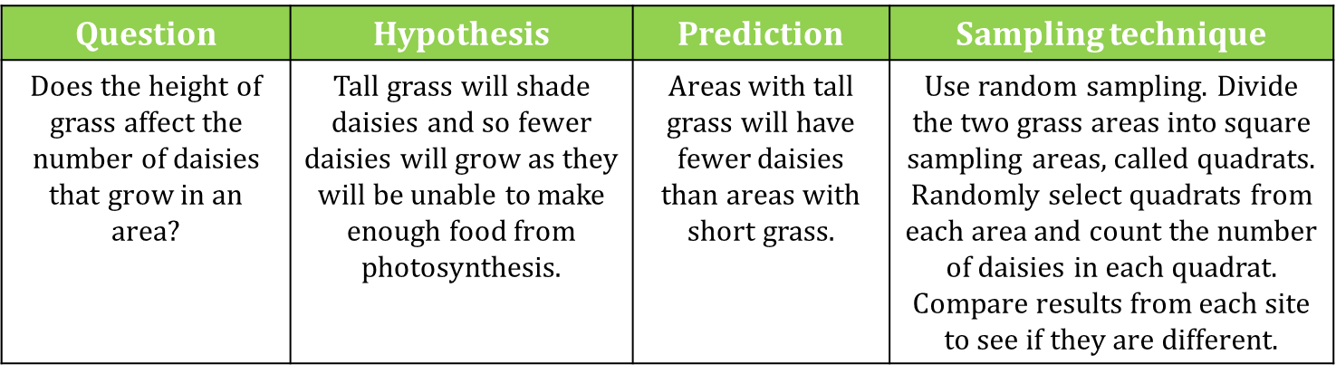

|  |  |  |  |
| --- | --- | --- | --- |
| Question | Hypothesis | Prediction | Sampling technique |
|  |  |  |  |

1. When studying living organisms it is important to observe and record the shape and structure of specimens. There are a number of reasons why they are important

* It leads to accurate observation and attention to detail. Having to draw a biological specimen not only increases the amount of time spent examining the specimen, which in itself will aid learning, but requires a much greater level of accurate observation than a casual examination.
* Active recording aids memory.
* The drawing provides a permanent record of what has been observed.

Biological drawings are simple but notoriously difficult to do well. Follow these guidelines to satisfy the requirements of the Practical Endorsement criteria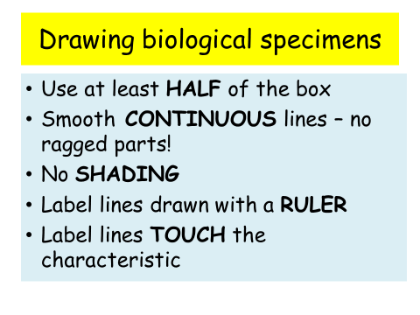. This is an example of a good biological drawing. Notice that they have added a title and some annotations to supplement the labels

In the space provided make a biological drawing of a single leaf from a plant in your garden or from a house plant. Try to follow the golden rules!

**Answers:**

**Some observations from the picture that you could have made are:**

1. Higher abundance of daisies around the pond
2. Low abundance of plants around the path
3. Dandelions tend to be on the south facing part of the tree
4. Dandelions only seem to grow in the long grass
5. Plants around the tree seem to be smaller than elsewhere

**Activity 5: Evolution**

Natural selection is a mechanism of evolution. Organisms that are more adapted to their environment are more likely to survive and pass on the genes that aided their success. This process causes species to change and diverge over time. Natural selection is one of the ways to account for the millions of species that have lived on Earth.

1. Darwin and Wallace developed their theory of Evolution[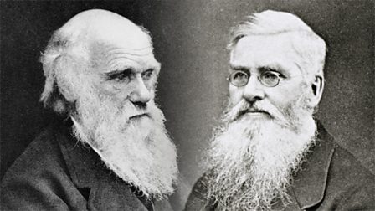](https://www.google.com/url?sa=i&url=https://www.bbc.co.uk/teach/charles-darwin-evolution-and-the-story-of-our-species/z7rvxyc&psig=AOvVaw1qLETTFgoB8z6GZ5GNnRGB&ust=1589992659738000&source=images&cd=vfe&ved=0CAIQjRxqFwoTCPCpva-uwOkCFQAAAAAdAAAAABAE)
2. 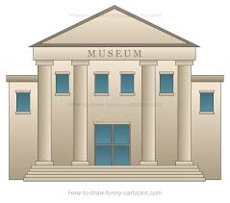Explore the evidence for natural selection at the Natural History Museum via this [link](https://www.nhm.ac.uk/discover/what-is-natural-selection.html).
3. 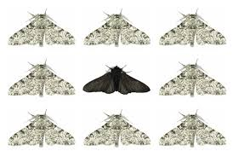Play this [game](https://www.ologames.com/Free_Games/Who-Wants-To-Live-A-Million-Years) to see if you could evolve quickly enough to survive for a million years.
4. Complete the [Seneca](https://app.senecalearning.com/classroom/course/12515570-076d-11e8-86cf-e3d64fef518f/section/b6e8b960-1650-11e8-94cd-bdd70dfee7b9/session) revision activity on Natural Selection and Evolution
5. Another [game](https://askabiologist.asu.edu/peppered-moths-game/) to play to see how Natural selection has caused the peppered moth to change colour.

**ANSWERS!!**

Now go through and mark your answers. [The first activity we will mark together in class] Are there any incorrect? Can you work out why? Do you need to go back and refresh your memory on any of the sections?

**Activity 2:  Biological Molecules ANSWERS**

|  |  |  |  |
| --- | --- | --- | --- |
| **Biological**  **Molecule** | **Key**  **Elements** | **Main**  **Functions** | **Named**  **Examples** |
| **Carbohydrates** | **Carbon, Hydrogen, Oxygen** | **Energy Store** | **Starch, Glycogen** |
| **Fats** | **Carbon, Hydrogen, Oxygen** | **Cell membranes, energy store** | **Cholesterol, Oleic acid** |
| **Protein** | **Carbon, Hydrogen, Oxygen, Nitrogen** | **Transport, Enzymes and Structural** | **Amylase, Haemoglobin** |

If I am the Answer, what is the Question?     
Complete the table by writing a question for which these would be the answer. Here are some suggested answers…..

|  |  |
| --- | --- |
| **Word** | **Question** |
| Atom | What is the smallest unit of matter? |
| Bond | What is the name given to the secure join between atoms? |
| Element | What do you call a substance that is made of one type of atom? |
| Function | What a cell, tissue or organ does! |
| Glucose | What is starch, glycogen and cellulose made from? |
| Lipid | A biological molecule that includes; waxes, steroids, fats and oils. |
| Peptide | What name is given to a compound that contains more than one amino acid. |
| Property | What is another word for quality or attribute? |
| State of Matter (e.g. gas/liquid/solid) | One of three forms that matter can exist |
| Structure | This word describes what something is made from and how the components fit together |

1. Complete the following sentences:

* Carbohydrates are made up of sugar units and have the general formula Cx(H2O)y. Mono.saccharides are the simplest carbohydrates, with only one sugar unit. Examples are glucose, fructose and galactose.
* Starch and glycogen are formed from many glucose units joined by bonds. They are good energy storage molecules because they are compact, insoluble in water and can be readily broken down.
* Cellulose has a structural function and is found in the cell wall of plant cells.
* Water is made up of 3 atoms from two different elements.
* Proteins have both structural and functional roles e.g. reinforcing connective tissue or catalysing cellular reactions.

Activity 3:  Maths skills answers

Answers to all of these questions should use standard form e.g. use 5.6 x 103 rather than 5600, use 4.2 x 10-2 rather than 0.042.

1. How many?

|  |  |  |  |  |
| --- | --- | --- | --- | --- |
| mm in a m | 1 x 103 |  | µm in a mm | 1 x 103 |
| µm in a m | 1 x 106 |  | nm in a µm | 1 x 103 |
| mm in a µm | 1 x 10-3 |  | m in a µm | 1 x 10-6 |
| µm in a nm | 1 x 10-3 |  | mm in a nm | 1 x 10-6 |
| µl in a litre | 1 x 106 |  | ml in a litre | 1 x 103 |
| µl in a ml | 1 x 103 |  | ms in a s | 1 x 103 |

1. Convert each of the following into metres.

|  |  |  |
| --- | --- | --- |
| (a) | 5 µm | 5 x 10-6 m |
| (b) | 1 mm | 1 x 10-3 m |

1. Convert each of the following into µm.

|  |  |  |
| --- | --- | --- |
| (a) | 4 m | 4 x 106 μm |
| (b) | 17 mm | 1.7 x 104 μm |

1. Areas and Volumes . How many?

|  |  |  |
| --- | --- | --- |
| (a) | μm2 in a mm2 | 1 x 106 |
| (b) | mm3 in a cm3 | 1 x 103 |

1. Convert each of these into more sensible units.

|  |  |  |
| --- | --- | --- |
|  | 0.0003 μm | 0.3 nm |
|  | 4500000 nm | 4.5 mm |
|  | 0.0007 s | 0.7 ms |

1. How would you express the following in numbers and units?

1. A woodlouse crawled 5 cm in 10 min.

5 mm min-1   or   0.5 cm min-1   or  30 cm h-1

1. A patient’s drip flowed with 10 drips every 30 s.

20 drips min-1   or  0.3 drips s-1

1. The growth of a slime mould colony was 40 cells per millimetre cubed per hour.

40 mm-3 h-1

1. A breathing rate of 20 breaths in 30 s.

40 breaths min-1   or  0.7 breaths s-1

1. A change in temperature of 1.2 degrees over three years.

0.4 oC yr-1

Activity 4: Cell structure answers

Complete the following worksheet to remind you of your basic cell structure.

Animal cell: 1. Nucleus, 2. Cell membrane, 3. Cytoplasm, 4. Mitochondrion

Plant cell: 1. Nucleus, 2. Cell wall, 3. Cell membrane, 4. Cytoplasm, 5. Chloroplast, 6. Vacuole, 7. Mitochondrion.

Nucleus – contains the DNA, controls the activities of the cell

Cytoplasm – site of many cell reactions

Cell surface membrane – controls what enters and leaves the cell

Mitochondrion – the site of aerobic respiration

Cell wall – surrounds and supports the cell

Chloroplast – site of photosynthesis

**Find out more….**

You will find biologists working all over the world in almost every setting imaginable: in research laboratories, hospitals, offices, classrooms, factories, boats, aeroplanes, submarines, museums, jungles, deserts, forests, caves, treetops, cliffs, frozen tundra…

Explore the options for studying Biology at university [here](https://www.ucas.com/job-subjects/biology). The options and range of paths to follow is vast and very diverse, for example you may want to:

**FEEDINGTHE HUNGRY** Plant scientists, geneticists and molecular biologists are working to improve the yields of our most important food crops and to prevent their destruction by pests, disease, and drought. Biologists are also improving nutritional health by packing our foods full of essential vitamins while toxicologists ensure that our food supplies are safe to eat.

**FUEL UP**

The race is on to find new and sustainable fuels for the future. Biotechnologists and biochemists are combining biology with chemistry and engineering techniques to develop sustainable sources of energy creating cleaner, greener fuels from sunlight, carbon dioxide and algae.

**[](https://www.google.com/imgres?imgurl=https://www.pinclipart.com/picdir/middle/96-967921_graphic-black-and-white-stock-medicine-free-on.png&imgrefurl=https://www.pinclipart.com/pindetail/ThJJRw_graphic-black-and-white-stock-medicine-free-on/&tbnid=KW11bKTKhcV8DM&vet=12ahUKEwiHwYKXwanpAhWu34UKHay0CB8QMygwegUIARCLAQ..i&docid=ltYCC9Rr5VOk5M&w=880&h=919&q=medicine%20black%20and%20white%20clipart&hl=en-US&safe=active&ved=2ahUKEwiHwYKXwanpAhWu34UKHay0CB8QMygwegUIARCLAQ)FINDTHE CURE**Biologists work in a huge range of health-related careers. Clinical biologists, physiologists, and pharmacologists develop and trial new medicines, test blood and tissue for diseases and advise medical practitioners on the best treatments for their patients. Geneticists are replacing defective genes enabling them to restore sight and help support people’s immune systems.

**WIN GOLD**

Human biologists, physiologists and sport scientists’ study human anatomy, from joints and muscles to genes and cell growth. They are uncovering how genetics, environment, diet and culture interact to determine athletic performance, and what makes the best the best.

**UPDATE YOUR STATUS**

There are a growing number of biologists working in science communication and education, helping to take biology from the laboratory to the public. You’ll find biologists in classrooms, designing museum exhibits, publishing work in newspapers, on the radio and TV, and using online tools such as blogs and social networks.

**PROTECT THE PLANET**

**[](https://www.google.com/imgres?imgurl=https://toppng.com/uploads/preview/clipart-free-stock-earth-svg-black-and-white-world-ma-11562901535crrc9cccog.png&imgrefurl=https://toppng.com/free-image/clipart-free-stock-earth-svg-black-and-white-world-ma-PNG-free-PNG-Images_171769&tbnid=YMN3uC7qWJZgBM&vet=12ahUKEwjIp5PRxKnpAhUNyxQKHYxbDnUQMygiegQIARB2..i&docid=GsYdLL6D2-hjgM&w=840&h=859&q=earth%20clipart%20black%20and%20white&hl=en-US&safe=active&ved=2ahUKEwjIp5PRxKnpAhUNyxQKHYxbDnUQMygiegQIARB2)**Conservation biologists, ecologists, and environmental managers travel the globe documenting our environment, monitoring the effects of global warming, protecting habitats from destruction or potentially harmful species, and rebuilding damaged ecosystems.

**SWING THE VOTE**

**[](https://www.google.com/imgres?imgurl=https://listimg.pinclipart.com/picdir/s/109-1098775_png-file-black-and-white-big-ben-icon.png&imgrefurl=https://www.pinclipart.com/pins/big-ben/&tbnid=r3aQ82W7WQMCPM&vet=10CAQQMyhlahcKEwjQ-tbDxanpAhUAAAAAHQAAAAAQAw..i&docid=iiqLv3oTo1_Z2M&w=320&h=927&q=big%20ben%20clipart%20black%20and%20white&hl=en-US&safe=active&ved=0CAQQMyhlahcKEwjQ-tbDxanpAhUAAAAAHQAAAAAQAw)**Science advisors are at work in nearly every department of the UK Government, advising policy makers on a variety of issues such as the contribution that biology research makes to the economy, how to prevent the spread of contagious infections, and stopping declines in the nation’s honeybee populations

As biology can be challenging, it helps to be curious and interested in the subject.  
 You could:

|  |  |
| --- | --- |
| Job of the Week: Development Chemist | CK Science | Investigate the types of jobs that need biology [here](https://www.rsb.org.uk/images/pdf/Student_Biology_Careers_Resource_Guide.pdf) – there are videos to watch and profiles to read – fancy being an immunologist, biochemist or a forensic scientist? |
| C:\Users\Joanna\AppData\Local\Microsoft\Windows\INetCache\Content.MSO\B212AA29.tmp | Follow biology on social media - @RoyalSocBio, @NatureCellBiology, @BiochemSoc on facebook, instagram and twitter etc. |
| Pictures: september calendar cartoon | Cartoon calendar showing ... | Find out more about important biologists from history at [On This Day in Biology](https://www.onthisday.com/science/biology) |
| C:\Users\Joanna\AppData\Local\Microsoft\Windows\INetCache\Content.MSO\5AE50457.tmp | Subscribe to a YouTube channel   * The RSB channel has loads of things on it including [Ask a Biologist](https://www.youtube.com/playlist?list=PLxu6ICEq35PdOgTji60h556fFjNSENA-r) demos that you could try at home * The [Crash Course biology](https://www.youtube.com/watch?v=QnQe0xW_JY4&list=PL3EED4C1D684D3ADF) videos will help you find out more and give you a taster of A-level biology. |
| [Lucius Annaeus Seneca Quotes](https://www.google.com/imgres?imgurl=http://www.notable-quotes.com/s/seneca_quote.jpg&imgrefurl=http://www.notable-quotes.com/s/seneca_lucius_annaeus.html&tbnid=95LPev2m8Po0tM&vet=12ahUKEwj8z6z2ysDpAhUO04UKHX_VB6wQMygqegUIARCBAQ..i&docid=lfJe9dk9tf6mxM&w=500&h=300&q=seneca&safe=active&ved=2ahUKEwj8z6z2ysDpAhUO04UKHX_VB6wQMygqegUIARCBAQ) | **Complete a free Seneca course on GCSE Biology**.  This is particularly useful if you haven’t studied any Biology for a while, or if you didn’t manage to complete the course in Biology at GCSE before the schools closed. Go to [www.seneca.co.uk](http://www.seneca.co.uk) and choose a GCSE Biology course (Higher Tier) from any of the exam boards listed there. If you wanted to complete the whole course, as a recap, they suggest this could take between 7 – 14 hours.  Why not spend 30min – 1hr a week, working through the topics you feel less confident about? |
| C:\Users\alisono\AppData\Local\Microsoft\Windows\INetCache\Content.MSO\56419648.tmp | Read a book. Books that might interest you include:   * On the Origin of Species, by Charles Darwin. ... * The Selfish Gene, by Richard Dawkins. ... * Silent Spring, by Rachel Carson. ... * I Contain Multitudes, by Ed Yong. |

Any questions you have before you start then please email Sarah Marshall [sarahma@richuish.ac.uk](mailto:sarahma@richuish.ac.uk)

**See you in September 😊**