

Chemistry

**Welcome!**

Chemistry is a challenging and rewarding A Level. You will extend your knowledge from GCSE and develop into a confident and resilient problem-solver during the course. You’re going to develop your practical skills and begin to appreciate the important role that chemistry plays in the world today.

Watch this [vide](https://edu.rsc.org/future-in-chemistry/making-the-difference)o as a taster of how you could make a difference.

**FAQ**

**What specification will I study?**

You’ll be covering the OCR A specification – you can find it [here.](https://www.ocr.org.uk/Images/171720-specification-accredited-a-level-gce-chemistry-a-h432.pdf)

**How many lessons will I have a week?**

You’ll have 3 lessons a week, each 1 hours and 30 minutes plus 25 minutes of academic mentoring a week.

**Who will my teacher be?**

The chemistry team is Jo Clare, Pete West and James Dawson – you’ll find out which of us are teaching you when you get your timetable.

**What subjects go well with Chemistry?**

It’s a challenging science subject so we recommend that you do other similar subjects. Maths and Physics help to support the problem-solving and maths. You need to have maths to study chemistry at some universities. It also goes well with Computer Science,Biology, Economics, Geography, and Environmental Science. Subjects with a lot of coursework or demands on your outside of lessons don’t always work well with chemistry.

**What grades should I have?**

We recommend at least a 6 in Chemistry or Combined Science as well as a 6 in Maths. If you have got less than a 7 in Maths then we suggest you also take Core maths as this will support your problem-solving.

**What will I study?**

In Year 1, you will study the following topics:

* Atomic structure
* Formulae and equations
* Moles calculations
* Acids and titrations
* Bonding and structure
* Redox
* Group 2 and group 7 chemistry
* Enthalpy changes
* Rates of Reaction
* Basics organic chemistry
* Alkenes and Haloalkanes
* Alcohols

**Getting ready…**

We recommend all students buy a textbook. We sell the following books through the [Huish Shop](https://store.huish.ac.uk/products/for-students/chemistry):

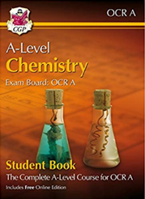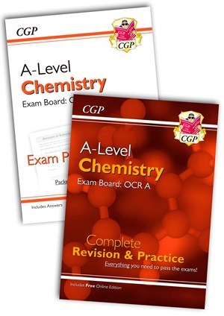

If you receive a bursary, you can use this to buy your book.

These books are also available to borrow from the LC:

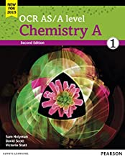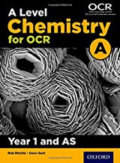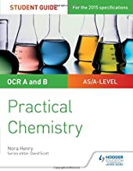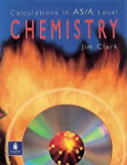

**You will also need:**

* A scientific calculator
* A folder with dividers
* Lined paper
* Pens and pencils
* Highlighters
* A ruler

**Students also find it useful to have:**

* Blank flashcards
* A whiteboard and whiteboard pens to use at home
* Plastic wallets
* A periodic table to have on your wall where you study. The one you get in exams can be found [here](https://www.ocr.org.uk/Images/536387-data-sheet.pdf).

**Activity 1: Organic Chemistry** - You should spend 2 hours on the independent learning tasks then 2 hours on the poster

Organic compounds are very important and are found in drugs, dyes, detergents, explosives and perfumes and just about everywhere else you can think of! During your A-level, you’ll study the chemistry of different families of organic molecule, discovering the reactions they do and learning how this can be applied to synthesise complicate useful molecules.

1. Extend your knowledge of organic chemistry by doing the tasks below:
2. Organic chemists use displayed, structural and skeletal formulae to describe compounds. Watch this [vide](https://www.youtube.com/watch?v=mD2lg85i7Y0&list=PLi6oabjl6coxUlfu8syK3K0iFXQIjwDUM&index=31)o about formulae as an introduction to this.
3. You have been introduced to naming alkanes at GCSE. This year, you will learn how to name branched compounds. Watch this [video](https://www.youtube.com/watch?v=40wnvuG8uQg&list=PLi6oabjl6coxUlfu8syK3K0iFXQIjwDUM&index=32) to introduce you to the naming rules.
4. At GCSE, you have met alkanes, alkenes, alcohols, carboxylic acids and esters. You will meet more functional groups at A-level. Here are lots…

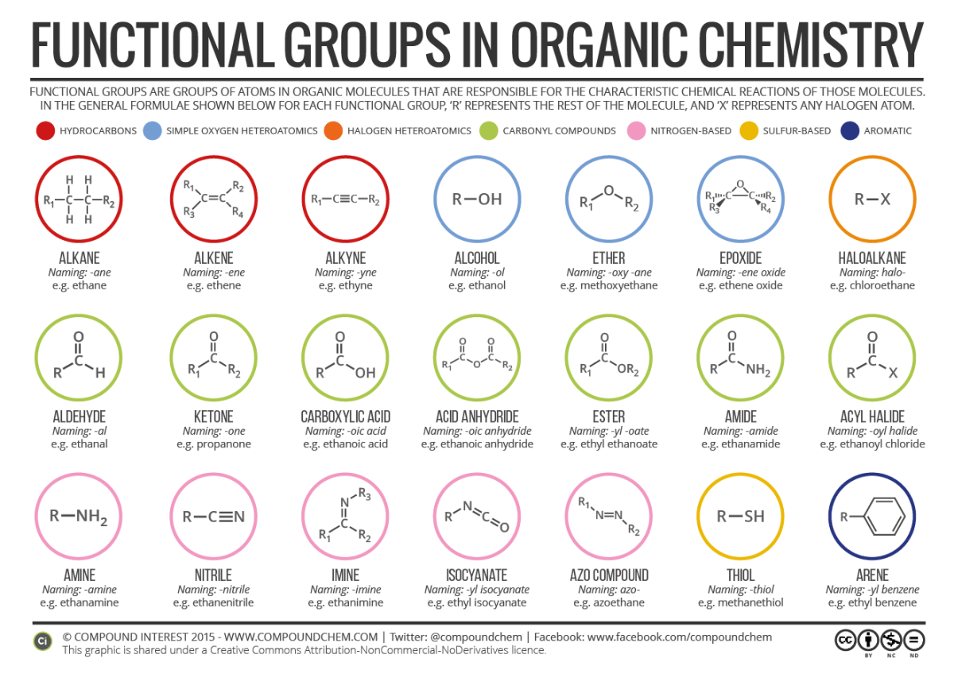

Try this [quiz](https://create.kahoot.it/share/organic-functional-groups/ffde4573-3ae9-41d2-8d84-e966cca9350d) to see how many you can identify…

1. Now choose a molecule to research – find out its formula and structure and what we use it for then make a factsheet…Molecules you could investigate include:

**Aspirin, TNT, paracetamol, oxytocin, capsaicin, Sudan red, DDT, caffeine, fluoxetine, theobromine, ibuprofen**

**HAND IN YOUR POSTER IN YOUR FIRST CHEMISTRY LESSON!**

**Activity 2: OPTIONAL Practical Investigation –** this will take you 4 hours if you complete it fully.

During your Chemistry A-level, you will keep a lab book as evidence of your experimental skills in order to achieve the Practical Endorsement. You have to show competence in:

* + Following instructions
  + Planning and implementing experiments
  + Health and safety
  + Recording data
  + Using software, researching and reporting your experiments.

**Task**: Carry out a project to investigate the natural dyes in plants. Starter by using red cabbage – you can use fresh or pickled! Extract the juice and then test it with different acids and alkalis that you have in your house e.g. vinegar, lemon juice and baking powder. Take photos of your results and use them to write a report explaining what you have done. You should include an introduction, a method and a results section. Extend your investigation to other fruit and veg – turmeric, red onions, beetroot and hydrangea flowers all contain natural indicators too.

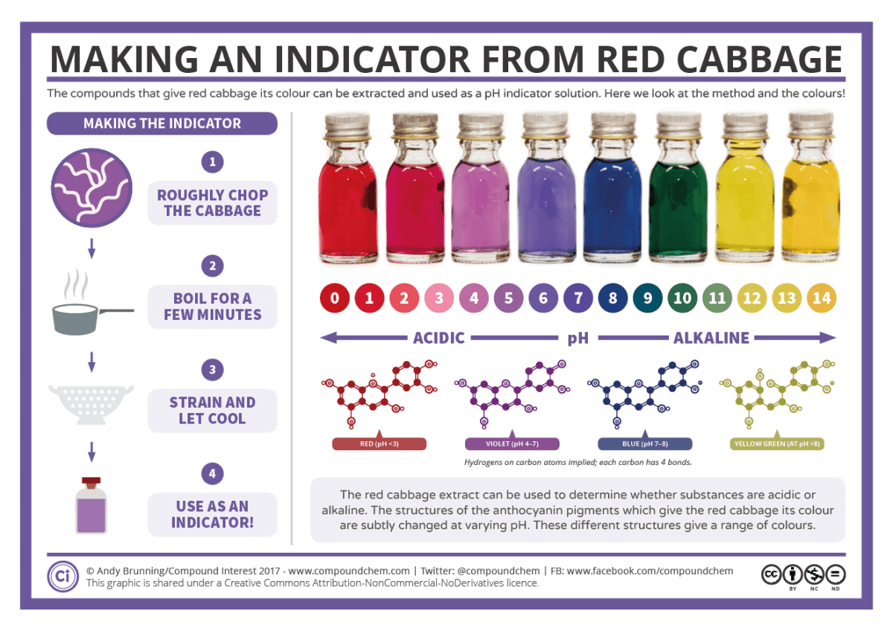

**Questions to think about:**

How will you make it a fair test?

What household acids and alkalis will you use to test your dyes?

Why do plants contain these compounds?

**Find out more….**

As chemistry can be challenging, it helps to be curious and interested in the subject. You could:

|  |  |
| --- | --- |
| Job of the Week: Development Chemist | CK Science | Investigate the types of jobs that need chemistry [here](https://edu.rsc.org/future-in-chemistry) – there are videos to watch and profiles to read – fancy being an astrochemist or an atmospheric chemist or a fine fragrance evaluator? |
| C:\Users\Joanna\AppData\Local\Microsoft\Windows\INetCache\Content.MSO\B212AA29.tmp | Follow chemistry on social media - @compoundchem, @chronicleflask, @cenmag, @chemistryworld can be followed on facebook, tik tok, instagram and X |
| Pictures: september calendar cartoon | Cartoon calendar showing ... | Find out more about important chemists from history at [On This Day in Chemistry](https://edu.rsc.org/resources/collections/on-this-day-in-chemistry) |
| C:\Users\Joanna\AppData\Local\Microsoft\Windows\INetCache\Content.MSO\5AE50457.tmp | Subsrcibe to a youtube channel   * The RSC channel has loads of things on it including [Chemistry in Your Cupboard](https://www.youtube.com/playlist?list=PLLnAFJxOjzZu0QhykI_sCKp05sDaa00kT) demos that you could try at home * The University of Nottingham have produced lots of [Periodic Videos](https://www.youtube.com/user/periodicvideos) including lots of investigations that you are not advised to try at home! * Bristol University has produced a whole range of videos including exciting demos and research talks by post graduate students [Bristol ChemLabS - YouTube](https://www.youtube.com/channel/UCD7Gud4DucBvmw_zCTKe70g) * The [Crash Course chemistry](https://www.youtube.com/playlist?list=PL8dPuuaLjXtPHzzYuWy6fYEaX9mQQ8oGr) videos will help you find out more and give you a taster of A-level chemistry. |
| C:\Users\Joanna\AppData\Local\Microsoft\Windows\INetCache\Content.MSO\811E5619.tmp | Find out about the Lower Sixth Cambridge Chemistry Challenge and start training – there is a weekly quiz to try. |
| Free Books Clipart | Read a book. Books that might interest you include [Travelling With the Atom](https://www.amazon.co.uk/Traveling-Atom-Scientific-Europe-Beyond/dp/1788015282/ref=sr_1_1?dchild=1&keywords=travelling+with+the+atom&qid=1589460442&sr=8-1), [The Science of Cooking](https://www.amazon.co.uk/Science-Cooking-Question-Answered-Perfect/dp/0241229782?ref_=s9_apbd_omwf_hd_bw_b1AJw&pf_rd_r=029HXPN56BXCEZRNHDFP&pf_rd_p=6f2ac06d-fa9c-5090-a698-97a1906eca69&pf_rd_s=merchandised-search-10&pf_rd_t=BROWSE&pf_rd_i=278004), [Molecules of Murder](https://www.amazon.co.uk/Molecules-Murder-Criminal-Classic-Murders/dp/0854049657) and [The Disappearing Spoon](https://www.amazon.co.uk/Disappearing-Spoon-other-tales-Periodic/dp/0552777501/ref=pd_sbs_14_4/262-4367621-9501700?_encoding=UTF8&pd_rd_i=0552777501&pd_rd_r=85507b57-98c0-4c22-a51a-c1a3bc522683&pd_rd_w=lUeFz&pd_rd_wg=7pB2t&pf_rd_p=2773aa8e-42c5-4dbe-bda8-5cdf226aa078&pf_rd_r=HS056N4ZHX6C9F8RJXPK&psc=1&refRID=HS056N4ZHX6C9F8RJXPK) |

Any questions you have before you start then please email Jo Clare, the chemistry course manager [joannac@richuish.ac.uk](mailto:joannac@richuish.ac.uk)

**See you in September 😊**