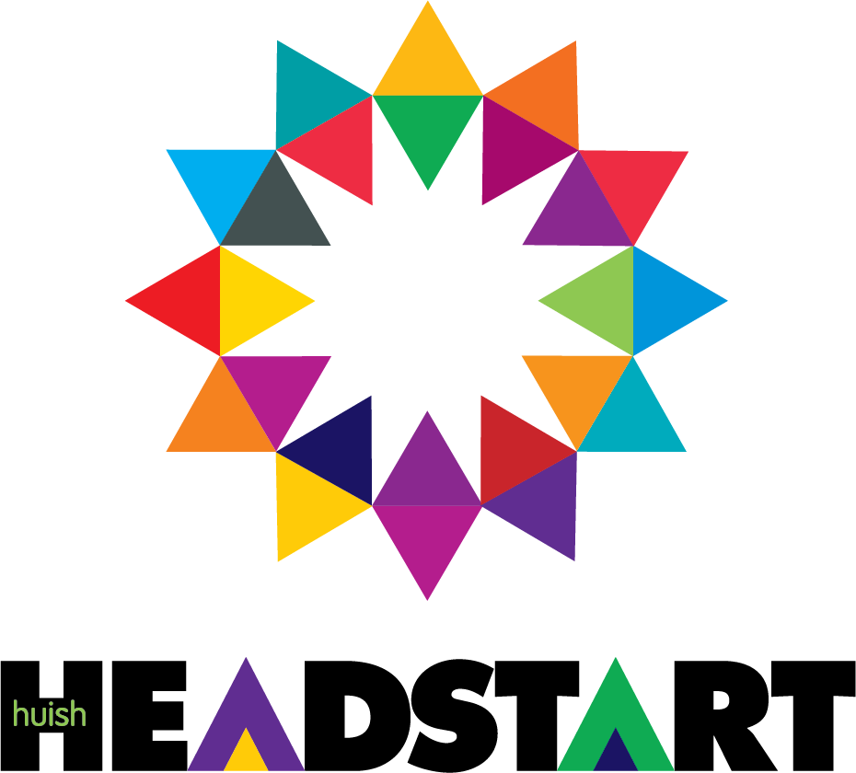

**Welcome to Computing: Application Development**

**Extended Certificate in App Development**

Career range – App Development covers a wide range of industries so will be valuable in any career that you choose to progress onto. There are certain specialist units which will give you a good head start such as Software Engineering, Mobile App Development, Programming, Gaming, Animation and Software Testing.

**Extended Certificate Computing: Application Development**

The equivalent of 1 A level, typically taken alongside either another AAQ or 2 A levels to make up your program.

**Why should I study App Development?**

**The Extended Certificate** course covers the topic in depth, which allows you to develop your knowledge and skills ready for a career in app development and its associated career strands. You will develop the kinds of skills and evaluative thinking that will stand you in good stead in competing for high level jobs. App Development is a great way to enhance your understanding of how information is used in industry and why it is an essential ingredient to giving organizations that competitive edge.

**Assessment method** – a mix of internally assessed units and externally assessed units.

**What typical careers can I go onto?**

**Some of the Industries requiring App Development skills include:**

Games Development, Website Development, Cyber Security, Logistics, Building, Finance, Retail, Farming, Armed Forces

**Extended Certificate students typically go on to University courses, or straight into a job, or Degree/Higher Apprenticeships**

A selection of careers for this course includes: UX/UI Designer, DevOps Engineer, Games Developer, Software Engineer, Mobile App Developer.

**Extended Certificate students typically go on to (when combined with your other subjects): University course, job or Degree Apprenticeship**

Industry Links

|  |
| --- |
| **Our links this year for IT have included working with the local NHS Trust to develop mobile apps for Dr’s and nurses. This work placement partnership will continue this year with further opportunities for students to develop applications.** |

Summer work to complete

Some quick quizzes to get you thinking about UX/UI and app development:

(For the quizzes – approximately 20 minutes)

**🎨 UX/UI Quiz 1: Fundamentals & Research**

1. What does UX stand for?  
   a) User Experience  
   b) User Execution  
   c) Unified Experience  
   d) User Extension
2. Which of the following is a UX research method?  
   a) Typography  
   b) A/B Testing  
   c) Color Grading  
   d) Wireframing
3. What is the main purpose of user personas?  
   a) To define brand identity  
   b) To test UI responsiveness  
   c) To represent target users  
   d) To create wireframes
4. What is a user journey map used for?  
   a) Tracking app downloads  
   b) Mapping user emotions and actions  
   c) Designing UI components  
   d) Creating backend logic
5. True or False: A good UX design should prioritize aesthetics over usability.  
   a) True  
   b) False

**🎨 UX/UI Quiz 2: Interface Design & Tools**

1. What does UI stand for?  
   a) User Interface  
   b) Unified Interaction  
   c) User Integration  
   d) Usability Interface
2. Which principle emphasizes consistency in UI design?  
   a) Feedback  
   b) Design Systems  
   c) Affordance  
   d) Typography
3. What is the purpose of a wireframe?  
   a) To test app performance  
   b) To visualize layout and structure  
   c) To write backend code  
   d) To create animations
4. Which of the following is a popular UI design tool?  
   a) GitHub  
   b) Figma  
   c) Postman  
   d) Unity
5. What does “responsive design” mean?  
   a) Design that reacts to user emotions  
   b) Design that adapts to different screen sizes  
   c) Design that loads quickly  
   d) Design with interactive animations

**📱 App Development Quiz: Concepts & Practices**

1. What is the main purpose of version control systems like Git?  
   a) To design UI components  
   b) To manage code changes and collaboration  
   c) To test app performance  
   d) To deploy apps to stores
2. What does “DRY” stand for in programming?  
   a) Don’t Repeat Yourself  
   b) Debug Regularly Yourself  
   c) Develop Rapidly Yourself  
   d) Design Reusable Yields
3. Which of the following is a mobile app development framework?  
   a) React Native  
   b) Blender  
   c) Figma  
   d) Selenium
4. What is the difference between frontend and backend development?  
   a) Frontend is for databases, backend is for visuals  
   b) Frontend handles user interface, backend handles server logic  
   c) Frontend is for testing, backend is for design  
   d) Frontend is for APIs, backend is for animations
5. What does CI/CD stand for?  
   a) Code Integration / Code Deployment  
   b) Continuous Integration / Continuous Deployment  
   c) Central Interface / Central Debugging  
   d) Continuous Innovation / Continuous Design

Task (approximately 30 minutes)

Watch this video and answer the questions

[UX Design vs UI Design - What's The Difference? (2024)](https://www.youtube.com/watch?v=5CxXhyhT6Fc&t=59s)

**Differences Between UX and UI Design**

1. What are the main responsibilities of a UX designer as described in the video?
2. Explain how the roles of UX and UI designers overlap in their work.
3. What is one example given in the video to illustrate the difference between UX and UI design?
4. How does a UI designer contribute to the overall user experience according to the video?
5. Describe the kind of tasks a UX designer engages in during the design process.
6. What factors should someone consider when deciding between a career in UX design and UI design?
7. How does the video differentiate between the environments in which UX and UI designers typically work?
8. What advice does the speaker give regarding the personal traits suitable for each role?
9. According to the video, what is the significance of user research in UX design?
10. Summarize the key differences between UX design and UI design presented in the video.

**Task (Approximately 2 hours)**

C# tutorials to get to grips with C#

* Complete the exercises in this list on W3Schools

[C# Exercises](https://www.w3schools.com/cs/cs_exercises.php)

**Task (approximately 30 minutes)**

* Research and answer the following questions:

**1. What are the different career paths available to software developers, and how do they differ in terms of skills, responsibilities, and work environments?**

* ***Research ideas*: Job descriptions, interviews with professionals, company career pages, or LinkedIn profiles.**

**2. How is the role of a software developer evolving with the rise of technologies like AI, cloud computing, and low-code platforms?**

* ***Research ideas*: Articles on future tech trends, developer surveys (e.g., Stack Overflow), or tech blogs.**

**3. What soft skills are important for a successful career in software development, and how do they complement technical abilities?**

* ***Research ideas*: Developer interviews, career advice videos, or articles from tech recruiters.**

Any queries? Email [Andyh@Richuish.ac.uk](mailto:Andyh@Richuish.ac.uk) (course manager) or ring the college on 01823 320800.

ANSWERS

**✅ Answers**

**UX/UI Quiz 1:**

1. a) User Experience
2. b) A/B Testing
3. c) To represent target users
4. b) Mapping user emotions and actions
5. b) False

**UX/UI Quiz 2:**

1. a) User Interface
2. b) Design Systems
3. b) To visualize layout and structure
4. b) Figma
5. b) Design that adapts to different screen sizes

**App Development Quiz:**

1. b) To manage code changes and collaboration
2. a) Don’t Repeat Yourself
3. a) React Native
4. b) Frontend handles user interface, backend handles server logic
5. b) Continuous Integration / Continuous Deployment

**UX/UI YT video Answers:**

**Answer Key:**

1. UX designers focus on understanding users and improving their experience. (0:56)
2. Both roles collaborate on projects, but UX focuses on overall experience while UI focuses on visual representation. (6:01)
3. The example of Spotify illustrates how UX designers define features while UI designers layout the visual elements. (2:49)
4. UI designers visually represent features and tools to enhance usability. (3:39)
5. UX designers conduct research, concepting, and problem-solving to enhance user experience. (4:11)
6. Factors include personal interests, work style, and thinking preferences. (8:03)
7. UX designers often work collaboratively with people, while UI designers may work more independently. (8:24)
8. Personal traits such as interest in user behavior for UX and focus on visual detail for UI are important. (8:16)