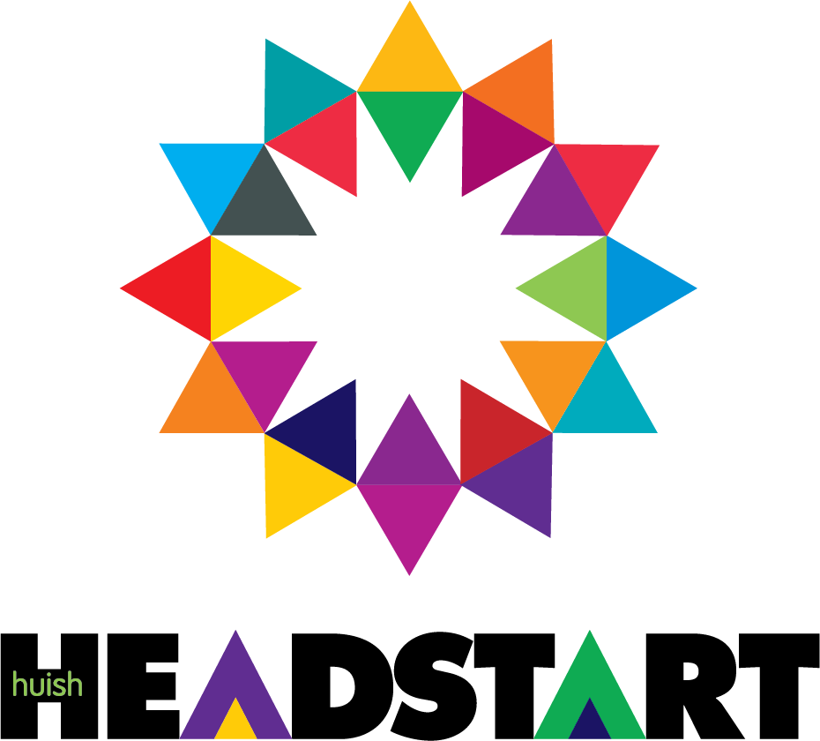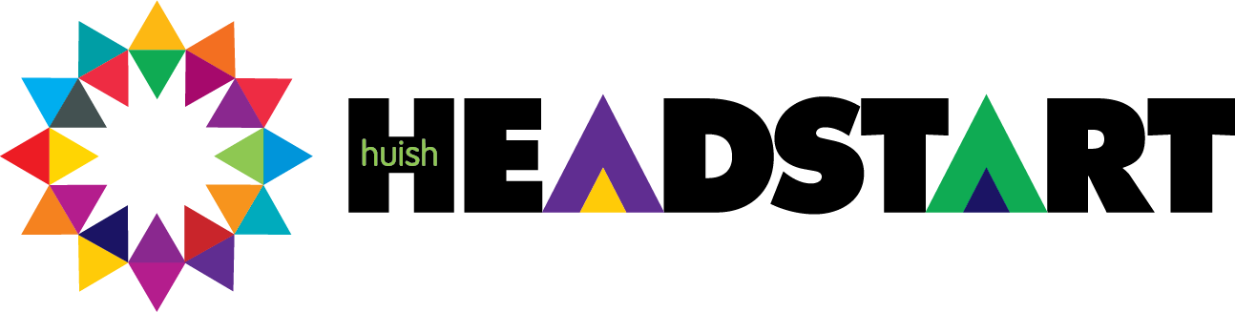

Education and Early Years

# Activity 1:

# Test your knowledge before looking at the answers on the final page

1. In which Key Stage do you take your GCSEs?
2. In Year 8, which Key Stage were you in?
3. What age range is covered by Key Stage 2?
4. When does Key Stage One begin?
5. Altogether, what is the name we give to all the Key Stages?
6. What happens before Key Stage One?

**This should take you about 20mins**

**Activity 2:** The Statutory Framework is a long document and can appear quite overwhelming to begin with. To make a start on this please click here: [EYFS statutory framework for group and school-based providers](https://assets.publishing.service.gov.uk/media/670fa42a30536cb92748328f/EYFS_statutory_framework_for_group_and_school_-_based_providers.pdf) to see a copy of it and then answer the following questions

1. What are the 7 areas of learning the Early Years Foundation Stage (EYFS) covers
   1. What are the prime areas? What do they mean by prime? 1.2What are the specific areas?
2. What are the 3 characteristics of effective teaching and learning?
3. What is a key person?
4. How is each child assessed in the EYFS? And when is this done?
5. What are the staff to child ratios for each age group?

**This should take you about 40mins**

# Activity 3

The Early Learning Goals are what a child would be expected to have achieved by the end of the Early Years Foundation Stage (EYFS) An Early Years Foundation Stage Profile (EYFSP) is written up by the practitioner and this will provide information for the Year One class teacher.

Make a poster to show the Early Learning Goals for each of the 7 areas of learning. Be sure to split the areas into categories where this is indicated. For example, physical development is divided into ‘health and self-care’ and ‘moving and handling’.

Make your poster bright and colourful and easy to read. You will find this a really useful resource to refer back to when you begin the course.

**This should take you about 2 hours**

# Activity 4: You now need to match your skills and abilities to the real world environment by applying for the job advertised below.

# Create a formal letter of application which includes full details of your current knowledge, skills, experience, values and beliefs.

(There is some guidance on the next page to help you with this)

Early Years Educator required: Are you who we are looking for?

* Warm, smiley face that makes every child feel special and loved
* Little bit of quirkiness…If a child requests that you be the captain of a pirate ship, you will be the best captain ever to sail the seas
* Ability to sing in tune is not necessary, however the ability to sing out of tune in front of a crowd is essential
* Knowledge of Frozen, Minions, Spiderman, Peppa Pig and Thomas the Tank engine would be advantageous
* A high level of multi-tasking is essential
* You must be able to distribute warm hugs when required
* Possessing the skill to rapidly count the heads of numerous moving small people is of utmost importance
* You must be able to remain focused in an environment with high noise levels
* Pretending to eat playdough creations realistically is required
* The ability to remember the names of 60+ children, their parents, grandparents, pets and soft toys is a key component of this job
* Your feelings must not be hurt easily
* You must have the ability to read a fairy tale with at least one interruption per page
* You must be prepared to have a lot of fun in the workplace
* You must want to feel loved, special and important to lots of young children

**Adapted from: https:**[**//www.glosjobs.co.uk/childcare-jobs-in-cheltenham/level-3-practitioner-part-time-permanent-489424/**](http://www.glosjobs.co.uk/childcare-jobs-in-cheltenham/level-3-practitioner-part-time-permanent-489424/)

(Keep scrolling for guidance)

|  |
| --- |
| **Things to include in your letter of application:** |
| **Knowledge:**  **Relevant formal learning: this should include your GCSEs, any training courses you have attended, skills you have learnt from a part time job**  **Relevant informal learning: this should include anything you have learnt in addition to school –**  **hobbies, home life etc.** |
| **Skills:**  **Communication: are you a good communicator? What language skills do you have - perhaps you speak more than 1 language? How about your non-verbal skills? Think about body language, eye contact, gestures. Do you know any sign language? How do you use your communication skills? Perhaps you know someone with a hearing loss or a learning disability – how do you communicate effectively with them?**  **Work experience: do you have a part time job? Have you done any work experience? Detail here the skills these experiences have given you**  **Practical skills: Do you play an instrument or bake a mean lemon drizzle cake? Do you participate in any sports? Tell us about it here**  **Working with others: Do you work well as part of a team? Please give some examples of when you have worked cohesively with others – this could be your peers or service users**  **Technical skills: eg use of IT – what are you skills in this area?**  **Personal skills: detail here your organisational and time management skills e.g include how you prepared for your exams or how you managed coursework to make sure it was handed in on time.** |
| **Values and beliefs:**  **What is important to you? This may include relationships, religion, dietary preferences. Use this information to tell us the sort of person you are. Try to describe yourself as others see you and use a wide vocabulary to outline your personality** |

**This should take you about 1 hour**