

A LEVEL ENVIROMENTAL SCIENCE

Welcome to the A level Environmental Science course! This booklet has a number of activities for you to do and is designed to give you a flavour of what this topical course covers, to support your introduction of the course and hopefully to inspire you to study A-level Environmental Science.

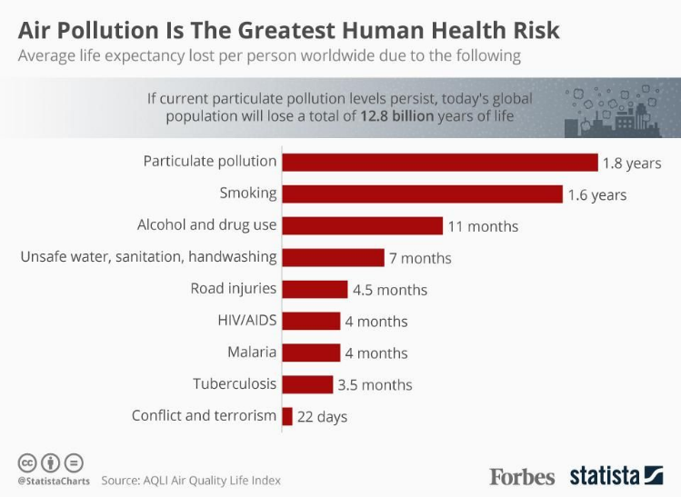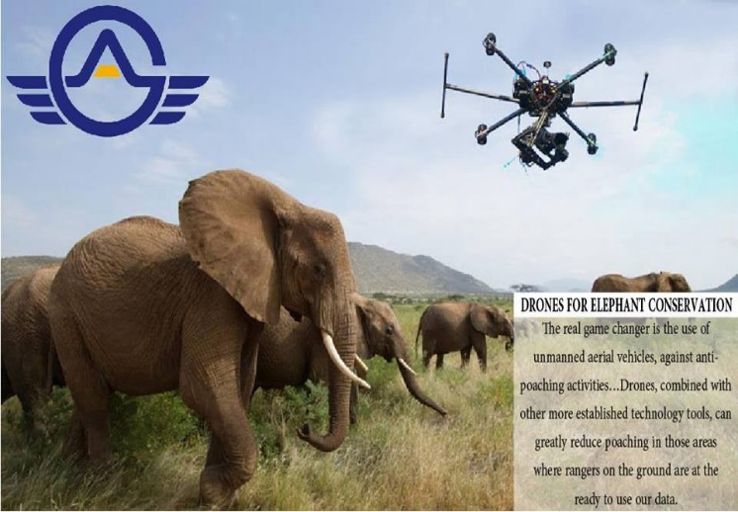

[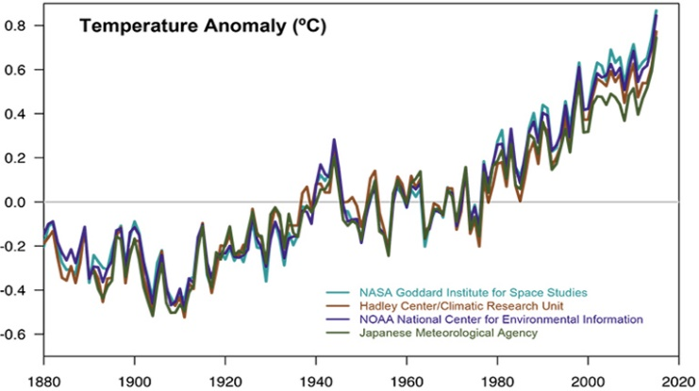](https://www.google.co.uk/url?sa=i&url=https%3A%2F%2Fwww.channel4.com%2Fnews%2Ffactcheck%2Fclimate-change-in-ten-graphs&psig=AOvVaw0D48mGabfTWyjsauBhyyol&ust=1589142777255000&source=images&cd=vfe&ved=0CAIQjRxqFwoTCIiozafQp-kCFQAAAAAdAAAAABAE)

[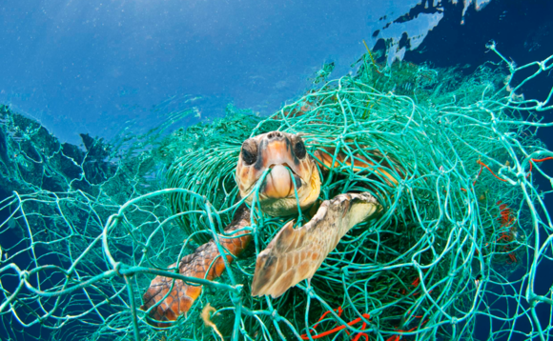](https://www.google.co.uk/url?sa=i&url=https%3A%2F%2Fwww.businessgreen.com%2Fnews%2F3073645%2Fmarine-plastic-pollution-costs-the-world-up-to-usd25bn-a-year-researchers-find&psig=AOvVaw0pt8ICE9gl-tjo__MbwJRH&ust=1589142565781000&source=images&cd=vfe&ved=0CAIQjRxqFwoTCMDU-8LPp-kCFQAAAAAdAAAAABAE)

Environmental Science is a popular course at the college and has grown steadily over the last few years. The course is exam assessed at the end of two years study and the exam board is AQA. Here is a link to the exam board website if you would like to look at the specification in detail:

[**AQA Environmental Science**](https://www.aqa.org.uk/subjects/science/as-and-a-level/environmental-science-7447)

Although the course is exam based, practical experience is one of the underlying principles of the course. You will carry out regular lab practical experiments on a range of topics and theories and here are some examples: cloning plants; testing insulation materials for an eco-build house; soil analysis; testing the energy density of biofuels; investigating the effects of acid rain on seed germination.

As well as lab experiments there are also a number of fieldtrips which are an important part of the course where you can learn the practical fieldwork skills that you will be assessed on in the exams. Here are some examples of recent trips: studying captive breeding at Paignton Zoo; working with Somerset Wildlife Trust coppicing woodland and restoring habitats at Westhay Moor NNR; studying marine conservation and fisheries at the National Marine Aquarium. In addition to this there is a 3 day residential fieldtrip.

**Why should you choose this course? (10 mins)**

Before you go any further write down in the box why you have picked this course:

1.

2.

3.

Students pick this course for a great number of reasons. Many of you may be worried about the state of the planet (and with good reason!) and would like to learn more about these problems. Some of you may also see this course as a good steppingstone to an interesting career and you’d be correct; the green sector is in the top 5 globally for job growth. There has never been a better time to study environmental science!!

**Course requirements**: This is a science A level and it is highly recommended to study this course in combination with at least one other science such as biology, chemistry etc or an earth science subject such as geography or geology. Many environmental problems need analysis and manipulation of data to understand them and to come up with solutions e.g. how quickly are the elephant numbers declining in Southern Africa? What is the % change each year? What ratio of elephants are killed in different countries and is there a statistically significant difference? Maths therefore comes up often in the exam and makes up 10% of all exam questions. You don’t need to be a brilliant mathematician, but you should be comfortable with applied mathematical questions and should have at least a 5 in GCSE maths. Here is a link to the AQA website showing you the maths content of the course:

[AQA | Environmental Science | A-Level | A-level Environmental Science](https://www.aqa.org.uk/subjects/environmental-science/a-level/environmental-science-7447/specification/appendix-b-maths-requirements-and-examples)

If you have any questions about any aspect of the course then please don’t hesitate to e-mail the course manager Richard Palmer at: [richardp@richuish.ac.uk](mailto:richardp@richuish.ac.uk)

**Activity 1 (15 mins)**

Environmental Science is a course with a lot of scientific terminology. You will gradually learn these new terms throughout the A level but to get you started see if you can match up the following terms with the definitions (the answers are on the last page of this booklet):

**Key term Definition**

1.Biotic a. The concept of a state of balance e.g. the earth’s natural systems (until recently altered by human activity).

2.Ecosystem b. The study of tree rings to determine past climates. Wider rings typically signify warmer years as trees grew faster.

3.Homeostasis c. Growing plants in a nutrient solution. Soil loss from erosion means this type of farming may become very important.

4.Dendrochronology d. A major causes of native species loss in the UK. The signal crayfish and Japanese knotweed are well known examples.

5.Biomimetics e. A factor relating to living things eg predation, disease, and competition.

6.Bycatch f. A community of species and how they interact with each other and other factors such as climate.

7.Invasive species g. An organism often used in conservation campaigns. Iconic species e.g. pandas and snow leopards are good examples.

8.Abiotic h. An underground store of water. In parts of the world these are being depleted and this could threaten food production.

9.Flagship species i. Discarded fishing gear that can stay in the oceans for many years entangling and drowning marine species e.g. turtles.

10.Aquifer j. A factor related to non-living things e.g. weather, soil and water chemistry.

11.Hydroponics k. A widely used pesticide now banned in Europe. Use of these insecticides nearly wiped out otter populations in the UK.

12.Ghost fishing l. The study of shapes in nature for engineering designs e.g. birds wing tips in aircraft design.

13.Organochlorine m. Non target species landed by fishing boats. Many are often thrown back dead; these fish are known as discards.

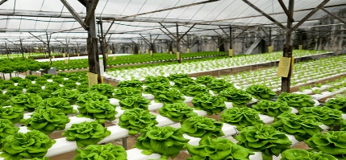[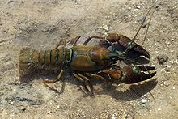](https://www.google.co.uk/url?sa=i&url=https%3A%2F%2Fen.wikipedia.org%2Fwiki%2FSignal_crayfish&psig=AOvVaw11aLURl5s4r8ntKrlBoyda&ust=1589208330270000&source=images&cd=vfe&ved=0CAIQjRxqFwoTCODElMHEqekCFQAAAAAdAAAAABAE)

**Activity 2: Research Task (1 -2 hours)**

Reading around the subject and following topical news stories is very important in A level

Environmental Science. This activity is therefore designed to get you used to researching

environmental issues and also to familiarise you with some of the best places to find

information.

The news frequently features species that are threatened with extinction. These are often chosen in

wildlife campaigns because they illicit an emotive response in people (flagship species) such as pandas

or rhinos. In reality, there are often many species that people never get to hear about that might be

more important from an ecological point of view – imagine trying to collect money to ‘save the

phytoplankton’!! The same can be said of habitats and tropical rainforests are often cited as being

very important – which they are. There are, however, other far less well-known habitats that are

equally, if not even more important. Your task is to compile a short research project about one such

habitat: sea grass meadows. Your project will need to cover the following key areas:

* What are sea grass meadows and where are they found?
* What species are they home to?
* Why are they considered to be so important?
* What are the key threats to sea grass meadows?
* What conservation efforts are taking place to try to preserve these vital marine habitats? Do you think they will work?

You will need to do your own research but here are a few web links to get you started. As

you will see, some of these are from the BBC news website and this is a great place to

research any environmental news story so try refining your searches by including the word

BBC. Good quality newspapers are also a great place to search:

[Ocean Habitats | Blue Meadows - Ocean Conservation Trust](https://oceanconservationtrust.org/ocean-habitats/?gclid=CjwKCAjwv8qkBhAnEiwAkY-ahoSASm_rqI9ZLtp80MmRq51XKQvRAh5Dp82w7kmMirEwGkUqiuqA9xoCIgMQAvD_BwE)

[Ambitious plan to restore 10% of UK seagrasses - BBC News](https://www.bbc.co.uk/news/uk-england-devon-61709335)

[Seagrass needs to be 'protected and restored' - BBC News](https://www.bbc.co.uk/news/av/uk-england-cornwall-56407896)

[Plymouth Sound volunteers plant seeds to restore seagrass meadows - BBC News](https://www.bbc.co.uk/news/uk-england-devon-56819082)

[Climate change: 'Forever plant' seagrass faces uncertain future - BBC News](https://www.bbc.co.uk/news/science-environment-56378397)

['Catastrophic': UK has lost 90% of seagrass meadows, study finds | Coastlines | The Guardian](https://www.theguardian.com/environment/2021/mar/04/catastrophic-uk-has-lost-90-of-seagrass-meadows-study-finds)

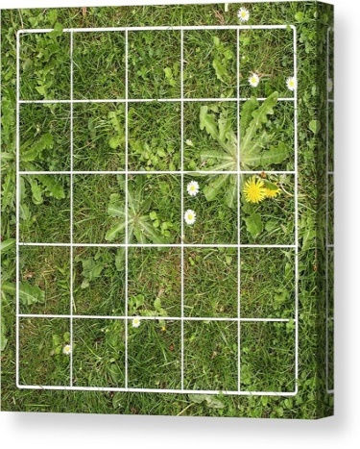**Activity 3 – A practical investigation (1-2 hours)**

As stated before, during the Environmental Science course we will carry out practical investigations in the lab and out in the real world. To start developing your observation skills we would like you to carry out a mini-bioblitz in your local area.

A BioBlitz is an event where people try and record as many species as they can in 24 hours. Your Bioblitz could be 30 minutes or you could keep a record of things you see in your garden or local park over a longer period. Many people do not know the huge diversity of species on their doorstep. You may be thinking that you won’t find much but when you start to look closely you may well be surprised. Even in a patch of grass you could find daisies, dandelions, plantain, clover and many more.

**Did you know?**

There are 270 species of bee in the UK – which includes 24 different types of bumble bee and only 1 species of honey bee

There are 59 different butterfly species but around 2500 species of moth in the UK

The UK is home to only 32 native tree species but many more have been introduced (some deliberately & some accidentally).

You will need paper/notebook and a pen to record what you see. You may also want to take photos as evidence or to get some help identifying the things you find. There are a selection of useful websites for identifying different groups of organisms below but one of the best is the app Seek by iNaturalist.

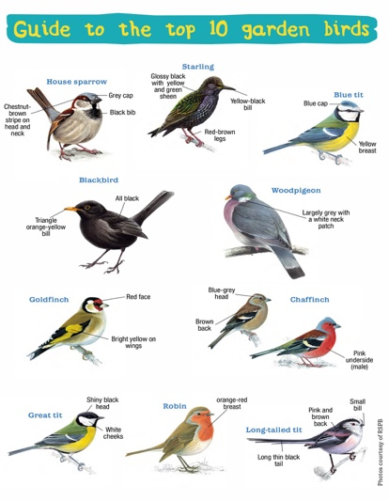

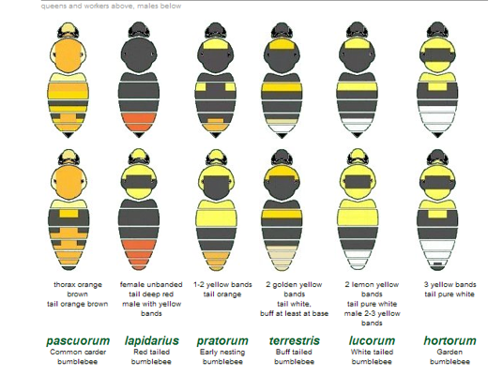

**Useful websites:**

If you would like to improve your identification skills you could use the following websites.

[www.opalexplorenature.org/xpollination](http://www.opalexplorenature.org/xpollination) quizzes and help identifying butterflies and bumblebees and ideas how you can help pollinators in your garden.

Take part in the Big Butterfly count and send in your records to this national survey. [www.bigbutterflycount.org](http://www.bigbutterflycount.org)

RSPB bird identifier <https://www.rspb.org.uk/birds-and-wildlife/wildlife-guides/identify-a-bird/>

Woodland trust tree identification <https://www.woodlandtrust.org.uk/trees-woods-and-wildlife/british-trees/>

Or you can use identification apps where you upload photos for experts to identify including [www.ispotnature.org](http://www.ispotnature.org)

[www.inaturalist.org/projects/city-nature-challenge-2020](http://www.inaturalist.org/projects/city-nature-challenge-2020)

**Answers to Activity 1**

**1e, 2f, 3a, 4b, 5l, 6m, 7d, 8j, 9g, 10h, 11c, 12i, 13k**