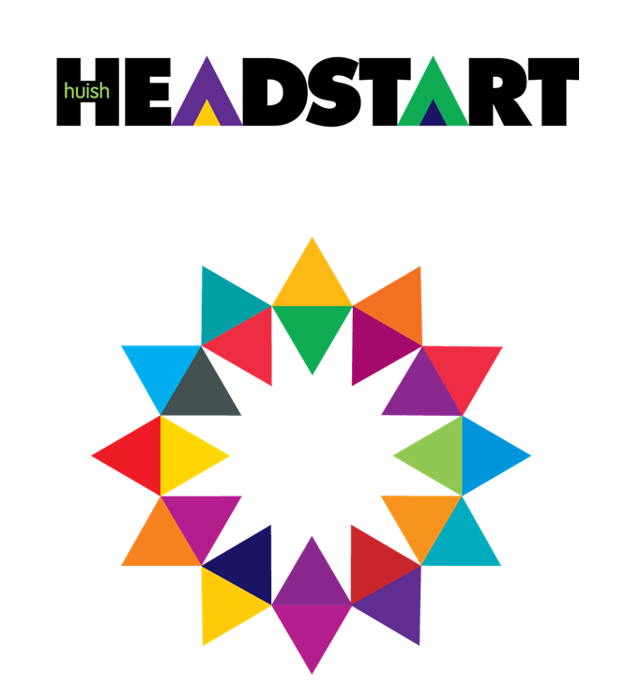

GEOGRAPHY

Exam board is EDUQAS.

Approximate plan of your A level

|  |  |
| --- | --- |
| Induction | Getting to know the course, each other, and some geographical tasks |
| Year 1 | Global Governance and Oceans |
| Water and carbon cycles |
| Changing Places |
| Coasts |
| Coursework planning |
| Summer holidays | Data collection for coursework |
| Year 2 | Coursework write up  Tectonics |
| Weather and climate |
| Development in an African context |

**Overview of the A level = 3 exams and coursework:**

1 = Component 1: Changing Landscapes (coasts or glaciers) and Changing Places

Written examination: 1 hour 45 minutes. 20.5% of qualification

2 = Component 2: Global Systems (water and carbon cycles) and Global Governance. Section C: 21st Century Challenges (synoptic essay). Written examination: 2 hours. 27.5% of qualification

3 = Component 3: Contemporary Themes in Geography (tectonics, weather and climate and development in an African context). Written examination: 2 hours 15 minutes. 32% of qualification

4 = Component 4: Independent Investigation. Non-exam assessment: 3000 to 4000 words. 20% of qualification. One written independent investigation, based on the collection of both field data and secondary information.

**FAQs**

* You do not need to have done GCSE; it will be helpful but not essential
* There is maths in geography, not loads, but it is included.
* The coursework is worth 20% of your A level

**Welcome to Huish – Geography Summer study.**

Our first module will be Global governance which is about global issues / events and what is being done about them.

To help you make a good start to the course we would like you to research the following topics.

Please produce a summary of each one and then comment on what makes it a GLOBAL issue.

Make sure you have about 500 words per topic. **In total this task should take you about 3 – 4 hours.**

You will need the knowledge and notes for the first part of the course.

* Russia’s invasion of Ukraine. Why did Russia invade? What has happened since then? Which countries are supporting Russia, and which are supporting Ukraine? Where have the refugees gone? What have the wider effects of this situation been for the world?
* The Windrush generation. Why is Africa linked to the Caribbean through trade? Outline the British part in this process. Why did people then move from the Caribbean to the UK? Why was there a scandal associated with this? What did the UK do in response?
* Different ways of managing immigration around the world ranging from very strict to less so. Have a look at the Australian system as well as the British system and then search for easiest countries to migrate into and look at one of those. Which countries have had some controversial immigration policies in recent years?
* Plastic pollution in the oceans. What is plastic usually made from? When did we start using it in huge amounts? How much waste plastic is there? What happens to it? Why does plastic waste cause problems in the sea / ocean? Why are we concerned about microplastics?
* The rise and fall of the British Empire with a focus on how it helped the UK to become rich and powerful. What is the Commonwealth and how is it different to the Empire? Does the UK have any strong relationships with any of these countries?
* The UN – Who are they? When were they set up? What do they do? Try to cover a few global issues that they are tackling.

We will be checking your basic geographical knowledge at the start of the course too – things like names of continents, key countries, latitude, compass directions so spending a bit of time on that (if you need to) would be a good idea. **This should take about an hour.**

Things you could use to help you with this:

 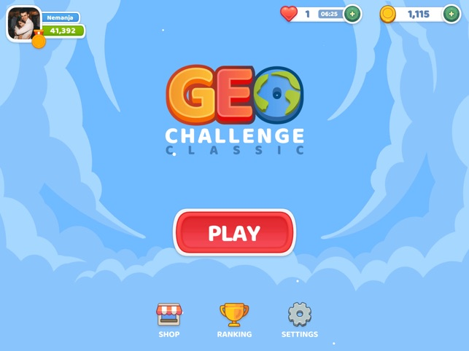

Geo Challenge app

[Geography Quizzes and Games](https://www.sporcle.com/games/category/geography/alltime) Sporcle geography quizzes

[Geography Quizzes](https://www.jetpunk.com/tags/geography) Jet Punk geography quizzes

**Optional:**

You could watch some useful documentaries over the summer before life gets busy at college. We would recommend the following on BBC iPlayer.

Any of Simon Reeves’ country documentaries; A perfect planet or most things with David Attenborough. The Earth documentary series. Union with David Olusoga

Or there are lots of good books like: ‘Prisoners of Geography’, ‘The Power of Geography’ and ‘the Future of Geography’. ‘How to spend a trillion dollars’ is also an interesting read.