
VOCATIONAL MEDIA
EXTENDED CERTIFICATE
YEAR 11 BOOKLET




VOCATIONAL MEDIA CERT
What This Booklet Is and How to Use It
So, you have chosen to study Vocational Media at Richard Huish College. Congratulations, a great choice. This will mean that you have an interest in the subject, but learning about Media may be new to you, or you may have studied it as one of your GCSEs. The activities in this booklet will help you, whatever the stage of your learning. For the complete beginner, they will give you a taste of the riches that await you when you choose to study Media at Richard Huish College. For those of you who took it for CGCSE, they will add real depth to your knowledge about the subject, while giving you fresh ideas about ways in which to approach it.
Part One
This part of the booklet is compulsory – we would like you to complete ALL of the tasks in this section, so that we can get an understanding of you as a Media Consumer.
Part Two
In this section materials are based around articles from the English and Media Centre’s magazine for A Level students of Media Studies and Film Studies, MediaMagazine. The tasks linked to each of the 2 articles use the following format:
- Read the article.
- Answer questions about it – this will help you to make sure that you fully understand the content, ideas and concepts associated with a particular aspect of media study.
- Complete various tasks and activities that use the article as a springboard.
These activities will begin the process of moving you towards the level of understanding, thinking and work that you will be working at on the Level 3 Course.
Please complete one task of your choice, and bring your work with you at the start of college in September. You can do both if you have time. As you work your way through the tasks you should start to see what a varied, interesting and intellectually challenging subject Media is!
Part Three
This section contains links to websites, blogs, vlogs, podcasts and online content that we think will help you prepare to be a Media student at Richard Huish. These activities can be found at the end of the booklet and suggest what you could be watching, reading, following, listening to and making to build up your skills ready for September. For this section, we ask that you keep a brief journal or diary of the content that you access from these resources, making note of anything new you learn, interesting content, things you’d like to learn more about or areas that you can see as a possible route into the Media for you. Students leaving our Media course have moved into jobs in production, marketing, radio, media apprenticeships and media related degrees, so gaining as much insight into the subject before you begin with us is a great headstart!
Part One
Pinterest Boards
On your Vocational Media Production course, the work will include looking at films, how they are produced and how they are made to appeal to specific audiences. In preparation for this work, we want you to carry out a research task to present to us in September telling us a little more about you as a person, your media interests and your taste in films!
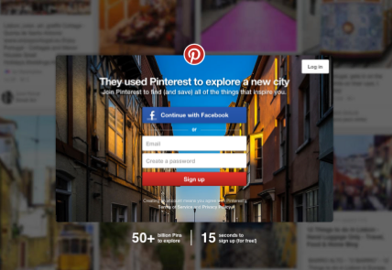
Task 1
The Internet is an important resource for us in Media Production. As a prospective Media student it is highly likely that you use the internet regularly. The first thing that we want you to do is to create a Pinterest account (if you already have one setup then please use this). Pinterest allows you to create different ‘interest’ boards where you can post and pin interesting things from the Internet that appeal to you. These can be links to web pages, images, videos etc. Log on to https://uk.pinterest.com/ to sign up.
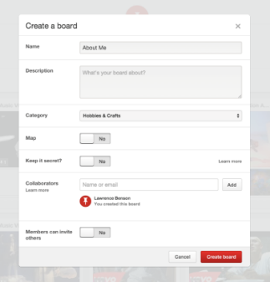
Task 2
After setting up an account, the first Pinterest board we would like you to create, titled ‘About Me’, should tell us a little bit about you as a person. What are your interests? Maybe you like sport, maybe you like to read, maybe you have a favourite actor or genre of music, maybe you enjoy playing video games. Whatever your interests are, pin them to your board.

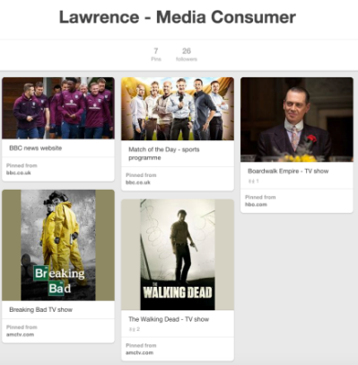
Task 3
The second Pinterest board we would like you to create should tell us a little bit about you as a ‘Media Consumer’. Pin some posts to a board that tells us the types of media you consume and use: this might be a television series you regularly watch, radio stations you listen to, a film you have recently seen, magazines, websites and social media sites that you like to use etc.
Task 4
For the final task we would like you to begin considering the types of films that you like, which may come from different genres. Create a Pinterest board titled ‘My Movies’ and pin images, trailers, clips and content that you find on the internet. (Some sites – like YouTube – allow you to post straight onto your boards https://www.youtube.com/user/movieclipsTRAILERS?gl=GB&hl=en-GB See below).
You could also include your favourite actors or directors, or genres. For each ‘thing’ that you pin to your board write a comment explaining why you like or are interested in it. (Consider camera work, music, storylines, characters, editing, storyline, what you learned etc..)
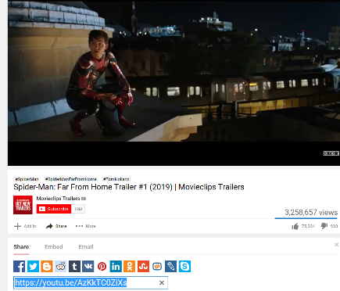
Part Two

Choose and complete one of the two tasks on the following pages:
Task 1
Video Production: Making and Breaking the 180-degree Rule
Or
Task 2
Deconstructing a Newspaper Front Page: Ownership and Bias
Task 1
Video Production: Making and Breaking the 180-degree Rule
- Watch this video on The 180 Degree Rule in Film www.youtube.com/watch?v=iW0bKUfvH2c
- And this clip from ‘The Last Jedi’
www.youtube.com/watch?v=1fh4EWHKHYU
Now read Star Wars and the 180-degree Rule, by Giles Gough below. The article for this task is taken from MediaMagazine 64.
Answer the following questions, using the article for information and ideas.
  - What does the article mean by a film’s ‘grammar’?
  - What is the 180-degree rule in filming and why was it necessary to use from a practical point of view?
  - What is distinctive about the use of the 180-degree rule in Star Wars to show the relationship between Rey and Kylo Ren?
  - What other stylistic choices are consistently used in Star Wars films? www.youtube.com/watch?v=cGqAu9gj_F0
  - What impact does the writer feel that the purchase of the Star Wars franchise by Disney will have on the way the films are made?
Extension activity: ‘Make’ with the 180 degree rule
If you have access to a video camera, or you can use your phone, set up a simple scene between characters and shoot a conversation using the rule of 180 degrees. Use toys or other objects if you don’t have two other people to film with. Think about where the camera needs to go and in what shots you would need for a conversation. Use this video to help: www.youtube.com/watch?v=Bba7raSvvRo
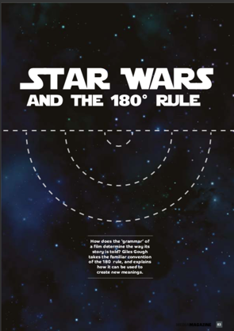
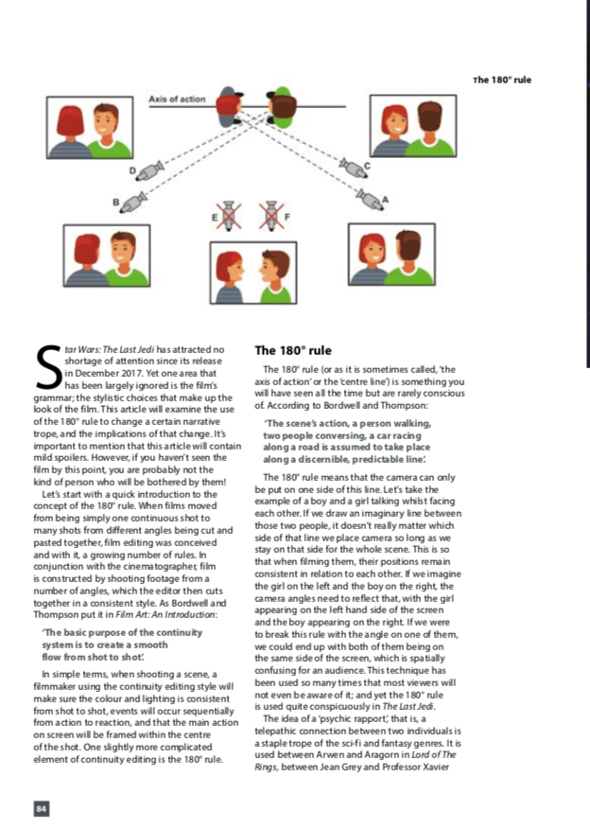
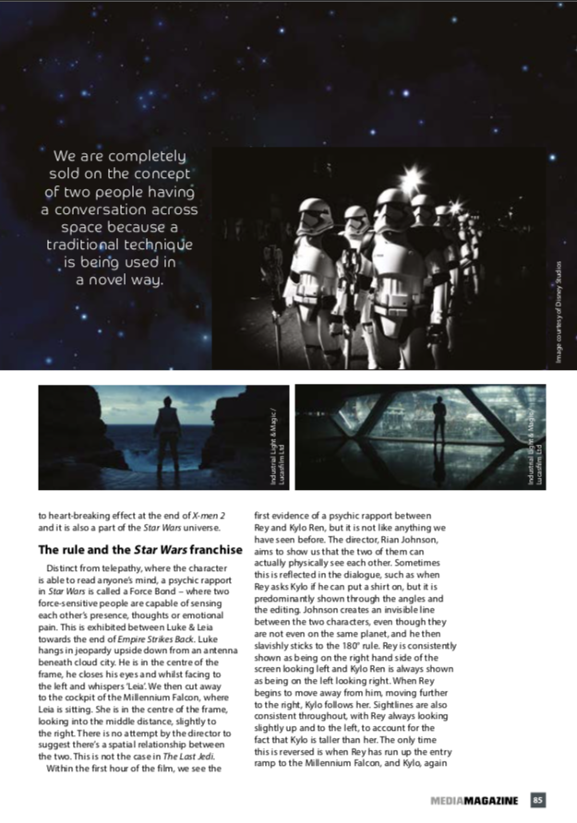
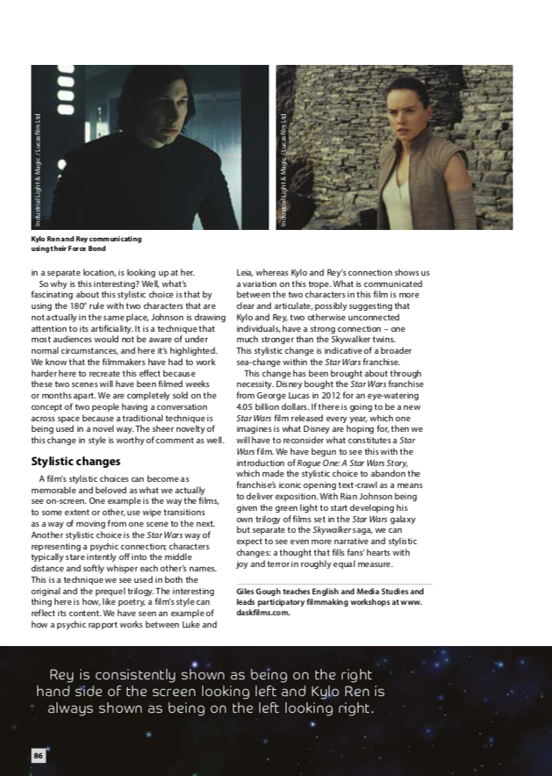
Task 2
Deconstructing a Newspaper Front Page: Ownership and Bias
Read the following March 29th, 2019: The Day Brexit Didn’t Happen by Jonathan Nunns, below. The article for this task is taken from MediaMagazine 69
Answer the following questions, using the article for information and ideas.
  - The article talks about ‘deconstructing’ a front page. What do you understand by deconstructing? Use a dictionary to help you if need be.
  - What are the different regulatory systems that govern broadcast and print news? What do you think about these systems and how they enable newspapers to show bias or a political view?
  - Consider where you get your own news from, and how reliable, biased or politically motivated it might be.
Selecting two newspapers to study
The BBC publishes all of the UK’s leading newspapers’ front pages every day at https://www.bbc.co.uk/ news/blogs/the_papers.
- Visit the web site and select two newspaper front pages that particularly interest you on that day.
- Before you begin to deconstruct the front pages, you are going to research each publication. You could make a factfile on each that includes the following:
- » Is it a tabloid or a broadsheet, or somewhere in between (a mid-range newspaper)? Why?
- » Political leanings – is the paper broadly left or right wing? Do they give support to a particular political party? Do they express strong views about particular issues? Do they campaign for any issues?
- » Readership – what is the demographic of the newspaper’s readership? You might think about their age, social class, gender, ethnicity and so on.
- » Ownership – who and what can you find out about the company or individual who owns this publication? What else do they own? What other media or business interests might they have?
Comparing coverage Now look at the front pages of your chosen newspapers on your chosen day.
- » What do you notice about the stories they have decided to cover?
- » How much space is given to different categories of stories e.g. political, UK, global, health, education, entertainment, celebrities etc.? What might this reveal about how the newspapers might be trying to affect public opinion?
Look more closely
- How does the language used in the headlines and captions differ across the front pages (this is especially interesting when the same lead story is covered across more than one paper)? What might this reveal about the audience or the attitude of the papers towards the subject being covered?
- Look at the images selected – Why are they chosen? Does the headline or caption add to the meaning?
- Write a comparison of the two front pages you have studied or, if you’re craving some production work, make a mock-up a front page of a new newspaper reflecting your views of the news on your chosen day.


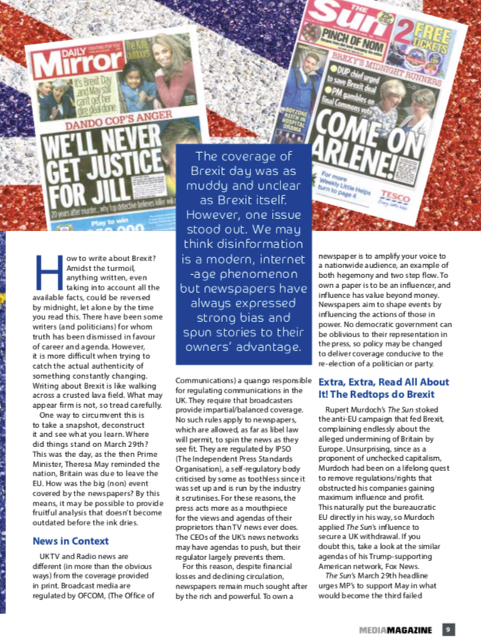
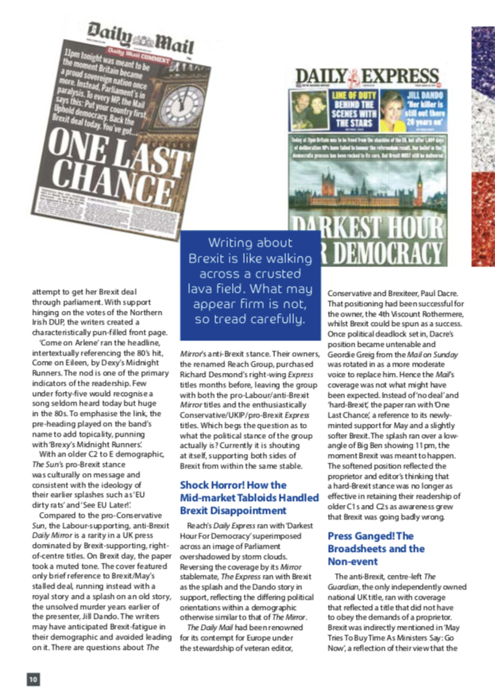

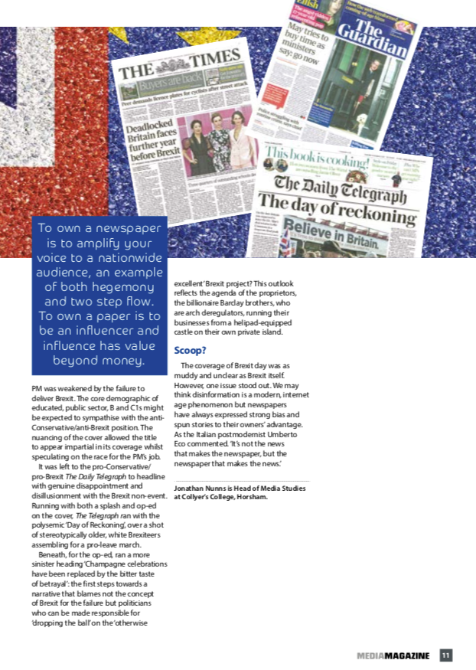

Part Three
Use the following resources to build up your understanding of media and keep a journal/diary, making note of anything new you learn, interesting content, things you’d like to learn more about or areas that you can see as a possible route into the Media for you.
Resource | Notes

Things to read
Empire Magazine www.empireonline.com/
BFI: Sight and Sound www.bfi.org.uk/news-opinion/sight-sound-magazine
BBC Technology news www.bbc.co.uk/news/technology
BFI Website www.bfi.org.uk/
Student Filmmakers www.studentfilmmakers.com/
Videomaker magazine www.videomaker.com/magazine
Filmmaker IQ https://filmmakeriq.com/
MovieMaker Magazine www.moviemaker.com/

Things to watch
On Netflix:
Black Mirror
The Movies that Made Us
The Social Network
The Great Hack
The Post

On YouTube:
Every Frame a Painting https://www.youtube.com/user/everyframeapainting
The Film Look www.youtube.com/channel/UCG8T8xZYuuiSxa5mOHz2Q2g

A History of Horror with Mark Gatiss www.youtube.com/watch?v=ZkZBJd4UTlM
www.youtube.com/watch?v=gaFNgHuYdPA www.youtube.com/watch?v=5EH1FiToj4w&has_verified=1
HuishMedia on Youtube www.youtube.com/channel/UCjywutzNifzCagQdPDRUFKA?app=desktop
Kermode and Mayo’s Film Review www.youtube.com/user/kermodeandmayo
Hey You Guys www.youtube.com/channel/UC2jXtsIZXdy6uAjEg1zyMYg
BFI www.youtube.com/user/BFIfilms
What’s so great about that? www.youtube.com/channel/UC3g8YdblbqlUAKEeAJbzMYw/videos
KaptainKristian www.youtube.com/channel/UCuPgdqQKpq4T4zeqmTelnFg
Cinema Cartography www.youtube.com/channel/UCL5kBJmBUVFLYBDiSiK1VDw
Now You See It www.youtube.com/channel/UCWTFGPpNQ0Ms6afXhaWDiRw/videos
Thomas Flight www.youtube.com/channel/UCUyvQV2JsICeLZP4c_h40kA
Nerdwriter1 www.youtube.com/channel/UCJkMlOu7faDgqh4PfzbpLdg
D4Darious www.youtube.com/user/D4Darious/featured
Film Riot www.youtube.com/user/filmriot

BBC Inside Cinema www.bbc.co.uk/iplayer/group/p07mj641

Things to listen to
Kermode on Film https://play.acast.com/s/kermodeonfilm
Pilot TV Podcast https://play.acast.com/s/pilottvpodcast
No Film School Podcast https://play.acast.com/s/the-no-film-school-podcast
The Empire Film Podcast https://play.acast.com/s/theempirefilmpodcast

Things to follow
Huishmedia on Instagram
Indie Filmmaking Blog www.lightsfilmschool.com/blog/

