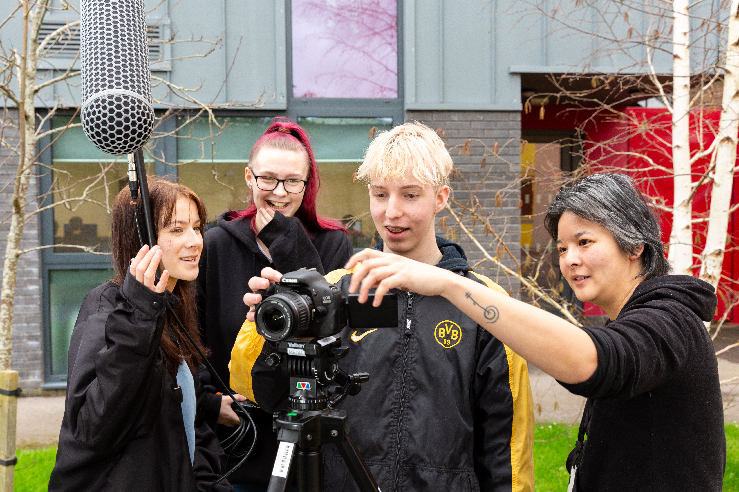
VOCATIONAL MEDIA
EXTENDED DIPLOMA
YEAR 11 BOOKLET


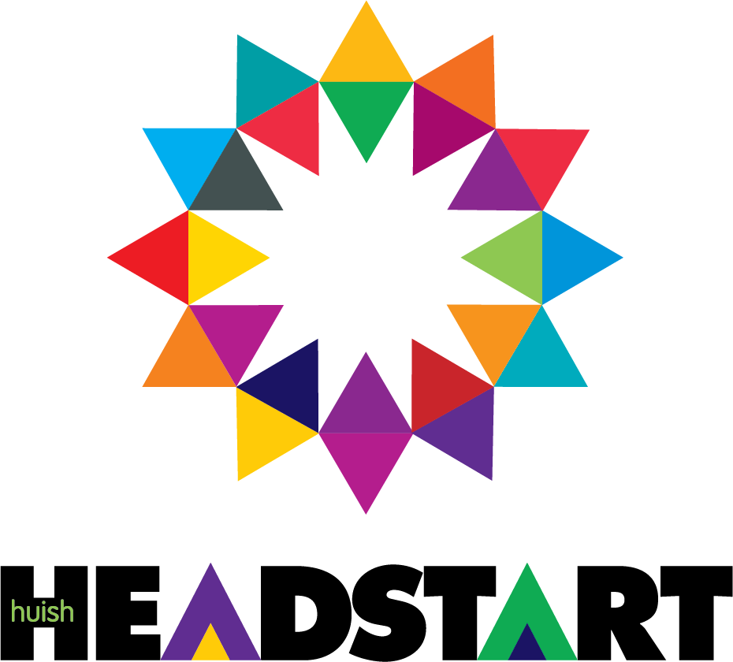

VOCATIONAL MEDIA EXTENDED DIPLOMA
What This Booklet Is and How to Use It
So, you have chosen to study Vocational Media at Richard Huish College. Congratulations, a great choice! This will mean that you have an interest in the subject, but learning about Media may be new to you, or you may have studied it as one of your GCSEs. The activities in this booklet will help you, whatever the stage of your learning. For the complete beginner, they will give you a taste of the course content that await you when you choose to study Media at Richard Huish College. For those of you who took it for GCSE, they will add real depth to your knowledge about the subject, while giving you fresh ideas about ways in which to approach it.
Introduction
On your Vocational Media Production course, the work will include looking at films, music, animations and a lot more. In preparation for this work, we want you to carry out a research task to present to us in September telling us a little more about you as a person, what you enjoy etc.

Pinterest Boards (30mins+)

Create a Pinterest account (if you already have one setup then please use this). Pinterest allows you to create different ‘interest’ boards where you can post and pin interesting things from the Internet that appeal to you. These can be links to web pages, images, videos etc. Log on to https://uk.pinterest.com/ to sign up.
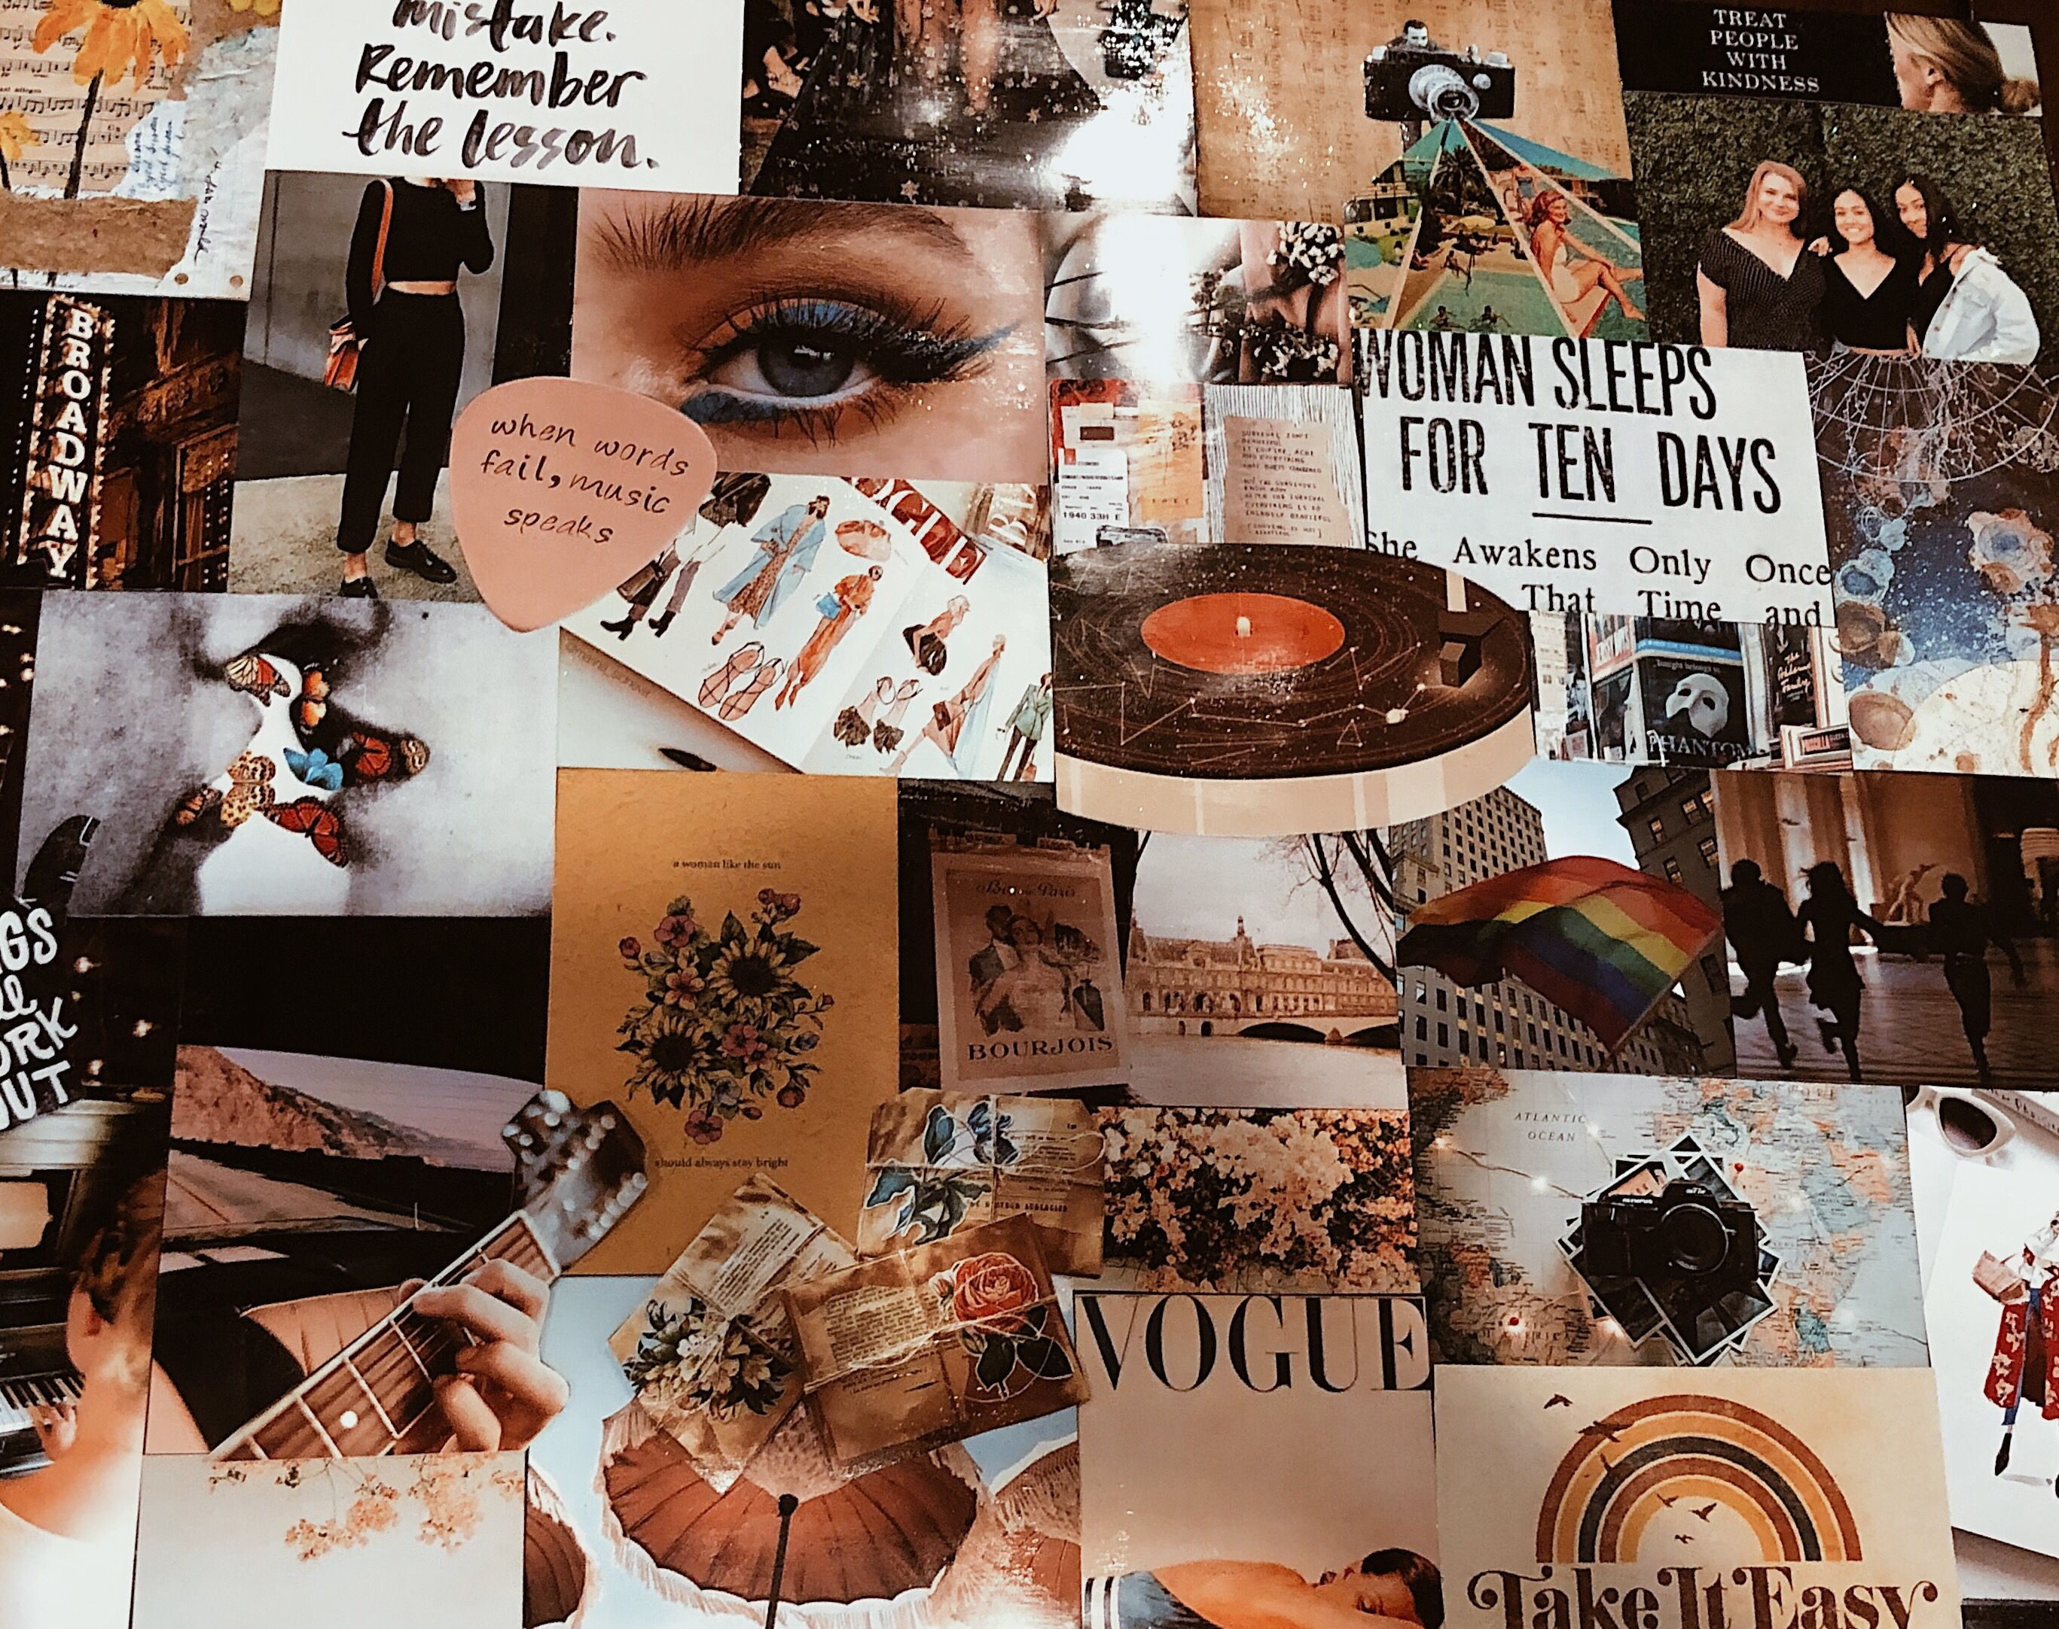
Task
- Create a board called ‘My Media’. Add pins for all of your favourite media content.
- Create a board called ‘About Me’. Add pins about your interests outside of media, your family, your hometown, your hobbies. Whatever you want really!

Shot Types and Storyboard
(2 hours+)
As part of the course an aspect will be animation, this is where you will create your own animation based upon a brief. For this task you will need to create a storyboard, online or on paper, clearly illustrating a storyline for your new animation.

Task: Finish the storyboard below. Try to bring the story to an end within 20 panels.

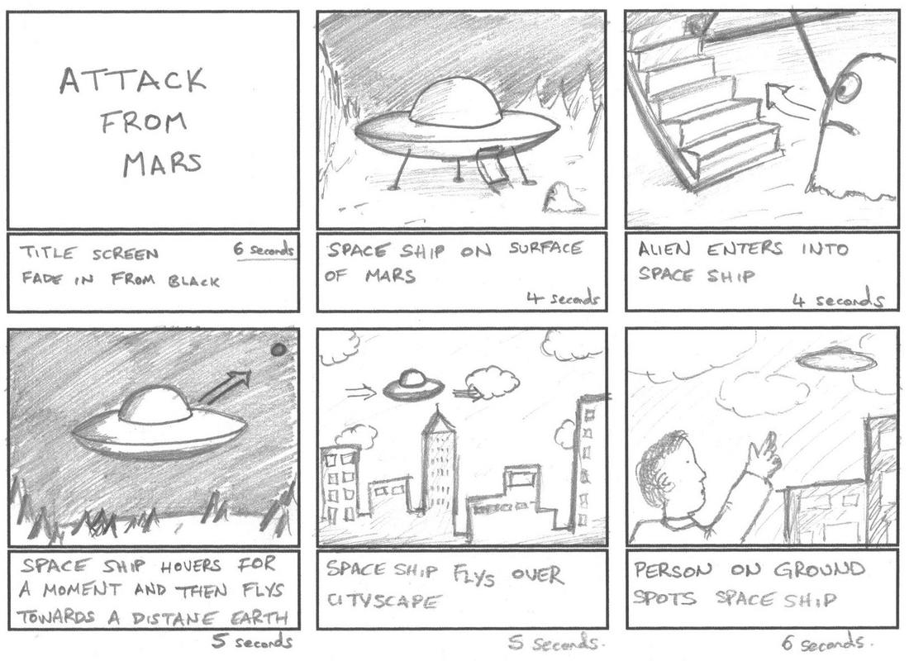
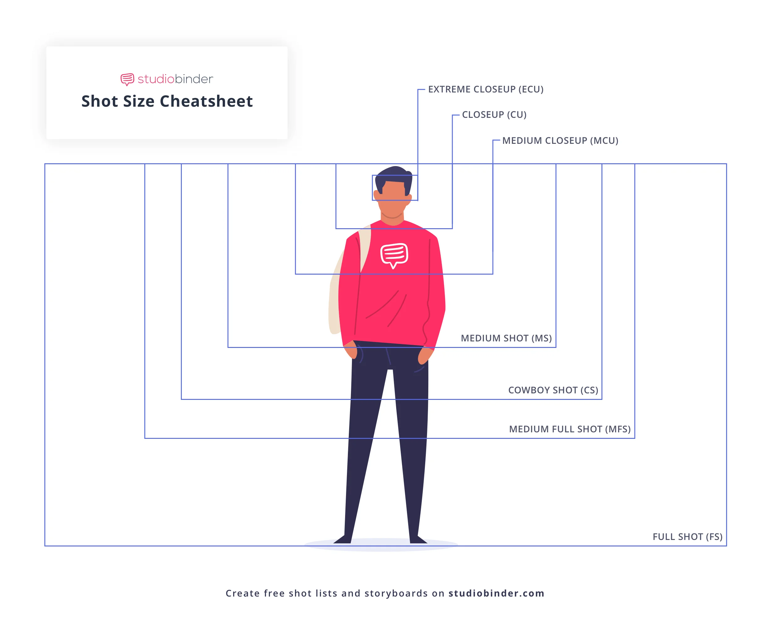
If you need help with your storyboards, research into SHOT TYPES and how they convey meaning:
Here’s a really good introduction to shot types: Types of shot - Camera - GCSE Moving Image Arts (CCEA) Revision - BBC Bitesize

Here’s a comprehensive guide to shot types, including really useful videos: Cinematography Techniques Guide: 50 Types of Camera Shots and Angles in Film (studiobinder.com)

Read the following to help you with the storyboard task:
How to Storyboard for Animation | Storyboarding Tips | Adobe

Storyboard template examples: FREE Storyboard Templates (PDF, PSD, PPT, DOCX) & Story board Creator (studiobinder.com)

Music poster/ Album cover
(1 hour+)
Here you will need to create a fresh album cover or poster for your favourite song or album. This can be created online (for example using the free version of Canva Canva: Visual Suite for Everyone) or on paper.

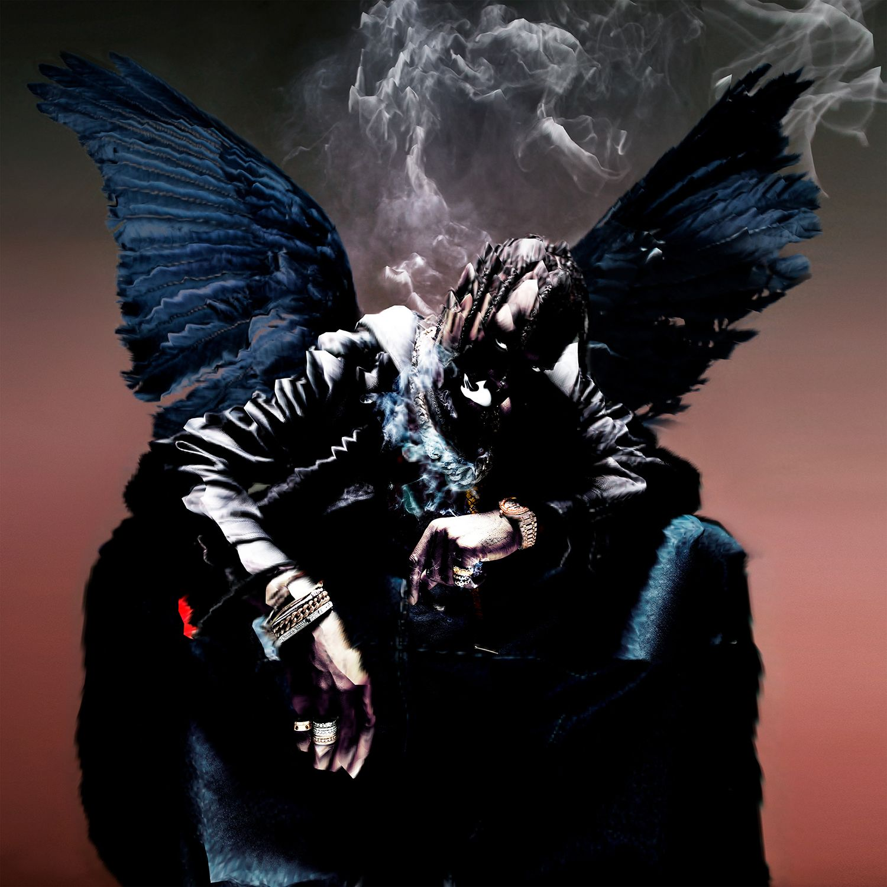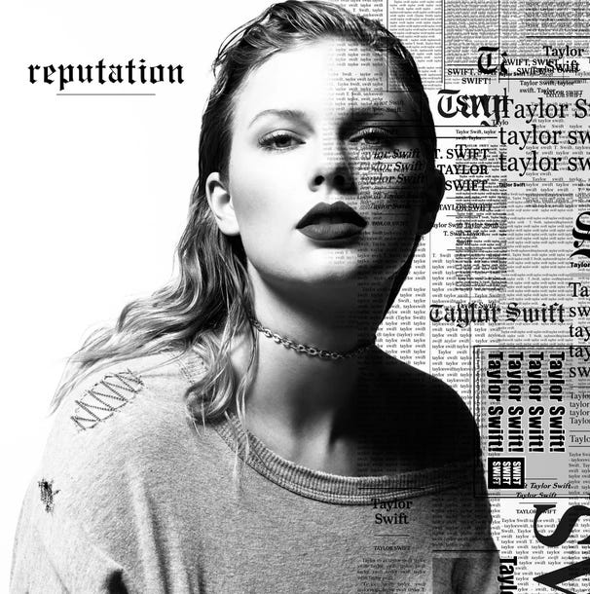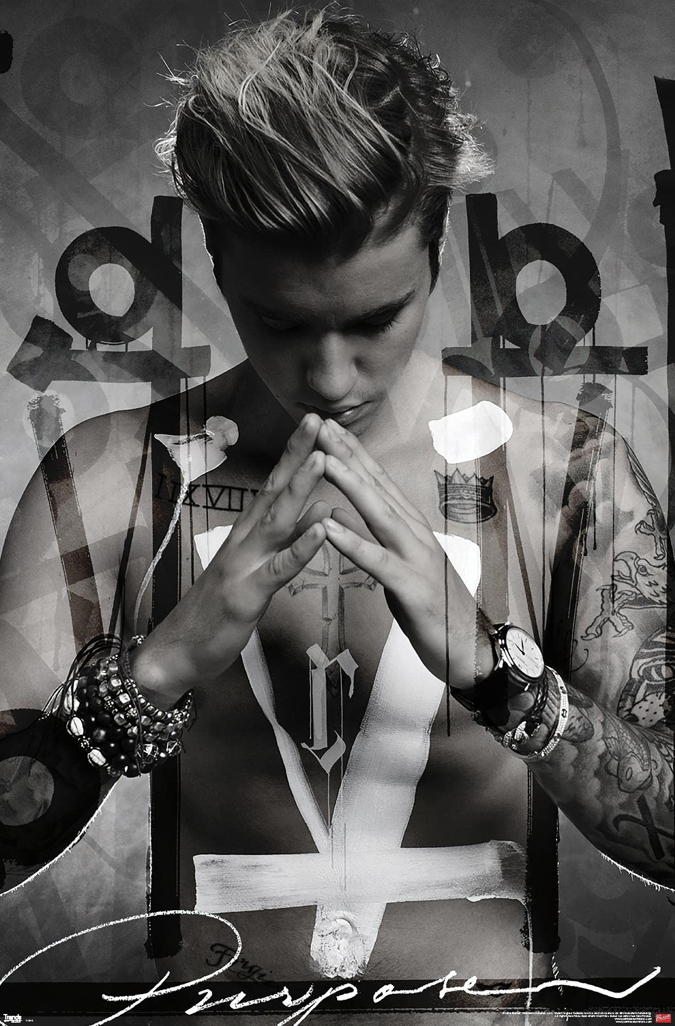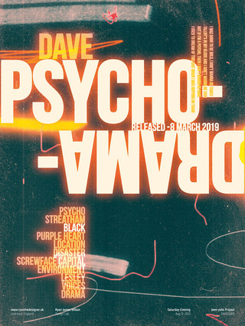
Create a Letterboxd account (30mins)
Create your own letterboxd account and create a list of your top 10 favourite films!

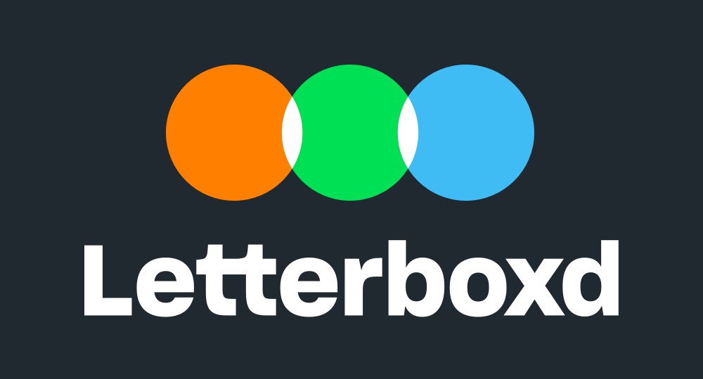

Film Review Task
(1 hour+)
Once you’ve decided what your favourite film is, write a 500-word review of the film – be specific as to why it’s so appealing to you. Think about the following:

- Shot types.
- Music
- Sound effects.
- Acting style
- Plot
- Locations
- Meaning – what is it about the film that resonates with you personally?
Here’s some extra guidance on how to write a film review: How to Write a Movie Review: 5 Tips for Writing Movie Reviews - 2024 - MasterClass

