

Music Production and Popular Music

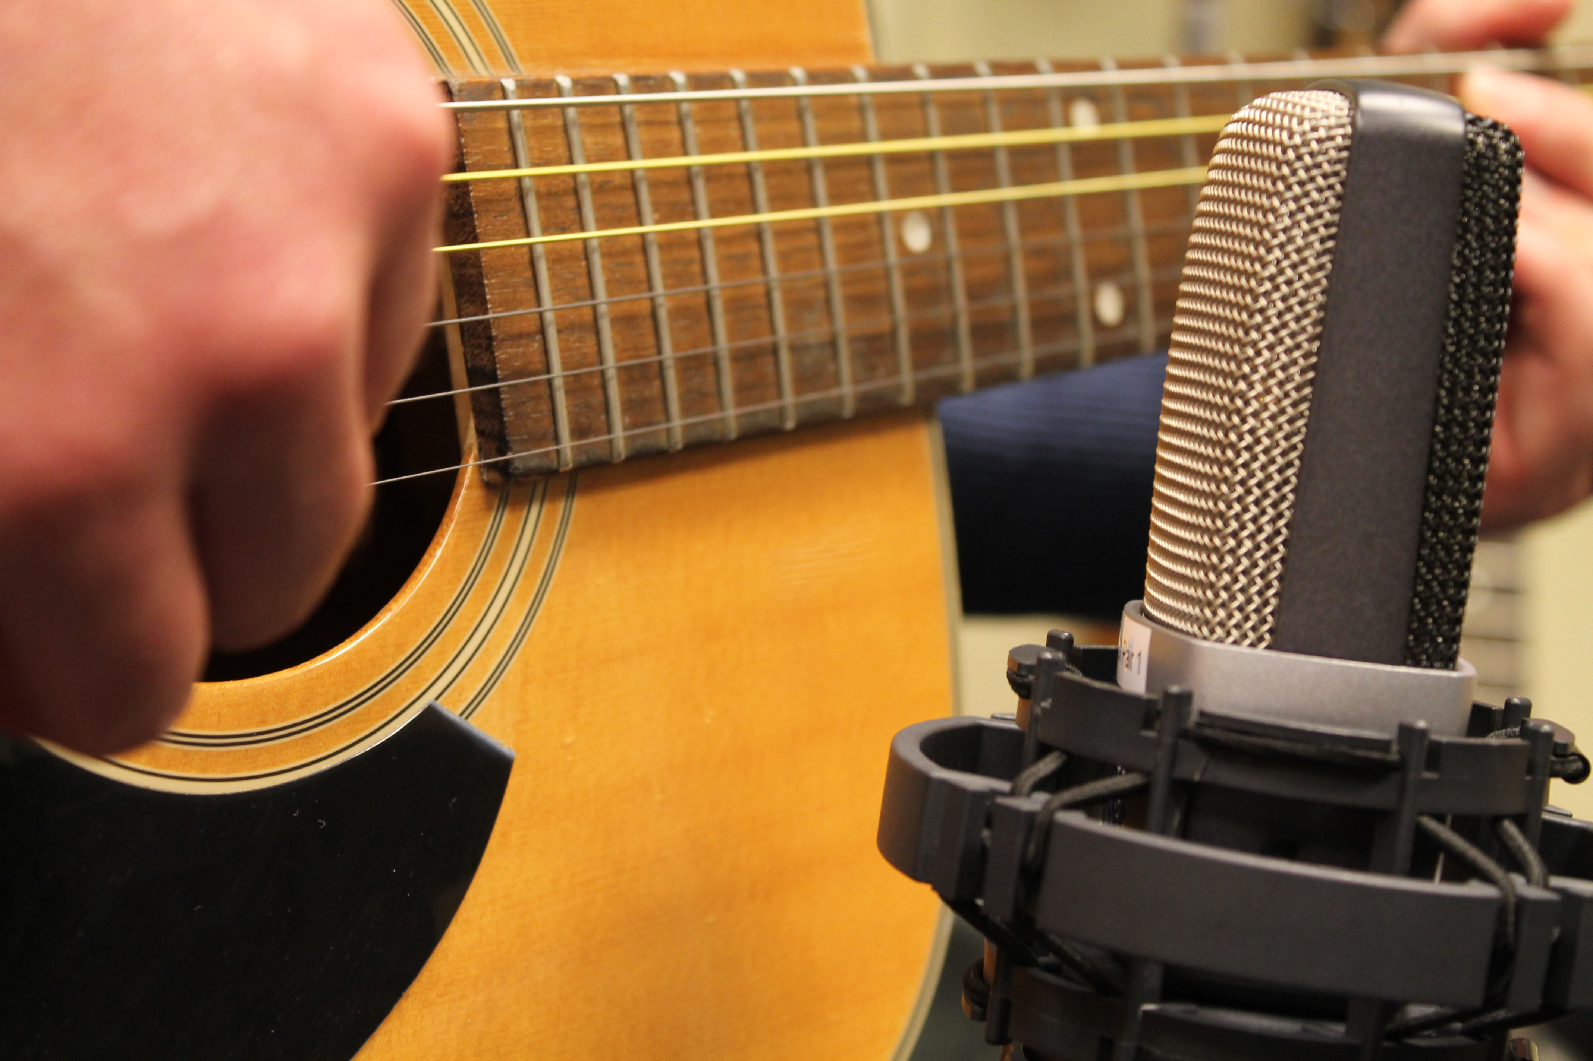

Contents

Welcome | Page 3
The Music Department | Page 4
Tasks for Pop and Production Students | Page 5
Tasks for Pop Music Students | Page 6
Tasks for Music Production Students | Page 7

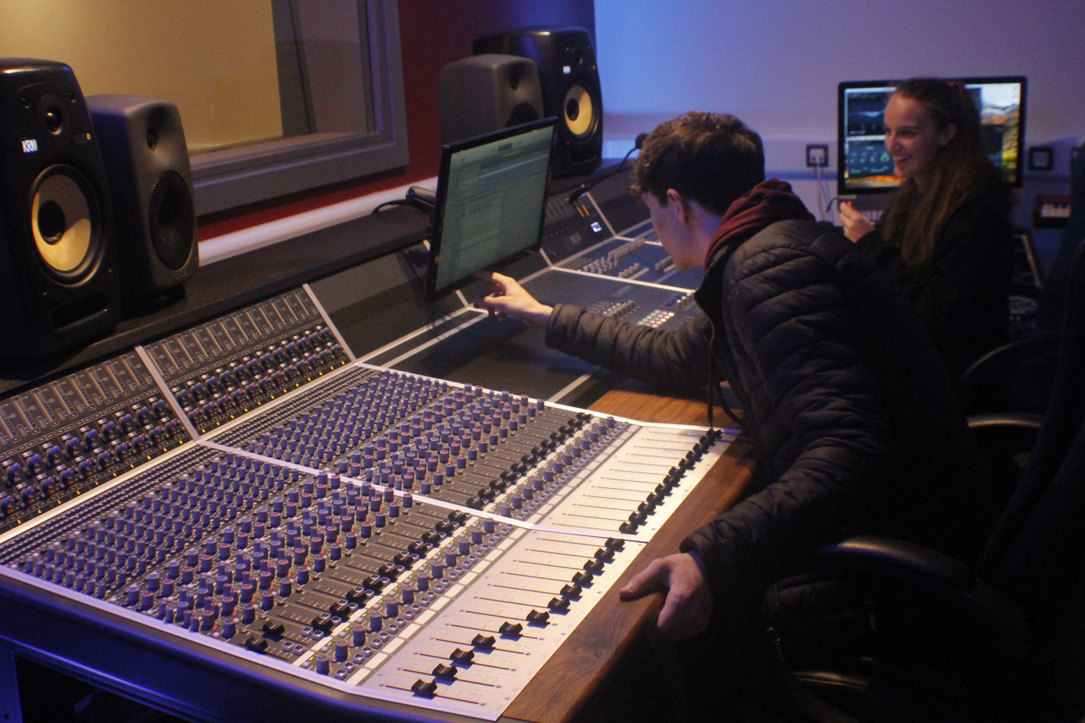
Pop Music and Music Production Summer Work

Welcome to Vocational Music. We are really looking forward to you coming to join us in creating, performing and recording music in September, but in the meantime, we have put together a few tasks and projects for you to get you ready for September.

If you are going to be studying on the Extended Diploma course, please have a look at all of the projects, otherwise just look at either the Pop or the Production ones (although if you are interested by the other projects, please have a go and then talk to us about studying these things further!).

Hopefully you have already been using this time to practise your instrument, or if you have the equipment, creating music on your DAW. It would be great if you could record some of what you have done so we can have a listen when you start with us (or send it through to me at the email below!).

If you have any questions about any of these tasks, please don’t hesitate to email me; Andyw@richuish.ac.uk

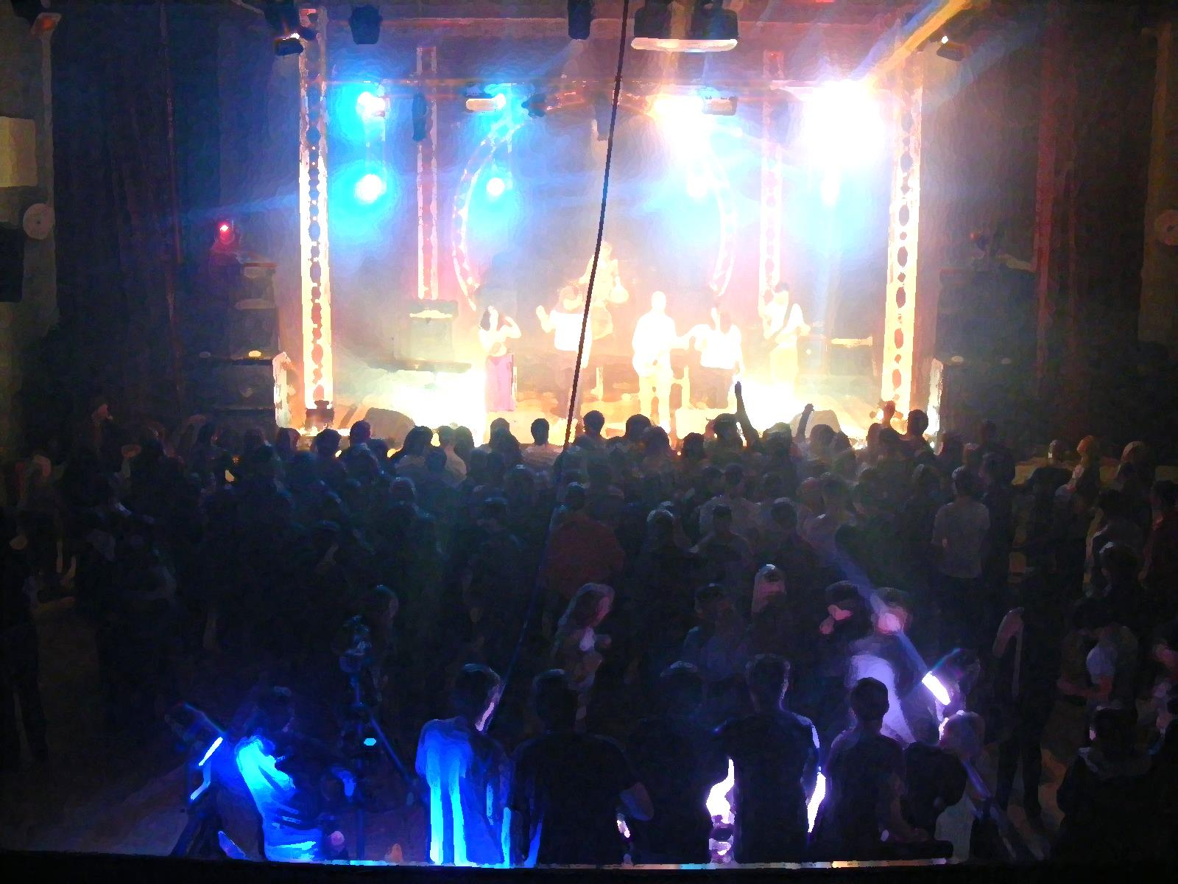
See you soon!

The Music Department

Aspen Recording Studios

Studio 1
Audient ASP8024HE Analog Desk
RedNet Technology
Genelec & KRK Monitors
ART & DBX Compressors
Lexicon FX
Nord Electric Piano
Logic X

Studio 2
Allen and Heath ZEDR16 Desk
RedNet Technology
KRK Monitors
DBX Compressors
Logix X

Aspen Rehearsal Rooms

Three dedicated music rooms
Acoustic Piano

One Band Rehearsal Space
Electric Drum Kit
Acoustic and Electric Piano
Bass Amplifier
Guitar Amplifiers
Vocal PA

Aspen Edit & Mac Suite

Edit Suite
Acoustic Piano
Allen and Heath QU-24 Digital Desk
KRK Speakers
Logic X
Ableton Lite
Mac Suite
Logic X
Sibelius
Audient iD4 Audio Interfaces
Selection of MIDI Controller Keyboards
ARP Odyssey Analog Synthesizer
Korg Minilogue Synthesizer
Arturia MiniBrute Synthesizer

Willow Rehearsal Rooms

Three dedicated music rooms
Acoustic or Electric Drum Kit
Acoustic Piano
Bass amplifiers
Guitar amplifiers
Vocal PA
Fully equipped with Logix X for recording

Equipment Available to Loan

Dynamic and Condenser Microphones
Electric and Acoustic Guitars
Bass Guitars
PA Systems
Audio Interfaces
Portable Recording Equipment
Loop Pedals
Cables / Stands etc

Aspen Classrooms

Two dedicated classroom spaces with grand pianos and access to laptops

Pop Music and Music Production Students

If you are doing either the single Pop Music course, or Production course, you should spend a total of 4 – 5 hours on the tasks. If you are doing the Extended Diploma full time course, you should spend 12 – 15 hours on the tasks.

Task One – Getting to know us

Watch the videos about the music department here
Pop Music and Music Production - YouTube

Task Two – Introduction to Music Theory

http://www.drawmusic.com/music-theory/intro
Read the introduction and click on the lessons on the top left – especially the Written Notes section (lessons 35-41).

Complete the tasks within each lesson, and try and put some of the theory into practice on your instrument or using your voice.
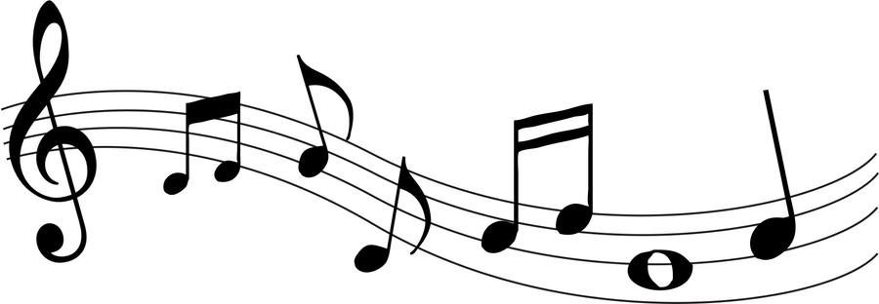

Lesson 1: Introduction - Pop Music Theory
Lesson 1: Introduction Pop Music Theory is a free, online, music theory and songwriting course. Pop Music Theory starts at the beginning (no prior music knowledge required). Our goal is for you to learn to analyze how real songs are composed, and apply the ideas you learn to creating your own music.
www.drawmusic.com

Task Three – Social Media

Like and subscribe to @Huishmusic on Instagram and Huish Music on YouTube.

Pop Music Students

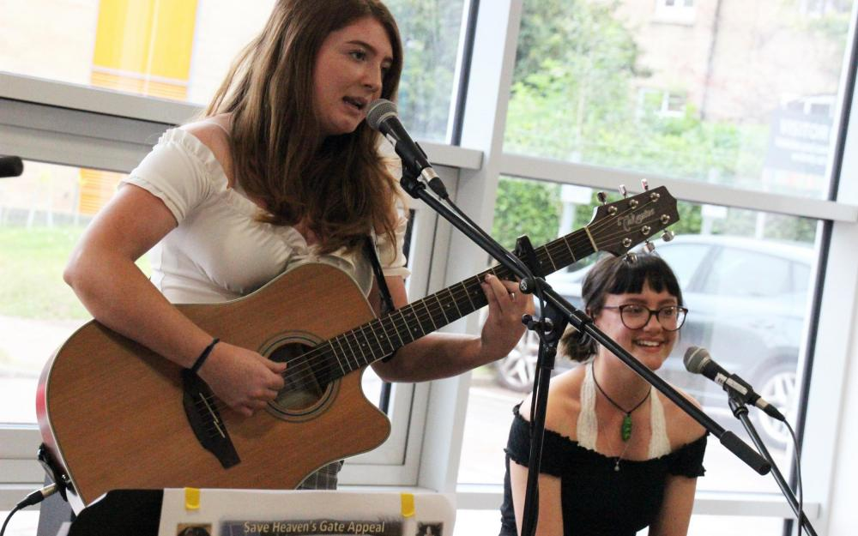

Task One – Songwriting

Complete the free online Song writing course
https://www.futurelearn.com/courses/songwriting

Create 1-3 minutes of original material for induction. (this can be recorded on your phone or any other medium you have access to)

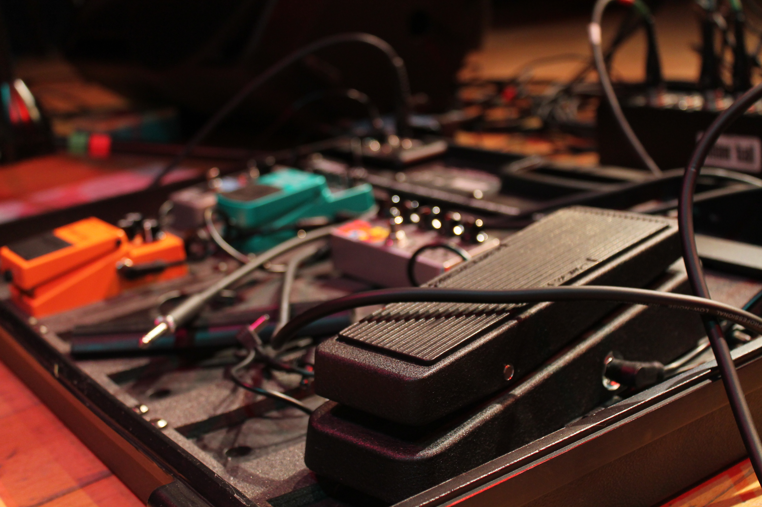
Task Two
Write one A4 page about the musical elements of your favourite song or genre
OR
Write about the social impact of your favourite band/artist.

Music Production Students

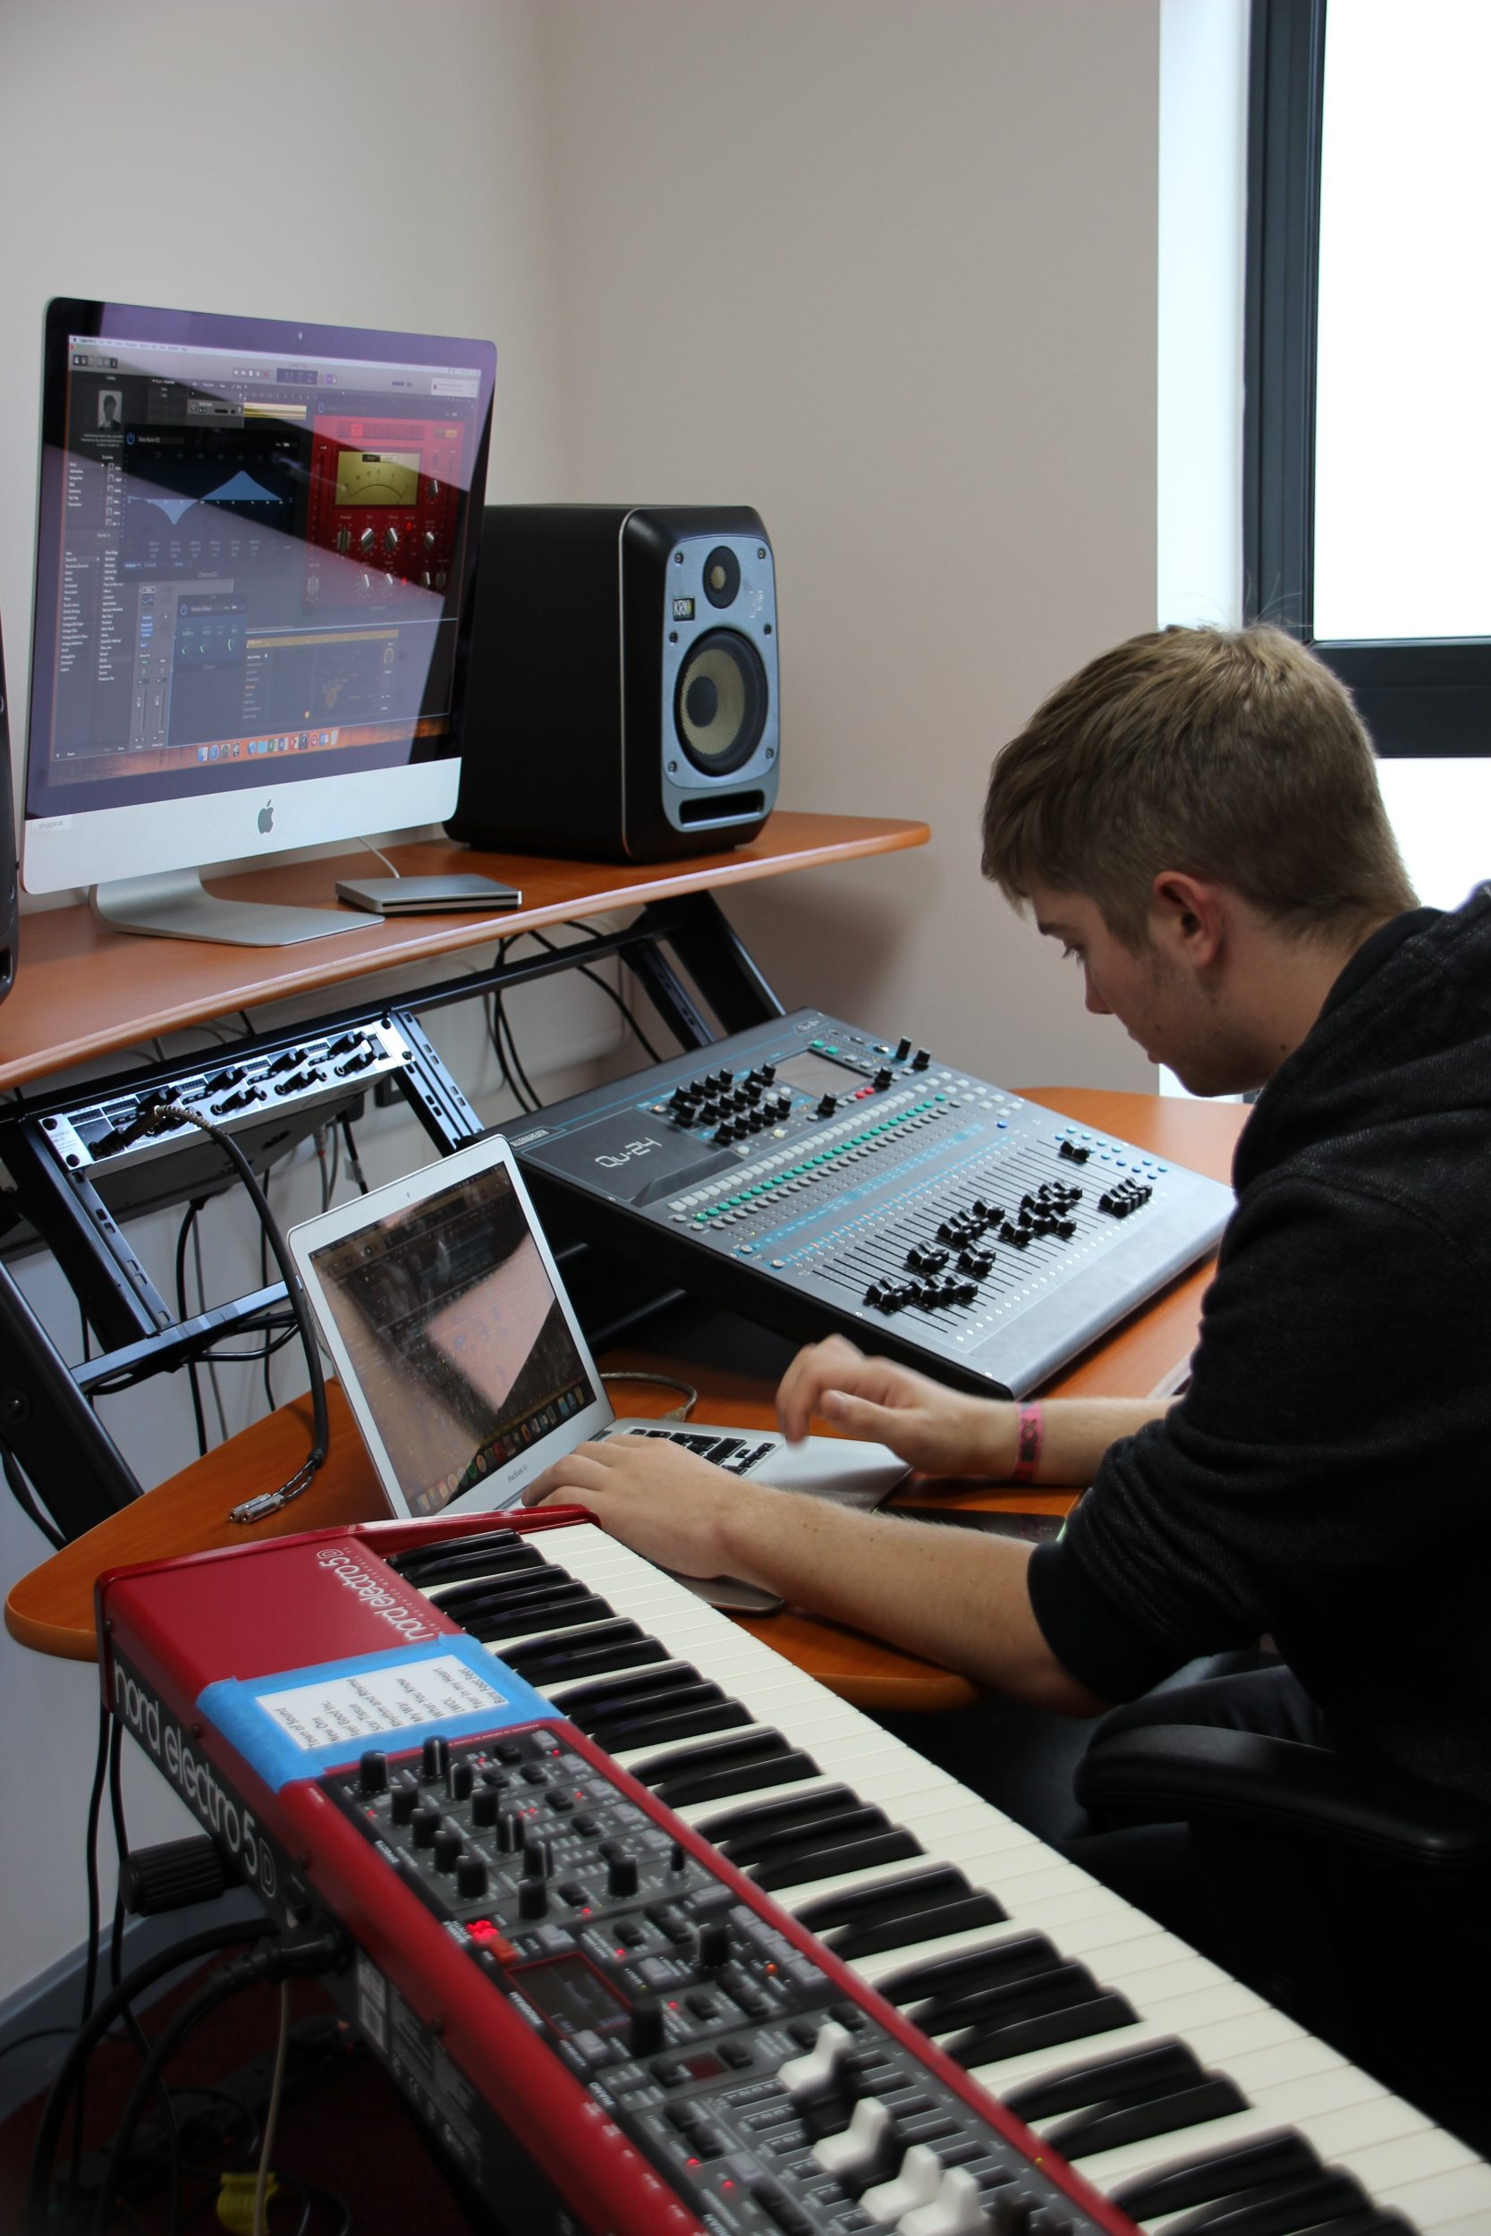
Task One – Music Apps

Lots of companies have released some free music apps. Moog, Korg and loads of others have released synth apps and music software so you can create your own sounds and make music. Find a couple of these that will either work on your phone (some are android or iPhone specific) or your computer and create some music and record it in any way you can.

Task Two – Analysis of production elements of a song

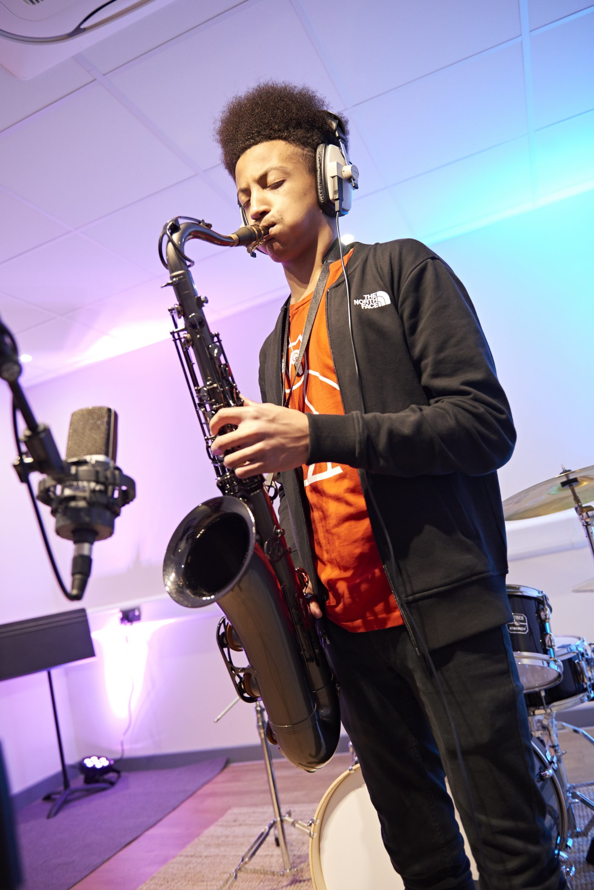
Take 2 songs you enjoy listening to and analyze what you are hearing. This could be: Instrumentation, use of effects, structure, panning etc. Write down your findings on one side of A4.

Things you will need in September:

Music Production students will need to get some headphones (if you are on a bursary, we can help with this!). Here are some examples of the kind of headphones that would be suitable at different price ranges:

AKG K52 Closed-Back Headphones- £32.30
https://www.gear4music.com/PA-DJ-and-Lighting/AKG-K52-Closed-Back-Headphones/1GVA?origin=product-ads&gad_source=1&gclid=CjwKCAjwg8qzBhAoEiwAWagLrBH6D1nWT-ruR3w_uZHjIZYyiHMAXma4Uh3fYwWuehT1fFWdO4-2QBoC_IcQAvD_BwE

AKG K92 Closed Back Headphones, Black/Gold- £35.00
https://www.gear4music.com/PA-DJ-and-Lighting/AKG-K92-Closed-Back-Headphones-Black-Gold/1GVE?_gl=1*1yh6wcf*_up*MQ..*_ga*NTcxODQ0MjI3LjE3MTg4MDg5NDA.*_ga_0WF1R5QW3K*MTcxODgwODk0MC4xLjEuMTcxODgwOTE0NC4wLjAuMTY5NjM2OTcwMw..&gclid=CjwKCAjwg8qzBhAoEiwAWagLrDNtTSwr-r9hygWDQsu7zGLPg9exJHgxIZlTj-ev7tgDO2fiSb_9DxoCbeIQAvD_BwE
Audio Technica ATH-M20x Monitor Headphones- £50.00
https://www.gear4music.com/Recording-and-Computers/Audio-Technica-ATH-M20x-Professional-Monitor-Headphones/X9B?origin=product-ads&gad_source=1&gclid=CjwKCAjwg8qzBhAoEiwAWagLrDNtTSwr-r9hygWDQsu7zGLPg9exJHgxIZlTj-ev7tgDO2fiSb_9DxoCbeIQAvD_BwE
These are one of the most common headphones used in bulk in the studio and sound great for the price. The Bigger brother ATH-M750x has become the industry standard but are about £130 now
Pop Music Students will need:

Guitarists and Bass players will need their own jack leads (2 please so you have a spare)

Drummers will need your own sticks

Singers, it would be good (and more hygienic) to have your own microphone the Shure SM58 is the industry standard if you can afford it (around £90) but there are cheaper alternatives.

If you are struggling to find these, or have financial restraints, we can look at it when you start after the summer!

