



MUSIC A LEVEL

# What will I study in AS/A level Music?

Both courses consist of 3 units, examined after 1 year for AS or after 2 years for A level;

1. Performing – solo performance​ to a visiting examiner
2. Composing – a portfolio of creative pieces ​(1 to fit a Classical brief)​
3. Appraising – a written exam with listening and essay questions on set works & Areas of Study.​

The course covers a mixture of styles, using a variety of ​learning approaches. We follow the Eduqas board and more information can be found here [AS and A Level Music | Eduqas](https://www.eduqas.co.uk/qualifications/music-as-a-level/#tab_keydocuments)  
If you have any questions, contact [kathrynf@richuish.ac.uk](mailto:kathrynf@richuish.ac.uk)

|  |  |  |  |
| --- | --- | --- | --- |
| **YEAR ONE (AS & A LEVEL)** | **Knowledge** | **Skills** | **Assessment** |
| **Term One** | Terminology – basic elements & theory  Western Classical Tradition  Development of the Symphony & Haydn | Solo performing Composition Orchestration  Sibelius basics Listening Analysis  Melodic dictation  Essay writing | Short mock paper Composing project - WCT  Solo performance in Dec |
| **Term Two** | Rock and Pop (AoS B)  Extended theory | Solo Performing Composing for voices /orchestra Essay writing Exam timing  Listening | Longer mock exam Composing project –song/orchestral  Solo performance in March |
| **Term Three** | Romantic Symphony and Mendelssohn  Exam criteria for  performances, composition and essays | Wider Listening  Synoptic essay writing | **AS level recital, composition deadline & exam** End of year Mock  Final solo recital |

|  |  |  |  |
| --- | --- | --- | --- |
| **YEAR TWO**  **(A LEVEL ONLY)** | **Knowledge** | **Skills** | **Assessment** |
| **Term One** | 20th century music  Poulenc & Debussy | Wider listening  Public performance and recital programming  Reviewing progress Independent study | Draft composition 1 completed  Mock recital November |
| **Term Two** | Recap Classical & Romantic music  Practice questions | Actual recitals  Honing actual composition Exam timing and technique | Draft composition 2 completed  Full 2-hour mock in Feb **RECITALS in March/April** |
| **Term Three** | Revision of all Yr 1 and 2 set works | Revision Wider listening  Exam technique Melodic dictation | **COMPOSITIONS SUBMITTED May**  **FINAL EXAM in June** |

Summer Homework

1. **Individual Instrument/Vocal practice** (2-100 hours)

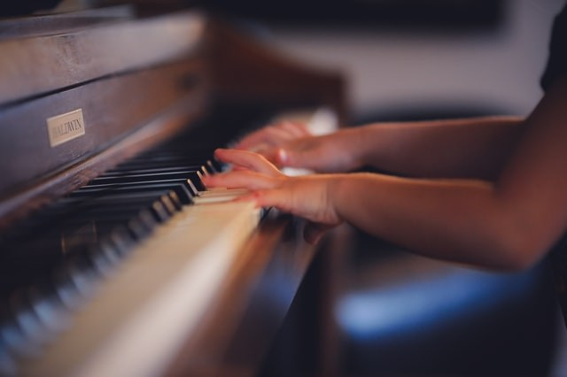

Performing is a large part of A-Level music, so your first task is to practise your instrument/voice as much as possible towards a short performance at the start of the year. You will need to be working on at least Grade 5 level pieces in Year 1 (and Grade 6-7 level in Year 2); this might be the perfect goal for you to aim for over the summer. You don’t have to have taken grade exams, just learn pieces around that level (and if you’re not sure of the level, try and find out by searching for piece titles online). Exam boards offer online or in-person grade exams (ABRSM, Trinity, MTB and others), and Huish has a team of excellent instrumental and vocal teachers who offer 1-1 lessons in your free periods. Details will be provided when you start college in September.   
Use at least 2 hours to practice and make progress on your instrument/voice as a soloist.

1. **Theory** (1 hour)

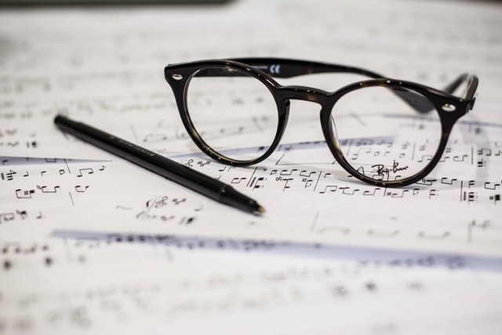

Music theory is sometimes people’s least favourite part of the subject for students, but it is crucial part that helps your understanding (and achievement) in all other parts, like performing and composing.

Ideally you will be able to read notation and recognise symbols and words at about Grade 5 standard, so go to the website <https://musictheory.pugetsound.edu/mt21c/MusicTheory.html>

From the drop-down list, read and check your knowledge on the topics in the **first five chapters** (Basic Concepts, Majors, Minors, Rhythm and Intervals). **Complete the practice exercises** at the end of each chapter, writing your answers on lined/manuscript paper, or alternatively print and complete the first 6 pages of this pdf <https://musictheory.pugetsound.edu/hw/MT21C-PRACTICE-EXERCISES.pdf>

This will help you to prepare for a **theory quiz in week one** of the course. Use manuscript paper (if you haven’t got any at home, you can print it from online, write digitally on a pdf or tablet screen, or use a free notation system like Noteflight).

1. **Research & Writing** (1 hour)

A level music involves the study of set works, which you can listen to in playlists for [Western Classical](https://youtube.com/playlist?list=PLp9mx_HwYyoujd1tuDwejDSj4VwN-GQX2&si=IW1JrQdlcylmL2fj), [Rock & Pop](https://youtube.com/playlist?list=PLp9mx_HwYyovuZ6Dj5zAV6bpmHZsgEBe7&si=YXrav0imgLpuOcPa) and [20th century music](https://youtube.com/playlist?list=PLp9mx_HwYyoubOrUK-Qi5RcstSR5v_50C&si=lGbi4RZqownZf7Ob). Our first set work is Symphony No 104 by Haydn, so to prepare, use research skills to complete the tasks below (print or write digitally)

**Haydn Symphony No 104 – Background Information**

|  |
| --- |
| This symphony is the twelfth and last of the symphonies specifically composed for a series of concerts in London. It was written in 1795 and first performed in the same year at the King’s Theatre, Haymarket. |

Task 1  
 Complete the following gap-fill by inserting the correct information from the given list (into the gaps)

|  |
| --- |
| ***Answers*** |
| strings |
| Esterhàzy |
| adventurous |
| drums |
| orchestration |
| score |
| bassoons |
| D |
| Classical |
| Salomon |
| keyboard |
| Folksong melodies |
| trumpets |
| 104 |
| clarinets |
| rhythmic |
| London symphonies |
| timpani |

|  |
| --- |
| Haydn (1732-1809) was one of the most important composers of the era in music, having written at least symphonies illustrating the development of this genre. After many years in the employment of the family, an invitation came in 1790 to compose twelve symphonies for London, for the British audiences that hailed him as the “greatest composer in the world”. He had been contacted by the German-born violinist Johann Peter who was working as a concert manager in London at that time. Haydn was to be impressed by the rich musical life, the cosmopolitan atmosphere and the very fine, large orchestras there.  As such, he was determined to live up to expectations, and the resulting are appreciated as the crowning glory of his prolific work as a symphonic composer. While they show no radical departure from his previous works, there were a number of outstanding features that contribute to their special character. They are works on a  ‘grand’ scale, giving a broader presentation of musical ideas, more brilliant , utilising often simplistic but effectively appealing thematic material with the occasional use of , more use of harmony and more purposeful  content.  In terms of the scoring, Haydn’s earliest symphonies were usually written for two oboes, two horns and , though there were exceptions to the rule with occasional use of a flute, and an additional horn.  http://www.theportobelloorchestra.co.uk/ProgrammeNotes/Haydn03.jpg  It was only in these last twelve symphonies that and  were used regularly, with making an appearance in five of the last set of six symphonies.  Symphony No 104 is scored for: 2 flutes, 2 oboes, 2 clarinets in A, 2 bassoons, 2 horns in , two trumpets in D, and strings. The première was extremely successful; and as was usual at the time, Haydn directed the performance himself from a instrument, though his part was not written down in the  . |

Task 2

♫ Find out why the following symphonies were given their well-known titles: the *Surprise* Symphony, the *Clock* Symphony, the *Drum Roll* Symphony. Write a short paragraph on each, whilst listening to the works, following the scores if possible. (Scores are available on [IMSLP: Free Sheet Music PDF Download](https://imslp.org/)).

♫ Haydn once said of his time at Esterhàzy Palace, “I was cut off from the world… I could make experiments… try new things… so I was forced to become original”. Write a paragraph on what you think he meant by this.

**Checklist**

## Individual practice

1. **Theory (5 chapters from website)**
2. **Symphony No 104 tasks**

**Optional extra work**

**

Here are some suggestions and links to documentaries to watch:

***[BBC documentaries on the History of Music](https://www.youtube.com/results?sp=mAEB&search_query=Howard+Goodall%27s+Story+of+Music)***    
[Stewart Copeland’s Adventures in Music](https://www.bbc.co.uk/iplayer/episode/m000db8k/stewart-copelands-adventures-in-music)    
Fab composer [Leonard Bernstein did a series of cool lectures](http://www.openculture.com/2012/03/leonard_bernsteins_masterful_lectures_on_music.html) about music and philosophy    
Heaps of [documentaries on music](https://www.youtube.com/playlist?list=PLKMaTwEXLotUkRVNjwhNPgZU8c7baQ435) in a YouTube playlist

If you enjoy reading, here are a few links to books that I recommend:

* [The Story of Music by Howard Goodall](https://www.amazon.co.uk/Story-Music-Howard-Goodall/dp/0099587173/ref=tmm_pap_swatch_0?_encoding=UTF8&qid=1587981499&sr=8-1) (goes alongside the BBC documentaries above)
* [How Music Works by John Powell](https://www.amazon.co.uk/How-Music-Works-listeners-classics/dp/1846143152/ref=pd_bxgy_img_2/260-8043017-0157846?_encoding=UTF8&pd_rd_i=1846143152&pd_rd_r=6c92b15c-01ef-4cb8-a502-c4f163bc3355&pd_rd_w=FrAW0&pd_rd_wg=u4L9y&pf_rd_p=c6e663a4-ad5a-49d5-9f57-e5f0aa7bd5f7&pf_rd_r=T882NNW3CFSCJKHRXNCW&psc=1&refRID=T882NNW3CFSCJKHRXNCW) the film composer (for Shrek and How to Train your Dragon)
* [Music: A Very Short Introduction by Nicholas Cook](https://www.amazon.co.uk/Music-Very-Short-Introduction-Introductions-ebook/dp/B005OQGC8E/ref=reads_cwrtbar_17?_encoding=UTF8&pd_rd_i=B005OQGC8E&pd_rd_r=9126f253-a41c-4383-9d22-2b8d5d4bb2e0&pd_rd_w=n6AuP&pd_rd_wg=tVKtY&pf_rd_p=1157b281-769f-489c-aa16-4dd23f165f5a&pf_rd_r=P5E66QFTY4VWNPCPDPF1&psc=1&refRID=P5E66QFTY4VWNPCPDPF1)
* [Listen to This by Alex Ross](https://www.amazon.co.uk/Listen-This-Alex-Ross/dp/0007319061/ref=tmm_hrd_swatch_0?_encoding=UTF8&qid=&sr=)

There are also heaps of podcasts out there;  
[The Listening Service BBC Radio 3](https://www.bbc.co.uk/programmes/b078n25h)   
[San Francisco Symphony: Programme Notes](https://www.sfsymphony.org/Discover-the-Music/Listen-to-Podcasts/Program-Notes-Series)   
[Composer of the Week](https://www.bbc.co.uk/programmes/p02nrvd3/episodes/downloads)

**Finally**

You might have taken GCSE Music or instrument/theory grades but don’t worry if you haven’t done this – everyone will be at different stages in their musical learning and the course can be adapted to suit you.

Music is an academic and creative subject that can transport you to a different place, change your mood and bring joy to others.

Keep listening and composing, expanding your experience and horizons in music, to give you the best tools for starting the AS/A Level Music course at Richard Huish College.

Looking forward to meeting you in September!

Kathryn Foyle