

A LEVEL POLITICS



In a world of increasing uncertainty, A Level Politics will allow you to better understand how and why things happen the way they do…

*Welcome to Huish! This pack is designed to give you a flavour of what A level Politics is all about. It will introduce you to some core political concepts and events, aid your understanding of politics and develop your skills ready for sixth form. Some of the tasks are compulsory, others are optional. The work is designed to take you approximately four hours, so you can break it up. Don’t feel you need to complete it all in one go…*

*Ceri Knott*

*Course Manger - Politics*

**What will I study?**

|  |  |
| --- | --- |
| **Year One** | **Year Two** |
| Politics of the UK   * Democracy and Participation * Elections and Referendums * Political Parties * Pressure Groups * Impact of the European Union on UK politics   Government of the UK   * Nature and Sources of the British Constitution * Devolution * Structure and role of Parliament * The Prime Minister and Cabinet * The Judiciary   Government of the USA (Part One)   * Constitutional Framework * Supreme Court   Comparative Politics ‘Pit stop’ | Government of the USA (Part Two)   * President * Congress   Politics of the USA   * Electoral Process and Direct Democracy * Political Parties * Pressure Groups * Civil Rights   Comparative Politics ‘Pit stop’  Political Ideas   * Liberalism * Conservativism * Socialism * Optional Ideology. |

Task One: UNDERSTAND - What is Politics? (Approx 1 hr)

*“Politics is the study of how a people, a nation or a state is governed.”*

Politics is about power, about people, equality, conflict and cooperation, freedom and finance. – it’s about the relationship between the state (the government) and its citizens, and the state and other states. It governs everything we can and will do…

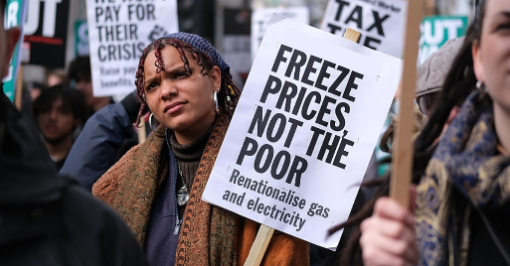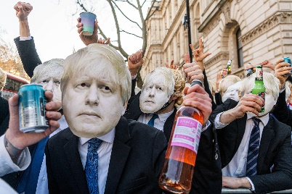 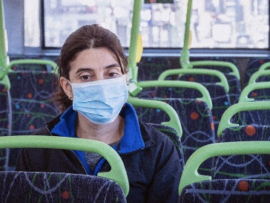



[This Photo](https://www.ip-watch.org/2016/06/24/uk-brexit-leaves-ip-community-with-many-unanswered-questions/) by Unknown Author is licensed under [CC BY-SA-NC](https://creativecommons.org/licenses/by-nc-sa/3.0/)

Brexit, Covid -19. Partygate and the cost of living crisis not to mention wars in Ukraine and Gaza…. We are living through unprecedented times. We are reliant on our politicians to tell us what we should and should not be doing, decisions made by them have had a massive impact on your lives in recent years and yet it seems that sometimes they do not follow their own rules. However, ordinary people can have a huge influence on politics. Take Brexit for example, if just one out of every 50 people who voted to leave the EU had voted differently, we wouldn’t have left. Each individual vote is vital, and yet in the 2024 general election over 40% of those eligible to vote did not bother to do so. In local council elections, that percentage is even higher and yet politics at a local level has more impact on our everyday lives than the politics we see happening in Westminster. That is why Politics matters, and why you should study it for A level!

Your first task is to help you develop a better understanding of what Politics is really all about. Use the internet (e.g. Wikipedia, YouTube and other sources) to research and understand what the following key terms mean and create a short definition for each *in your own words*.

You are welcome to try to get your families involved in this – they may have some understanding of these concepts already! The most important thing in an A level is *your understanding* – so it’s not about having the “right” or “word-perfect” definition, it’s about you being able to *understand* what a concept means ☺

|  |  |
| --- | --- |
| **Term** | **Explanation** |
| Power |  |
| Authority |  |
| Legitimacy |  |
| Government |  |
| Constitution |  |
| Prime minister |  |
| Cabinet |  |
| Parliament |  |
| Participation |  |
| Manifesto |  |
| Mandate |  |
| Supreme Court (UK – not US!) |  |
| Rule of Law |  |
| Direct democracy |  |
| Representative democracy |  |
| Parliamentary sovereignty |  |
| Constitutional monarchy |  |
| Fusion of powers |  |
| Separation of powers |  |
| Devolution |  |
| Presidency (USA) |  |
| Congress (USA) |  |
| Constitution (USA) |  |
| Checks & Balances (USA) |  |
| Supreme Court (USA) |  |
| Republican Party (USA) |  |
| Democratic Party (USA) |  |
| Liberalism (Ideology) |  |
| Conservatism (Ideology) |  |
| Socialism (Ideology) |  |

Task Two: KNOWLEDGE - British Politics

Who represents you? (Approx 15 mins)

Conduct some research into the role of your local MP. They may be new to the job or been doing it for many years. Find out who your local MP is and the following details about them:

MP’s name:

Political party:

Constituency (the area they represent):

Areas they have a particular interest in:

What do political parties stand for? (Approx 1 hour)

You do not need to have any prior knowledge of Politics before you start the course, however it would be useful to find out a little bit about what the main parties are all about. Use the links below to help you complete the next page:

[Conservatives | Help us renew](https://www.conservatives.com/)

[The Labour Party](https://labour.org.uk/)

[Liberal Democrats](https://www.libdems.org.uk/)

Choose one policy from each party and explain why you support OR do not support that policy. You could also research the policies of another minor party if you prefer.

Party: __________________________

Manifesto policy: ______________________________________________________________________________________________________________________________________________________________________________

_______________________________________________________________________________________

Agree/disagree & why:

______________________________________________________________________________________________________________________________________________________________________________

Party: __________________________

Manifesto policy: ______________________________________________________________________________________________________________________________________________________________________________

_______________________________________________________________________________________

Agree/disagree & why:

______________________________________________________________________________________________________________________________________________________________________________

Party: __________________________

Manifesto policy: ______________________________________________________________________________________________________________________________________________________________________________

_______________________________________________________________________________________

Agree/disagree & why:

______________________________________________________________________________________________________________________________________________________________________________

Task Three: SKILLS - Making a Case (Approx. 45mins)

Politics at A level will require you to make judgements about issues. You need to create a for/against case for the issue of: *should we lower the voting age from 18 to 16?*

You can use websites such as: <https://yougov.co.uk/topics/politics/articles-reports/2012/02/15/and-against-lowering-voting-age> or Google search “for and against [issue]” to get more information about the issue at hand. A sample paragraph is written below to help you– I’m interested in you ARGUING your case with evidence!

*Some who think we should extend the vote to 16- and 17-year-olds say that it may lead them to understand political issues more if they have to research them. If under 18s have to make choices on issues like taxes, the NHS and the size of the army, they would have to research them, so this will improve their understanding and they will make good choices. However, this argument doesn’t hold water because over-18s as it is rarely research political issues – if we don’t have adults researching taxes, the NHS or the size of the army before elections why would we expect children to? Therefore, this is not a good argument for extending the vote to 16- and 17-year-olds.*

Write your paragraphs below.

TASK 4 : DEVELOP – Keeping up with the News!

(5-10 mins a day)

Politics is a living, breathing, fast moving subject. You will need plenty of current examples to illustrate points you make. Use a news app such as **BBC News** to keep track of political developments over the summer and create a quiz to test someone when you come back.

1._________________________________

2._________________________________

3._________________________________

4._________________________________

5._________________________________

6._________________________________

7._________________________________

8._________________________________

9._________________________________

10.________________________________

TASK 5: PROGRESS -What can you do with Politics?

(optional)

Not all people who study Politics go on to be politicians …. 



[This Photo](http://saboramujer-start.blogspot.com/2015/06/resena-de-la-pelicula-spy-una-espia.html) by Unknown Author is licensed under [CC BY-SA-NC](https://creativecommons.org/licenses/by-nc-sa/3.0/)

***Miranda Hart : Comedian Will Young: Singer Kristnan Guru- Murthy – Journalist and Presenter***

***Political Science UWE, Bristol Politics, University of Exeter PPE (Philosophy, Politics and Economics), Oxford***

BUT obviously some do!

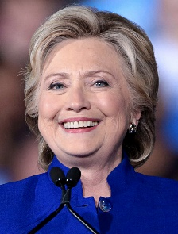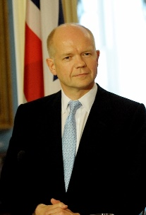 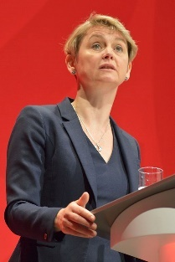

RESEARCH:

Use the following links to find out where studying Politics can take you, make a note of possible career options below.

<https://www.thecompleteuniversityguide.co.uk/subject-guide/politics>

<https://www.prospects.ac.uk/careers-advice/what-can-i-do-with-my-degree/politics>

TASK 6 : EXTEND - How can I prepare myself further?

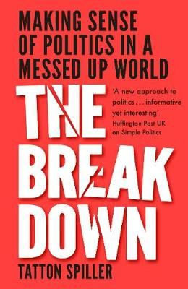(optional)

GETTING READY FOR POLITICS A-LEVEL

**If there is one book I would recommend you read this summer to get you into the right frame of mind for studying Politics at A level it is this one.**

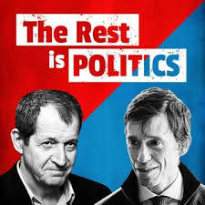

**If there is one podcast I would recommend you listen to this summer to get you into the right frame of mind for studying Politics at A level it is this one.**

Here are some more suggestions to build your general political knowledge. They are not compulsory but let me know about any you have found particularly interesting or useful.

Have a good summer, See you in September!