ESPAÑOL



[](https://www.google.com/url?sa=i&url=https%3A%2F%2Fwww.shutterstock.com%2Fsearch%2Fespanol&psig=AOvVaw0HCCbYldEEks8ULaxWN_bH&ust=1589546238693000&source=images&cd=vfe&ved=0CAIQjRxqFwoTCKi4samvs-kCFQAAAAAdAAAAABAW)

**Content page**

Bienvenidos a español….......................................................................................................................... 2

A Level Course Overview......................................................................................................................... 3/4

Tasks ....................................................................................................................................................... 5

Optional preparation…............................................................................................................................ 6

Read/Watch/ listen….................................................................................................................. 7

Grammar Practice....................................................................................................................... 8

What should I know by now? ........................................................................................ 8

Links to Grammar Practice Exercises ............................................................................. 8

**¡Bienvenidos a español!**

|  |  |
| --- | --- |
| [Español 1 Etapa Preliminar - Lessons - Tes Teach](https://www.google.com/url?sa=i&url=https%3A%2F%2Fwww.tes.com%2Flessons%2FYKBmdpQZqMg9Cw%2Fespanol-1-etapa-preliminar&psig=AOvVaw0HCCbYldEEks8ULaxWN_bH&ust=1589546238693000&source=images&cd=vfe&ved=0CAIQjRxqFwoTCKi4samvs-kCFQAAAAAdAAAAABAu)  Congratulations on choosing to study Spanish at Richard Huish College. At A level, students greatly develop their awareness of the culture, society and recent history of Spain and Spanish-speaking countries.  Throughout the two years, all students are actively encouraged to develop their listening and reading skills through the use of the media, including interactive web resources. Literature and film studies as well as independent research are also important features of the course. |  |

**How to prepare for Spanish at A Level**



The best way to prepare yourself is to ensure that you have a firm grasp of the language and skills which you have already used at GCSE.

Thorough revision of these over the summer will make you more confident when you start the course in September and prepare you for a more independent approach to learning.

**YEAR 1 - ASPECTS OF HISPANIC-SPEAKING SOCIETY: CURRENT TRENDS**

**Year 1 and Year 2 Spanish Course Topics and Exam Format (AQA)**

|  |
| --- |
| **Cyberspace (El ciberespacio)**   * + La influencia de internet * Los móviles inteligentes en nuestra sociedad * Las redes sociales: beneficios y peligros   **Modern and traditional values (Los valores tradicionales y modernos)**   * Los cambios en la familia * Actitudes hacia el matrimonio/el divorcio * La influencia de la Iglesia Católica   **Equal rights (La igualdad de los sexos)**   * La mujer en el mercado laboral * El machismo y el feminismo * Los derechos de los gays y las personas transgénero |

**YEAR 1 - ARTISTIC CULTURE IN THE HISPANIC WORLD**

|  |
| --- |
| **Modern day idols (La influencia de los ídolos)**   * Cantantes y músicos * Estrellas de televisión y cine * Modelos   **Spanish regional identity (La identidad regional en España)**   * Tradiciones y costumbres * La gastronomía * Las lenguas   **Cultural heritage (El patrimonio cultural)**   * Sitios turísticos y civilizaciones prehispánicas: Machu Picchu, la Alhambra, etc. * Arte y arquitectura * El patrimonio musical y su diversidad |

**YEAR 2 - ASPECTS OF HISPANIC SOCIETY: SOCIAL ISSUES AND TRENDS**

|  |
| --- |
| **La inmigración**   * Los beneficios y los aspectos negativos * La inmigración en el mundo hispánico * Los indocumentados - problemas   **El racismo**   * Las actitudes racistas y xenófobas * Las medidas contra el racismo * La legislación anti-racista   **La convivencia y la integración**   * La convivencia de culturas * La educación * Las religiones |

**Year 1 and Year 2 Spanish Course Topics and Exam Format (AQA)**

**YEAR 2 - ASPECTS OF POLITICAL LIFE IN THE HISPANIC WORLD**

|  |
| --- |
| **Jóvenes de hoy, ciudadanos del mañana**   * Los jóvenes y su actitud hacia la política : activismo o apatía * El paro entre los jóvenes * Su sociedad ideal   **Monarquías y dictaduras**   * La dictadura de Franco * La evolución de la monarquía en España * Dictadores latinoamericanos   **Movimientos populares**   * La efectividad de las manifestaciones y las huelgas * El poder de los sindicatos * Ejemplos de protestas sociales (eg. El 15-M, las madres de la Plaza de Mayo …) |

|  |  |  |  |  |
| --- | --- | --- | --- | --- |
| |  |  | | --- | --- | | **Speaking Test** : **Oral** | **21-23 minutes (including 5 minutes preparation time)** | | **Weighting:** | 30% of A level |   **Part 1: discussion of one sub-topic (5-6 min)**  You will select one of two stimulus cards based on a sub-topic and prepare answers to the 3 printed questions. **You must ask the examiner 2 questions.** This will last five to six minutes.  **Part 2: presentation and discussion of your individual research project (2 min + 9-10 min)**  You will present the findings on your research for up to 2 min and will take part in a conversation on that topic. This will last nine to ten minutes. |

|  |
| --- |
|  |

|  |  |  |  |  |
| --- | --- | --- | --- | --- |
| |  |  | | --- | --- | | **Written Paper 1: Listening, Reading and Writing** | **2 hours 30** | | **Weighting:** | 50% of A Level |   A range of listening questions based on the topics plus questions on a selection of written texts, covering both fiction and non-fiction material. Questions will target the main points, gist and detail and will include writing a summary of listening and reading material. |

|  |  |  |  |  |
| --- | --- | --- | --- | --- |
| |  |  | | --- | --- | | **Written Paper 2: Writing** | **2 hours** | | **Weighting:** | 20% of A Level |   Two written essays based on each of the two works you have studied, a book and a film. |

**Tasks**

It will be great to see them in the front of your subject folders as a demonstration of the work you have undertaken to prepare for studying at College.

|  |
| --- |
| **TASK 1** |
| Read through the course overview (pages 3 and 4) so that you have an idea of what we will be studying. This will also help you with task 2 below. |

|  |
| --- |
| **TASK 2** |
| Summarise, in Spanish, 2 articles (that were in Spanish!) that you have read from one of the websites/ papers below and say why they interested you. If you cannot print the article, make a note of the website. Try and make these related to one of the topics we will study (see course view)  TIME: 4 hours (1 hour reading + 1 hour writing per article) |

**Optional preparation for AL SPANISH!**

The activities below (pages 6-8) are all designed to be fun, accessible and to keep you actively learning about topics you are interested in. Whilst you will not be formally assessed on the completion of these, you will find them hugely beneficial during your time at College.

|  |  |  |  |  |
| --- | --- | --- | --- | --- |
|   **Complete** this MOOC.  This free online course explores your creativity as well as your ability to follow instructions in Spanish  [¡El artista está en casa!](https://www.udemy.com/course/el-artista-esta-en-casa/)  *Udemy* | **Listen** to this podcast and learn about the letter **ñ**, unique to the Spanish alphabet: its origins, how to type it and much more. You can download the PDF transcript or access it [here](https://unlimitedspanish.com/wp-content/uploads/2020/02/USP-182-La-letra-N%CC%83.pdf)!  [La letra ñ](https://unlimitedspanish.com/182-la-letra-n/)  *Unlimited Spanish- Habla Español* |   **Read** this article about common mistakes in Spanish. Be ahead of the game by raising your awareness of these traps. You will have plenty of opportunities in A Level to test this knowledge.  [Errores comunes](https://www.spanishdict.com/guide/common-mistakes-in-spanish)  *Spanish Dict* | **Watch** this TED talk about why and how music raises our emotions. You can follow this by downloading the app [Lyrics](https://play.google.com/store/apps/details?id=com.elasthink.lyricstraining&vlink=%2F&%24fallback_url=https%3A%2F%2Fplay.google.com%2Fstore%2Fapps%2Fdetails%3Fid%3Dcom.elasthink.lyricstraining&_branch_match_id=771401213792256185) and learn Spanish through songs.  [¿Por qué nos emociona la música?](https://www.youtube.com/watch?v=uIDYtj8kQUs)  *TED Talk – Paolo Bortolameolli* | **Complete** this interactive lesson on inland Spain, an aspect less known by tourists. This includes activities at different levels and gives you an insight on things we study at A Level.  [La España interior](https://www.profedeele.es/actividad/unidad-didactica-interactiva/unidad-didactica-interactiva-sobre-la-espana-interior/)  *ProfeDeELE.es* |
|   **Listen** to this video that explores the wall in the Spanish city of Melilla, designed to stop illegal immigration between the European Union and Africa. Learn about this controversial topic which we will be studying in detail in class.  [La Valla de Melilla](https://www.youtube.com/watch?v=ntc0kC9lI6A&list=PLLhUyPZ7578fO1FAne436D26PBdXhqG4p&index=12&t=0s)  *Youtube - BBC Mundo* | **Read** this article about Donovan Carrillo. In this interview to an  exceptional ice skater you will find inspiration, as well as an opportunity to check your understanding of tenses.  [Entrevista con…Donovan Carillo](https://www.muyinteresante.com.mx/junior/entrevista-con-donovan-carrillo-el-campeon-mexicano-patinaje-hielo/)  *Muy Interesante Junior* | **Watch** this video and learn about surprising habits in the Spanish culture, such as organ donation or why we hang pig legs in bars…all useful to know for A Level!  [20 Curiosidades de España](https://www.youtube.com/watch?v=BDlydbVLP5w)  *Youtube – Supercurioso* |   **Complete** this course  on understanding and using natural language. You will learn to express yourself better, improve your audio skills and learn culture through a series of video activities  [Understanding spoken Spanish](https://www.open.edu/openlearn/languages/intermediate-spanish-understanding-spoken-spanish/content-section-0?active-tab=description-tab)  *Open University* | **Listen** to this podcast about Spanish inventors: from mops to cable cars! The podcast is followed by a small quiz.  [Inventos españoles](https://www.profedeele.es/actividad/podcast/5-inventos-espanoles/)  *ProfeDeELE.es* |
|   **Read** this article about civilizations prior to the arrival of Christopher Columbus to the Americas. Place the countries in a [map](http://www.free-world-maps.com/printable-white-transparent-political-blank-world-map-c3). We will be extending this knowledge in class.  [Culturas precolombinas](https://hablacultura.com/culturas-precolombinas/)  *Hablacultura.com* |   **Watch** this video about expressions in Spanish related to food. They are so quirky. There are many more funny videos like this [here](https://www.youtube.com/channel/UCVSSYYfjLmPo49M9rSM5qOQ).  [Expresiones en español de comida](https://www.youtube.com/watch?v=1KFHZ45JSJg)  *Youtube – Hoy hablamos* |   **Complete** this MOOC on the most controversial region of Spain: Catalonia. Learn about its language, history, culture and why it is up in arms.  [Getting to Know Catalonia](https://www.futurelearn.com/courses/catalan-culture?fbclid=IwAR3N5dKKyi3mvX9l_HrL2Jd-g52fNmyziBrquRDb0RpXg1hhin-U5rCf7oI)  *Future Learn* |   **Listen** to this podcast about the Spanish monarchy. Learn why a female heiress to the throne is an issue and compare it to the British monarchy.  [La Familial Real](https://www.notesinspanish.com/2007/05/08/intermediate-spanish-podcast-30-la-familia-real/)  *Notes in Spanish* | **Watch** this TED talk A picture containing drawing  Description automatically generated on “writing” the story of your life! This is a humorous reflection and philosophical insight. Great for literature and language lovers too!  [Reescribe el cuento de tu vida](https://www.ted.com/talks/lucas_raspall_reescribe_el_cuento_de_tu_vida)  *TED Talks – Lucas Raspall* |

[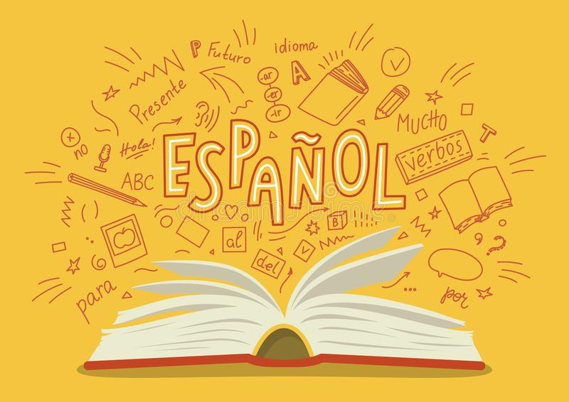](https://www.google.com/url?sa=i&url=https%3A%2F%2Fwww.dreamstime.com%2Fespanol-translation-spanish-open-book-language-hand-drawn-doodles-lettering-education-vector-illustration-image129097701&psig=AOvVaw0HCCbYldEEks8ULaxWN_bH&ust=1589546238693000&source=images&cd=vfe&ved=0CAIQjRxqFwoTCKi4samvs-kCFQAAAAAdAAAAABA4)**Read …**

**Newspapers and Magazines**

Read a foreign language newspaper – El Mundo in Spanish is available in larger paper shops. El Mundo has its own website <http://www.elmundo.es/> so that you can read the paper online. You do not have to read the paper cover to cover, just scan the headlines and pick out ONE article that grabs your attention.

* This website is a more light hearted newspaper which covers global stories as well as gossip. <http://www.20minutos.es/> Also try <http://www.20minutos.tv/> This is the TV Channel for this newspaper:

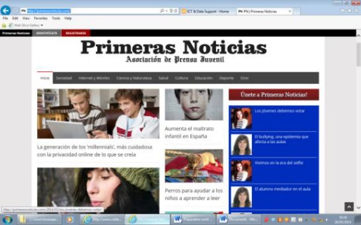In Spain there is also a news website for young people: <http://primerasnoticias.com/> It has sections on the Internet and Mobile Technology; Science and Wildlife; Education; Culture; Sport; Society and Health. A glance today contained articles about Facebook, video games and bullying to name but a few.

**Websites**

Look at the BBC website <http://www.bbc.co.uk/languages/spanish/tv/onlinenews.shtml> for links to Spanish programmes available on line. And <http://www.bbc.co.uk/mundo/> takes you through to news in Spanish.

**Watch…**

**Movies**

[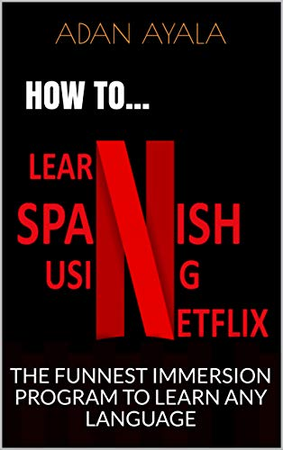](https://www.google.com/url?sa=i&url=https%3A%2F%2Fwww.amazon.co.uk%2FHOW-LEARN-SPANISH-USING-NETFLIX-ebook%2Fdp%2FB07HNLPT6Y&psig=AOvVaw1r4j_qymI2N81_880MPwp4&ust=1589558961869000&source=images&cd=vfe&ved=0CAIQjRxqFwoTCMCCntzes-kCFQAAAAAdAAAAABAE)

Watch Spanish films and TV shows on Netflix.

Money Heist, Elite, Cable Girls, The Ministry of Time… Ideally in Spanish with English subtitles.

[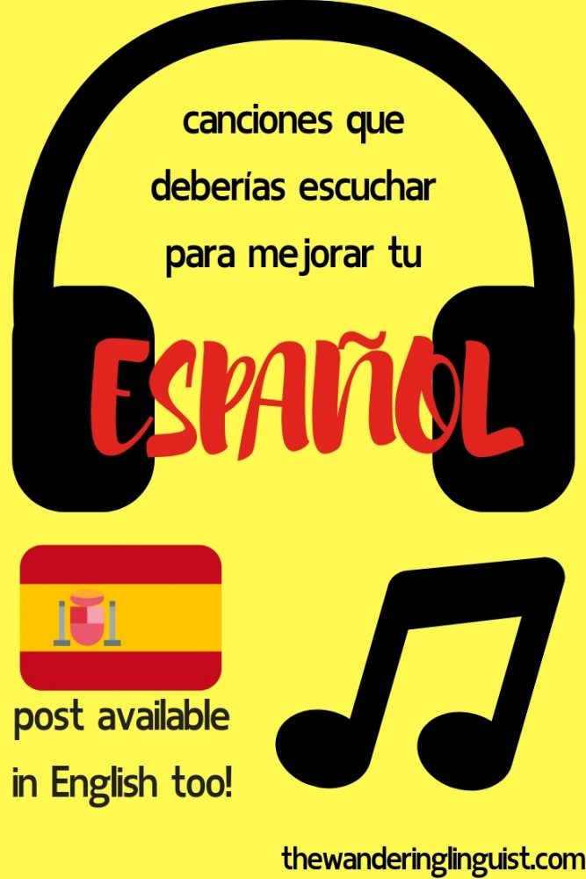](https://www.google.com/url?sa=i&url=https%3A%2F%2Fthewanderinglinguist.com%2Fcanciones-para-aprender-espanol%2F&psig=AOvVaw3InqPfzfgBUv5GtD579r4M&ust=1589546871098000&source=images&cd=vfe&ved=0CAIQjRxqFwoTCKDx8taxs-kCFQAAAAAdAAAAABAF)**Listen to the music…**

On Youtube or Spotify: start with Alvaro Soler, Shakira, DVicio, Pablo Alborán, Rosalía… Find your favourite songs and look for the lyrics!!

[](https://www.google.com/url?sa=i&url=https%3A%2F%2Fapps.apple.com%2Fgb%2Fapp%2Fspotify-new-music-and-podcasts%2Fid324684580&psig=AOvVaw3v5qyVaLCKf9TOce6XK23w&ust=1589561533847000&source=images&cd=vfe&ved=0CAIQjRxqFwoTCODszabos-kCFQAAAAAdAAAAABAE)

**Grammar Practice**

**What should I know by now?**

This is a common question asked by students about to start their A level. You should be able to:

|  |  |
| --- | --- |
| **TOPIC** | **CONTENT** |
| Recognise and use a range of tenses with **regular** verbs. | Regular –AR, -ER, -IR verbs:  Tenses:  Present  Preterite  Imperfect  Near Future (ir + a + inf.)  Future (eg. Sera)  Conditional (eg. sería) |
| Recognise and use a range of tenses with **irregular** verbs. | Common irregular verbs: **ser, estar, tener, hacer, ir**  Tenses:  Present  Preterite  Imperfect  Near Future (ir + a + inf.)  Future (eg. será)  Conditional (eg. sería) |
| Give opinions with reasons | • A range of opinion expressions  • Positive and negative reasons for opinions  • To be able to agree |

**Links to Grammar Practice Exercises**

The following websites are also very useful interactive sites for grammar and language based activities.

**Languages on line:** The Grammar Revision resources on [www.languagesonline.org.uk](http://www.languagesonline.org.uk) are great as you can then select what tense you want to revise, read the explanations and complete the exercises. You can do these as often as you like and it gives you a percentage. Another useful tactic is to translate the examples and exercises into English to ensure you understand the meaning of each tense.

**Lightbulb languages**: at <http://www.lightbulblanguages.co.uk/resources-sp-al.htm>

**Conjuguemos:** a great website for practicing your verb conjugations. Find it here: <https://conjuguemos.com/k>

**Duolingo, Memrise:** By making use of the websites, Duolingo [www.duolingo.com](http://www.duolingo.com) or Memrise [www.memrise.com](http://www.memrise.com)