



BTEC National Extended Diploma in Uniformed Protective Services – Level 3



**Welcome**

We are delighted that you have shown an interest in studying Uniform Protective services (UPS) at Richard Huish College.

In order to get you thinking about the subject, we have produced this Headstart booklet to help you prepare for your studies when you join us in September. As the course contains both practical and theoretical elements this booklet contains both practical and theoretical activities for you to do.

**Level 3 UPS**

Is a two-year BTEC Extended Diploma is equivalent to three A-levels. It consists of 13 units. 2 units are assessed through examinations, the rest through coursework comprising of written assignments, presentations and practical activities.

BTEC Uniformed Protective Services can help you take your first steps towards an exciting career in protecting the public. Its main aim is to help prepare you for roles in the armed services, fire and rescue service, police force, prison services, however it does also develop your skills for a wide range of careers.

You will develop knowledge and understanding by applying your learning and skills in a work-related context. The teaching team create a series of relevant assignments, which can be written, or activity based. These include activities such as fitness testing, map reading, teambuilding and outdoor pursuits. The assessments are completed through a combination of internal and external assessment.

In the **first** year you will study 5 units

Unit 1 Citizenship and Diversity (Pearson-set theme different every year)

Unit 2 Behaviour and Discipline in the Uniformed Protective Services EXAMINED

Unit 4 Physical Preparation, Health and Wellbeing

Unit 5 Teamwork, Leadership and Communication in the Uniformed Protective Services

Unit 10 Skills for Outdoor Activities and the Uniformed Protective Services



In the **Second** Year of the course you will study 8 units

Unit 17 Understanding the Third Sector

Unit 11 Expedition Skills

Unit 6 Government and the Protective Services EXAMINED

Unit 7 Planning for and Responding to Emergency Incidents

Unit 12 Developing Personal Fitness Programmes

Unit 14 Principles of Managing Security Threats

Unit 19 Professional Development in the Uniformed Protective Services

Unit 3 Global Affairs, the Media and the Uniformed Protective

To fully understand the sector there are trips to Public Service providers such as Police, Fire and Rescue, Mountain Rescue, Army and Airforce.

There may be additional trip and equipment costs for this course.

Click the link below for the specification [BTEC L3 Extended Diploma Specification](https://qualifications.pearson.com/en/qualifications/btec-nationals/uniformed-protective-services-2020.html)

[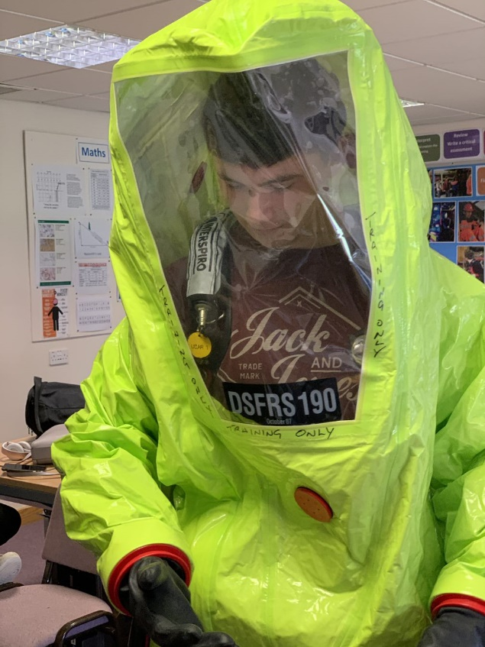](https://qualifications.pearson.com/en/qualifications/btec-nationals/uniformed-protective-services-2020.html)

**Tasks**

**Please complete tasks 1-3 in the booklet ready for 1 September**.

**Please read through the activities before you start them, some will be quick to complete while others will take longer.**

**Contents**

Task 1 Fitness diary 4

Task 2 Conformity assignment 5

Task 3 Major incidents assignment 7

Additional resources (optional) 8

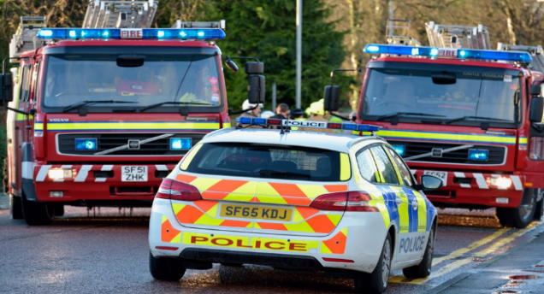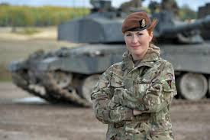

# Unit 4 – Fitness Diary

The Uniformed Protective Services require their employees to have a basic standard of fitness. It is therefore important for Public Service students to develop both a theoretical understanding of, and a sound practical level of fitness

One of the activities we are still able to take part in is exercise and of course it is really important to do this for both physical and mental reasons.



Please record in a daily diary the activity / exercise that you take part in during a 2 week period. If you have a day without any exercise record this as a rest day. Include all activity eg. Walking / running / cycling / Joe Wicks / Yoga

|  |  |
| --- | --- |
| Day / Date | Activity - including eg. Time / Distance /reps |
| Week 1 | |
|  |  |
|  |  |
|  |  |
|  |  |
|  |  |
|  |  |
|  |  |
| Week 2 | |
|  |  |
|  |  |
|  |  |
|  |  |
|  |  |
|  |  |
|  |  |

# Unit 2 – Behaviour & Discipline in the Public Services.

The following work relates to Unit 4, this unit asks learners to develop their understanding of how important discipline is to the effective running of our public services. It is usually delivered in the first year and the unit contains a mix of practical, theoretical, and self-reflective study. Here we are going to look at one characteristic of the unit which is conformity.



**Conformity in the public services.**

There are several definitions of conformity, the following is from Simple Psychology

“Conformity is a type of social influence involving a change in belief or behaviour in order to fit in with a **group**.”

If we look at the quote above, the “**group**” refers to the service you are thinking about joining. E.g. the Police.

Take a good look at yourself, why do you think you would make a good, police officer, soldier, sailor, firefighter, member of the air force (service of your choice)?

Please answer the questions below: try to provide detailed answers, demonstrating you have thought about the issue’s involved and how your personality would fit with that of your chosen public service.

**Here is some help to get you started**,

You do not just instantly become a police officer or member of the armed forces overnight, it take’s time, to join all of the forces you have to successfully complete a period of training. All initial training has a similar purpose to get you to conform to the requirements of that service. If you cannot, you will be asked to leave!

As you have been living under Covid 19 restrictions you have experience of knowing there are rules and regulations to follow, orders to obey, social distancing to maintain, only going out when necessary and not being able to see friends and family to name some.

Use this experience to support your answers.

**Questions**

1. Identify which public service you would like to join?
2. What is it about the work/role they do that interests you?
3. How good are you at conforming?

The following 5 points are for you to discuss in your answers.

1. Would you be happy wearing a uniform and have the skills to keep it clean and ironed?
2. Do you need to get a haircut or learn how to put it up?
3. How good are you following rules and regulations

e. What is your level of self-discipline? On a scale of 1-10 (10 is very self-disciplined)

|  |  |
| --- | --- |
| Identify the changes that you will need to make in yourself to fit in with your future colleagues and meet the challenges of the role? | How are you going to change so that you conform to the requirements of the service? |
|  |  |
|  |  |
|  |  |
|  |  |
|  |  |

# Unit 7 Planning for emergency incidents

This unit will help you understand the roles and responsibilities of Public Service organisations during a major incident. You will study the cause of major incidents, how incidents affect individuals, public service workers and the importance of planning



[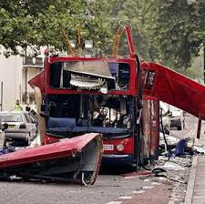](https://www.google.com/imgres?imgurl=https%3A%2F%2Fm.belfasttelegraph.co.uk%2Fmigration_catalog%2F1cf3f%2F25760970.ece%2FAUTOCROP%2Fw300%2FUK%2520News%25208-1.jpg&imgrefurl=https%3A%2F%2Fwww.belfasttelegraph.co.uk%2Fnews%2Fuk%2F77-proposals-are-being-ignored-28609711.html&tbnid=8s6wVntyvsmGIM&vet=10CFQQMyiNAWoXChMIwLDuv5mx6QIVAAAAAB0AAAAAEAM..i&docid=kuEhaa5G7fTxOM&w=300&h=299&q=major%20incidents%20in%20the%20uk&safe=active&ved=0CFQQMyiNAWoXChMIwLDuv5mx6QIVAAAAAB0AAAAAEAM)[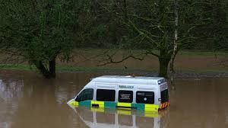](https://www.google.com/imgres?imgurl=https%3A%2F%2Fimages.lbc.co.uk%2Fimages%2F124192%3Fcrop%3D16_9%26width%3D660%26relax%3D1%26signature%3D4kSuVNM_QnD9cdb0K7koIRpsrFI%3D&imgrefurl=https%3A%2F%2Fwww.lbc.co.uk%2Fnews%2Fmajor-incident-declared-in-south-wales-as-storm-de%2F&tbnid=fhYhj07ZaPh4uM&vet=12ahUKEwi5v4O_mbHpAhXOw4UKHW_0CPkQMyg1egUIARCIAQ..i&docid=Drh1ggMHUicrGM&w=660&h=371&q=major%20incidents%20in%20the%20uk&safe=active&ved=2ahUKEwi5v4O_mbHpAhXOw4UKHW_0CPkQMyg1egUIARCIAQ)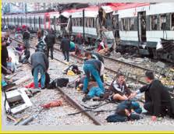

Although there are many types of disasters ranging from flooding to explosions to transport incidents, the causes of these can generally be divided into 5 broad categories--

1. **HUMAN CAUSES.**
2. **TECHNOLOGICAL CAUSES.**
3. **NATURAL CAUSES.**
4. **HOSTILE ACTS.**
5. **HEALTH RELATED.**

Using the **HEALTH RELATED** - Covid 19 Pandemic as an example answer the following questions

|  |
| --- |
| 1 What was the cause of the crisis? |
|  |
| 2 Describe the role of the following public services in the crisis |
| NHS |
| Ambulance Service |
| Police |
| Government |
| St John Ambulance |
| Fire and Rescue |
| The Armed forces |

# Additional Recourses

The public services are often portraited in the media.

It is important for you to watch TV programmes depicting them (real or fictional) and keep up to date with current events being able to give examples.

The news always has good examples, you could download the BBC news app to ensure you are always kept up to date.

|  |  |
| --- | --- |
| **Factual Documentaries** | **Fictional Dramas** |
| 999 what’s your emergency | Shetland |
| Commando | Vera |
| 24 hours in Police custody | Casualty |
| Warship Life at Sea | Our girl |
| SAS who dares wins | Line of Duty |
| First time on the front line | Rockface |
| Rescue - River deep mountain high | Soldier Soldier |
| Ambulance | Broadchurch |
| Saving lives at sea | Red caps |
| Into the fire | London’s Burning |

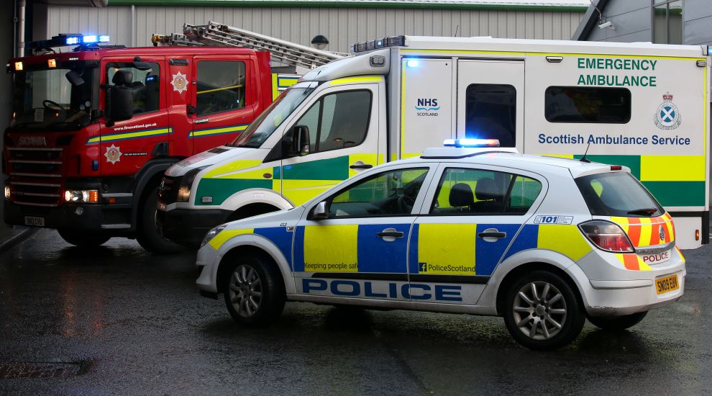

**Looking forward to seeing you in September**