

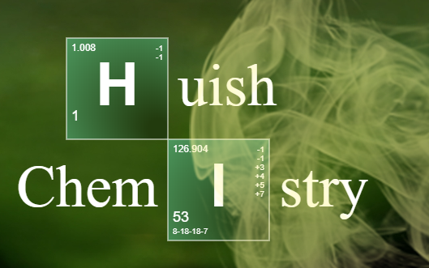

Preparing for A-level Chemistry

Welcome!
Chemistry is a challenging and rewarding A-level. You will extend your knowledge from GCSE and develop into a confident and resilient problem-solver during the course. You’re going to develop your practical skills and begin to appreciate the important role that chemistry plays in the world today.

Watch this video as a taster of how you could make a difference.

FAQ
What specification will I study?
You’ll be covering the OCR A specification – you can find it here.
How many lessons will I have a week?
You’ll have 4 lessons a week, each 1 hours and 5 minutes
Who will my teacher be?
The chemistry team is Jo Clare, Pete West and James Dawson – you’ll find out which of us are teaching you when you get your timetable.
What subjects go well with Chemistry?
It’s a challenging science subject so we recommend that you do other similar subjects. Maths and Physics help to support the problem-solving and maths. It also goes well with Biology, Economics and Environmental Science.
What grades should I have?
We recommend at least a 6 in chemistry or Science as well as a 6 in Maths. If you have got less than a 7 in Maths then we suggest you also take Core maths as this will support your problem-solving.

What will I study?
In Year 1, you will study the following topics:
- Atomic structure
- Formulae and equations
- Moles calculations
- Acids and titrations
- Bonding and structure
- Redox
- Group 2 and group 7 chemistry
- Enthalpy changes
- Rates of Reaction
- Basics organic chemistry
- Alkenes and Haloalkanes
- Alcohols
Getting ready…

We recommend all students buy a textbook. We sell the following books at the IT helpdesk…
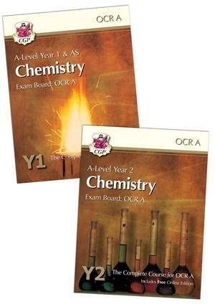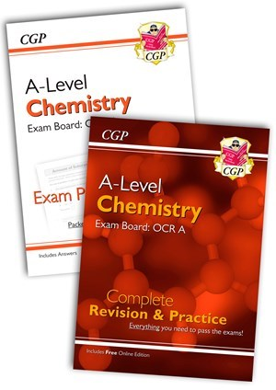

If you receive a bursary, you can use this to buy your book.
These books are also available to borrow from the LC:

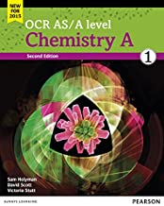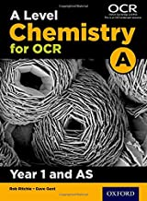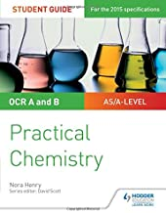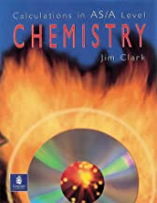

You will also need:
- A scientific calculator
- A folder with dividers
- Lined paper
- Pens and pencils
- Highlighters
- A ruler

Students also find it useful to have:
- Blank flashcards
- A whiteboard and whiteboard pens to use at home
- Plastic wallets
- A periodic table to have on your wall where you study. The one you get in exams can be found here.

This booklet contains activities that will help you recap your GCSE knowledge and prepare for A-level chemistry. If you didn’t attend Welcome to Huish, please print out your booklet. Complete the tasks in the booklet then use the answers at the back to assess how you’ve done.. Hand in your completed booklet in your first lesson. All these topics will be developed in Year 1 of your studies

Activity | Activity | Page
1 | Atomic structure | 4
2 | Formulae and Equations | 6
3 | Structure and Bonding | 8
4 | Moles Calculations | 11
5 | Basic Organic chemistry | 14
6 | Practical Investigation | 15
7 | Maths skills | 16

Activity 1: Atomic Structure
- Watch this cartoon on the history of the atom.
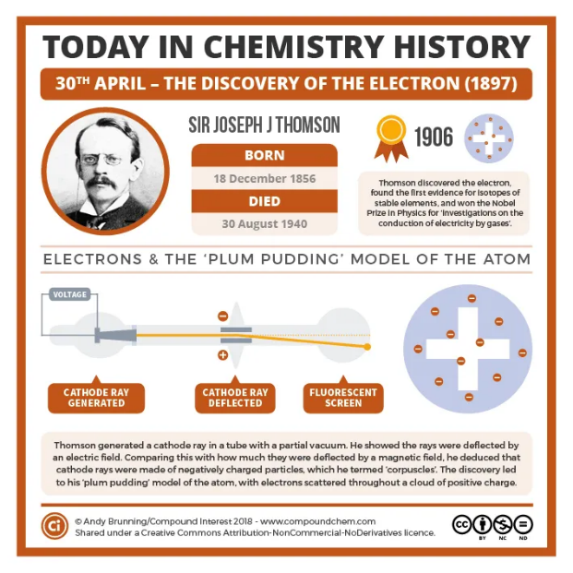
- Now research the scientists involved and the key pieces of research that contributed towards the models we use today.
Scientists to include are:
- Neils Bohr
- John Dalton
- Ernest Rutherford
- Democritus
- James Chadwick
- JJ Thomson
- Louis De Broglie
The website, compound chemistry is a good place to start your research.

- Revise atomic structure – make sure you can describe the structure of an atom and link the sub-atomic particles to the numbers on a periodic table. This video will help you recap.

- Revise relative atomic mass calculations – this video will help you recap.

When you’re ready, do the questions on the next page to test yourself (answers at the back of the booklet) ….

- Complete the table to show the location, relative charge and relative mass of each sub-atomic particle found within an atom

Sub-atomic particle | Location | Relative charge | Relative mass
Neutron
Electron
Proton

- Complete the missing data in the table below :

Atom | Atomic No. | Mass No. | No. of protons | No. of electrons | No. of neutrons
N
K
 | 5 | 11
 |  |  | 18 |  | 22

- Calculate the relative atomic mass of the following elements. Give your answers to 3SF.

Remember for each isotope you have to take into account it mass and its relative abundance, e.g. %

- Boron contains: 19.77% ¹⁰B & 80.23% ¹¹B

Ar: _____________
- Silicon contains: 92.18% ²⁸Si, 4.70% ²⁹Si & 3.12% ³⁰Si

Ar: _____________
- Unknown X contains: 4.31% ⁵⁰X, 83.76% ⁵²X, 9.55% ⁵³X & 2.38% ⁵⁴X

Ar: _____________

Use the periodic table to work out the identity of this unknown element: ________________________
Activity 2: Formulae and Equations

- You need to know the formula and charge of common ions and compounds. This list includes some of the common ions you should know:
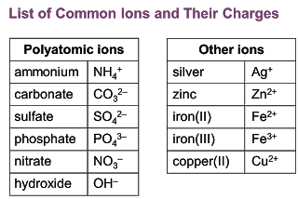

Use this quizlet to learn the formulae and test yourself until you are confident.

- This video here will help you recap how to write chemical formulae for ionic compounds.

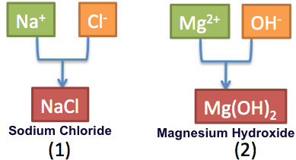

- Now play the balancing equations game – can you beat level 3?

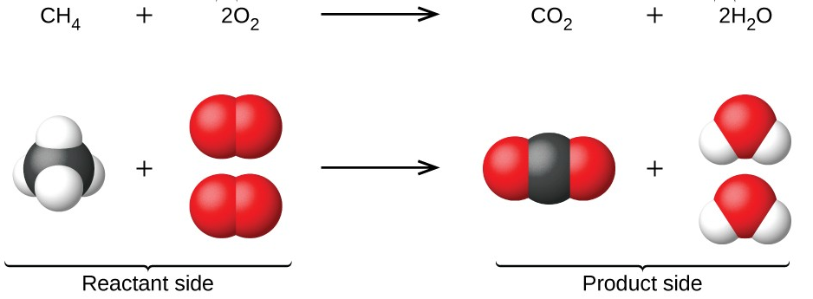

When you have completed the tasks, do the questions on the next page to assess your understanding (answers at the back of the boolet)…
- Construct formulae for these ionic compounds:

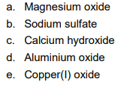

- Balance the following equations:

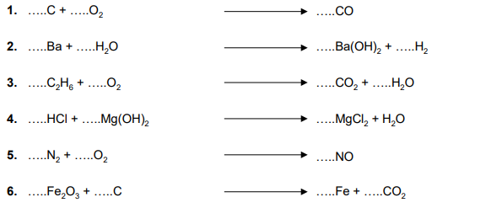

- Write balanced equations for each of these reactions from their description. You need to work out the formulae of the reactants and products first then balance the equations.

Hint: Common gases like nitrogen and oxygen are all diatomic molecules (they go around in pairs like O₂).

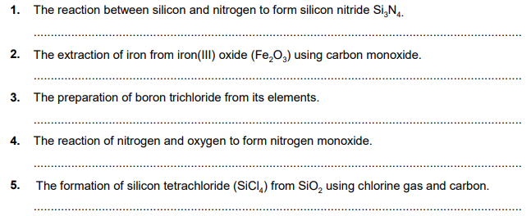

Activity 3: Structure and Bonding
- Watch this video to quickly recap the ideas about structure, bonding and properties that you have met at GCSE.

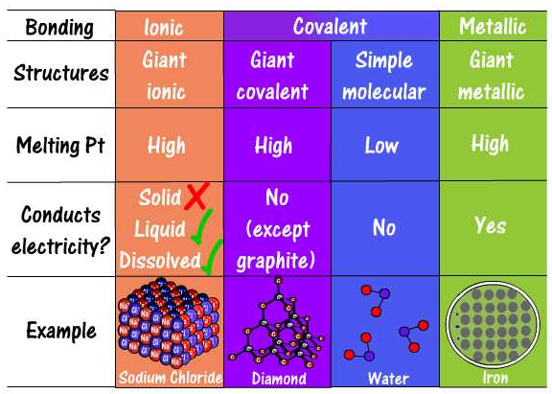

- At A-level, you will learn more about the intermolecular and electrostatic forces that hold structures together. Watch this video to give you a taster of how the structure and bonding in water gives it unique properties.

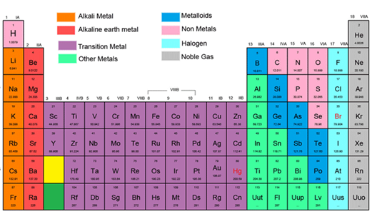

Now answer these GCSE questions and assess your knowledge (answers at the back of the booklet)…
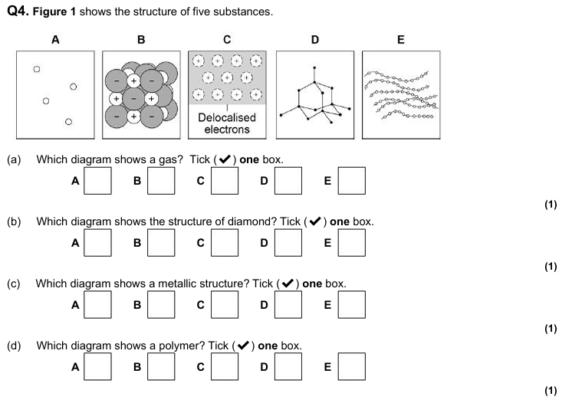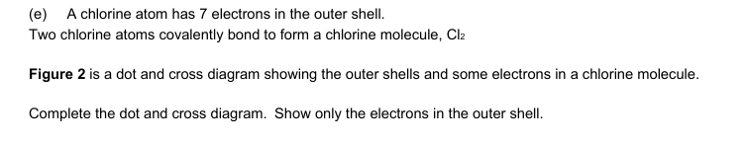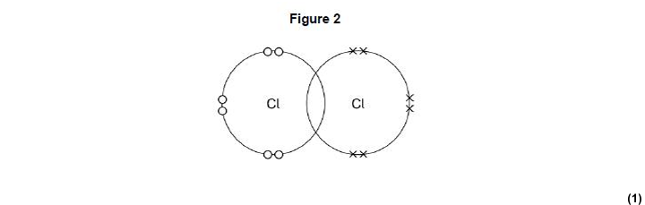
Q1
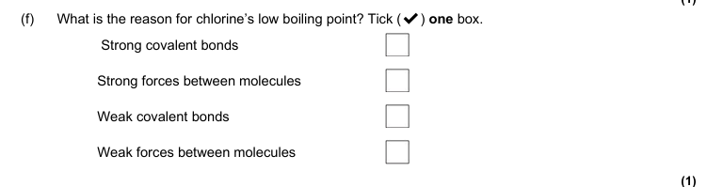
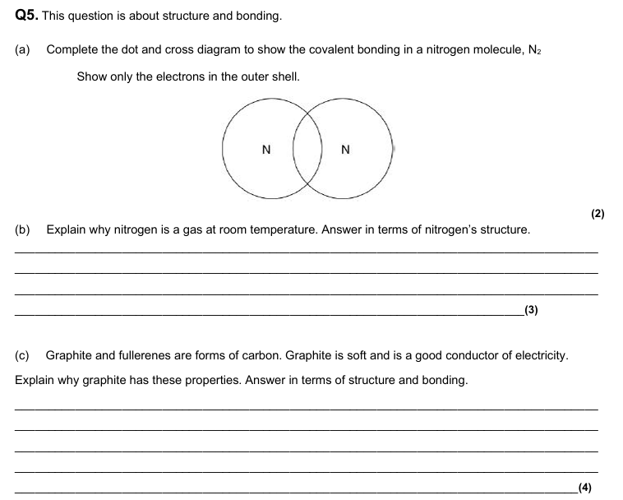
Q2
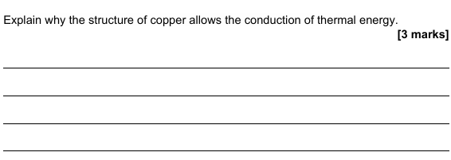
(d)

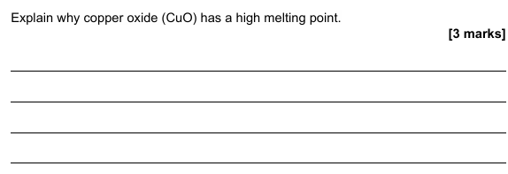
(e)

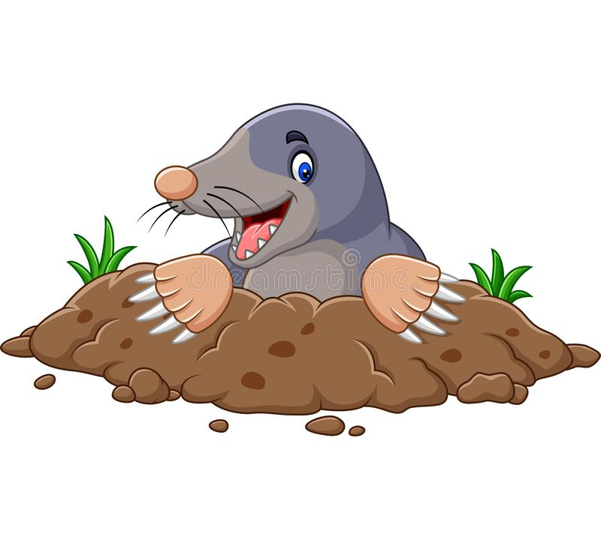
Activity 4: Moles calculations
Some students are daunted by the maths in chemistry before they begin their A-level. The more you practise calculations, the better you will get at them so here are some activities to help you recap what you have done at GCSE.

  - Watch this video to recap the basic ideas you’ve met at GCSE.

  - Do this quiz to practise calculating M_{r} (molar mass) for different compounds.
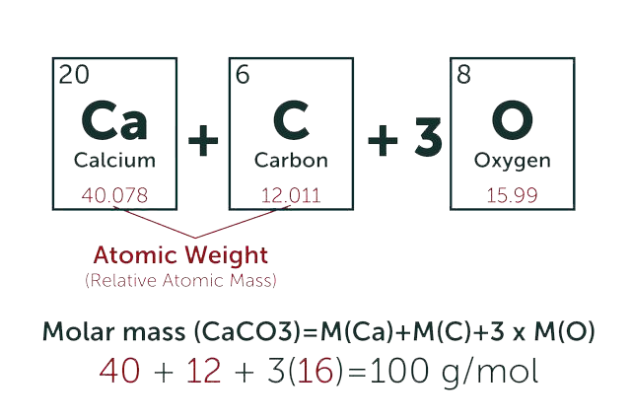
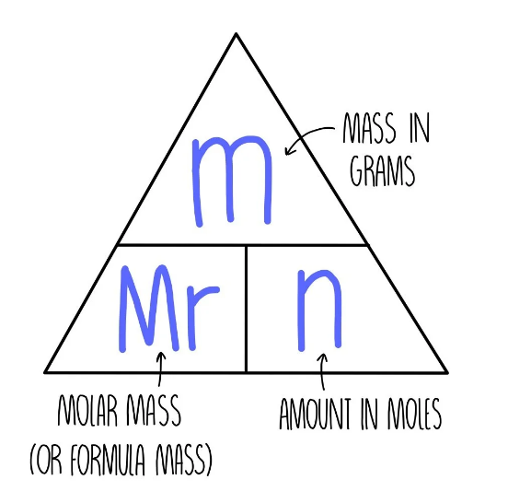

  - Watch this video to recap how to do reacting mass calculations. You might have been shown a different way at GCSE so don’t panic – we cover these again in Year 1.

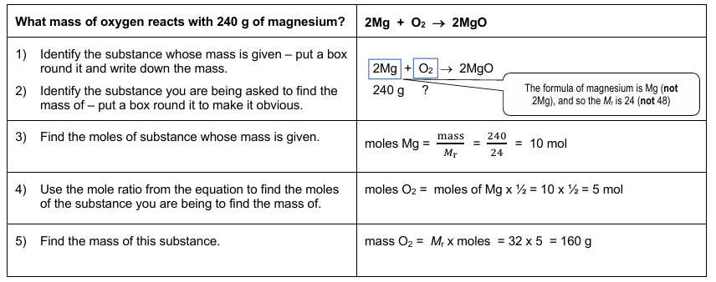

- Calculate the Mr of each compound listed below, showing full working:
- CaCO₃
- Cu(OH)₂
- (NH₄)₂SO₄
- Calculate the number of moles in the following:

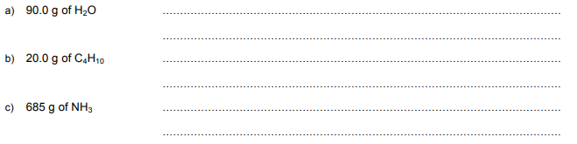
- Calculate the mass of the following:

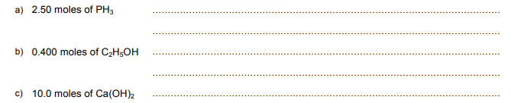

- Carry out these reacting mass calculations:
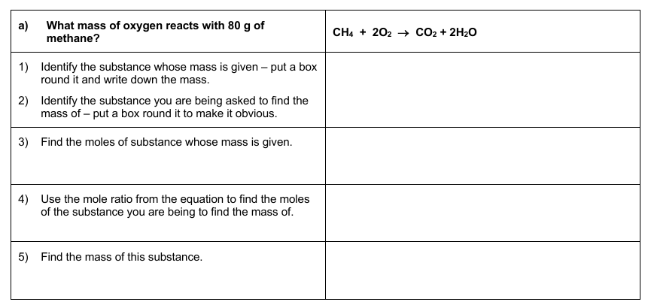
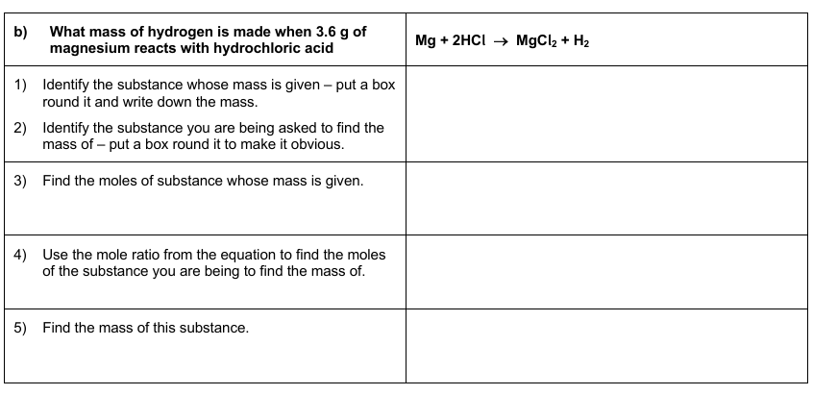
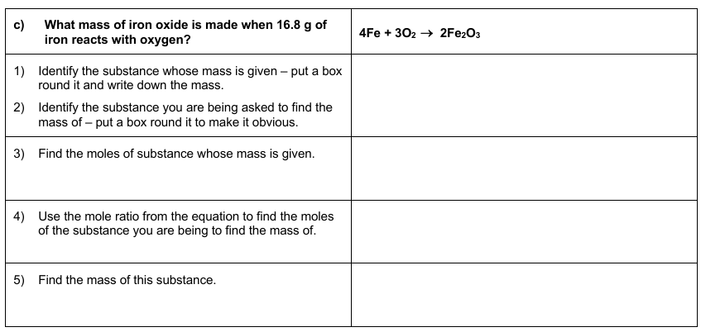
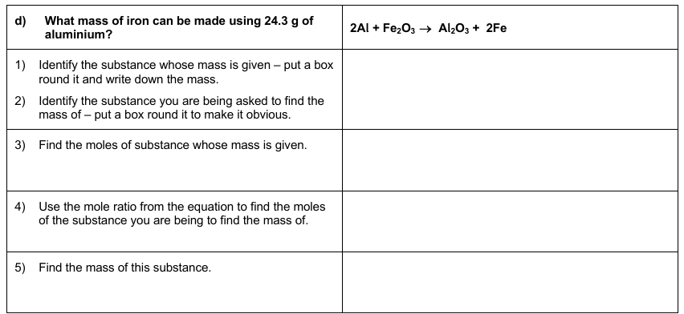
Activity 5: Basic Organic Chemistry
- Organic chemists use displayed, structural and skeletal formulae to describe compounds. Watch this video about formulae as an introduction to this.

- You have been introduced to naming alkanes at GCSE. This year, you will learn how to name branched compounds. Watch this video to introduce you to the naming rules.

- At GCSE, you have met alkanes, alkenes, alcohols, carboxylic acids and esters. You will meet more functional groups at A-level. Here are lots…

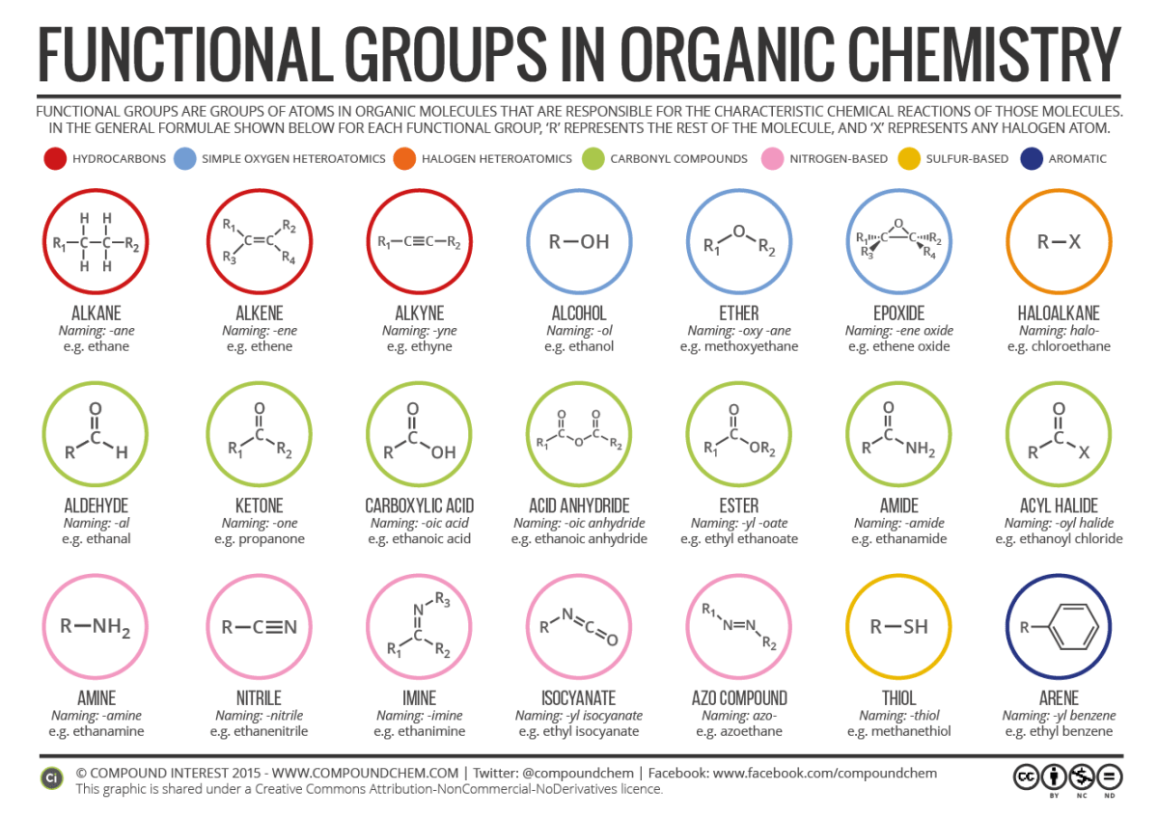
Try this quiz to see how many you can identify…
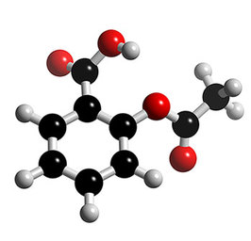
- Organic compounds are very important and are found in drugs, dyes, detergents, explosives and perfumes and just about everywhere else you can think of! Choose a molecule to research – find out its formula and structure and what we use it for then make a factsheet…

Molecules you could investigate include:

TNT, paracetamol, oxytocin, capsaicin, Sudan red, theobromine, ibuprofen, DDT…

Hand in your poster with your completed booklet in your first chemistry lesson in September!
Optional: Practical Investigation

During your Chemistry A-level, you will keep a lab book as evidence of your experimental skills in order to achieve the Practical Endorsement. You have to show competence in:

  - Following instructions
  - Planning and implementing experiments
  - Health and safety
  - Recording data
  - Using software, researching and reporting your experiments.

Task: Carry out a project to investigate the natural dyes in plants. Starter by using red cabbage – you can use fresh or pickled! Extract the juice and then test it with different acids and alkalis that you have in your house e.g. vinegar, lemon juice and baking powder. Take photos of your results and use them to write a report explaining what you have done. You should include an introduction, a method and a results section. Extend your investigation to other fruit and veg – turmeric, red onions, beetroot and hydrangea flowers all contain natural indicators too.
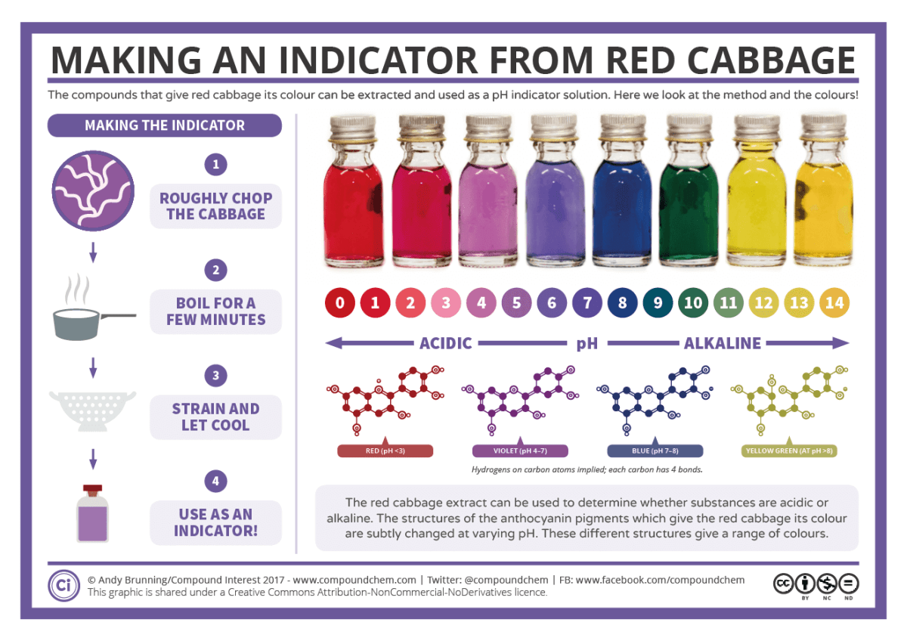
Questions to think about:
How will you make it a fair test?
What household acids and alkalis will you use to test your dyes?
Why do plants contain these compounds?

Extra help: Maths skills for chemists
20% of the marks at A-level Chemistry are testing GCSE level maths skills. You need to be confident at the following:
- Significant figures and decimal places
- Using standard form
- Calculating percentages
- Converting units
- Rearranging equations
- Drawing graphs
- Finding a gradient of a point on a curve using a tangent

This booklet here has some worksheets you can do to practise your maths skills (you might have to register with the Royal Society of Chemistry website to access it).
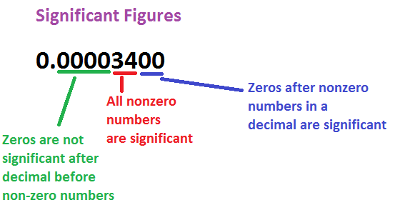
Here are some more resources you could use to practise your basic skills…

- Significant figures and decimal places quiz
- Video on significant figures
- Video on decimal places

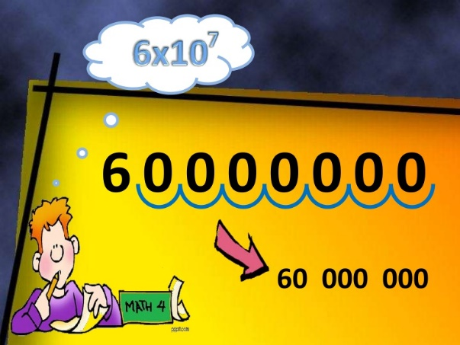

- Quiz on standard form
- Video on standard form

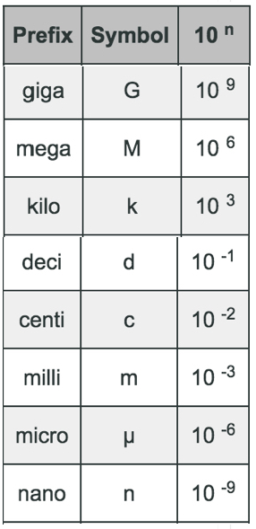

- Watch this video to help you understand why standard form and prefixes are useful in science
- Recap how to convert units here
- Use these flashcards to test yourself

Answers:

Activity 1:
Sub-atomic particle | Location | Relative charge | Relative mass
Neutron | Nucleus | 0 | 1
Electron | In shells | -1 | 1/1820
Proton | Nucleus | +1 | 1

Atom | Atomic No. | Mass No. | No. of protons | No. of electrons | No. of neutrons
N | 7 | 14 | 7 | 7 | 7
K | 19 | 39 | 19 | 19 | 20
B | 5 | 11 | 5 | 5 | 6
Ar | 18 | 40 | 18 | 18 | 22

    - 10.8%
    - 28.1%
    - 52.0%, chromium

Activity 2:

- MgO
- Na₂SO₄
- Ca(OH)₂
- Al₂O₃
- Cu₂O

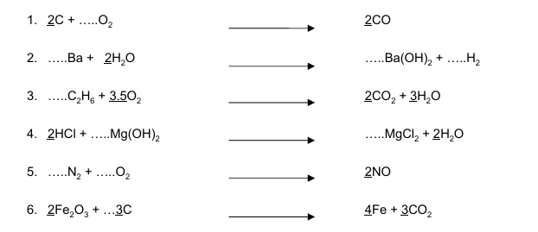

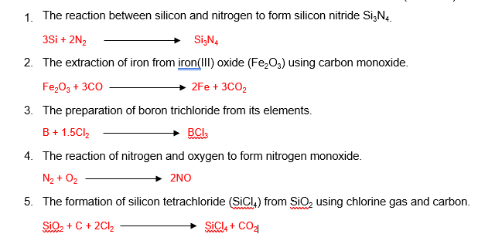

Activity 3:

1.
a) A
b) D
c) C
d) E

e) Dot and cross drawn in overlap between the two atoms.

O
X

- Weak forces between molecules ✔

2.
a) Triple bond represented as 3 dots and 3 crosses in overlap between the atoms ✔
2 Non-bonding electrons on each nitrogen ✔
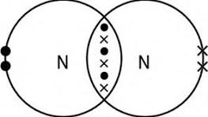

b) Nitrogen is a simple covalent molecule ✔
Molecules are held together by weak intermolecular forces ✔
Only a small amount of energy is needed to overcome the forces ✔

c) In graphite, each carbon bonds to 3 other carbons ✔
To give layers of hexagonal rings ✔
It conducts electricity as there are declocalised electrons between the layers ✔
It is soft as the layers can slide ✔

d) delocalised electrons ✔
move through the structure ✔
and transfer energy ✔

e) strong electrostatic attractions ✔
between oppositely charged ions ✔
that require large amounts of energy to break the bonds. ✔

Activity 4:

- CaCO₃ 100.1
- Cu(OH)₂ 97.5
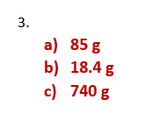
- (NH₄)₂SO₄ 132

- 5 moles
- 0.345 moles
- 40.3 moles
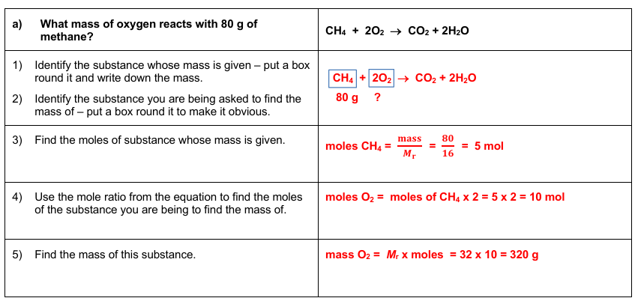

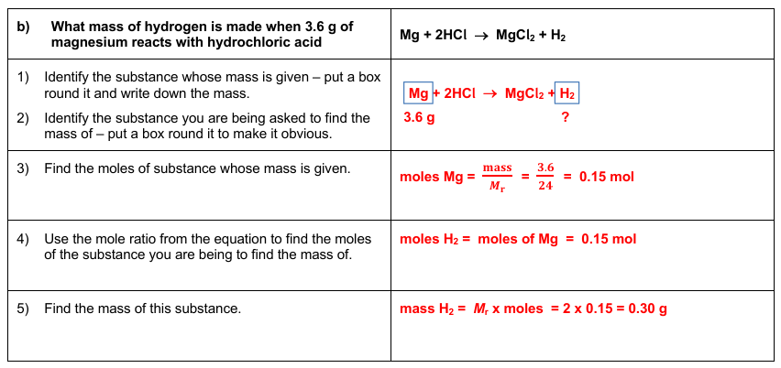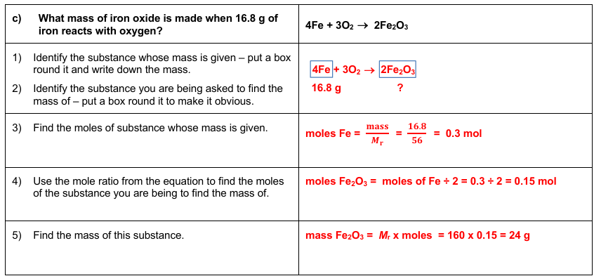
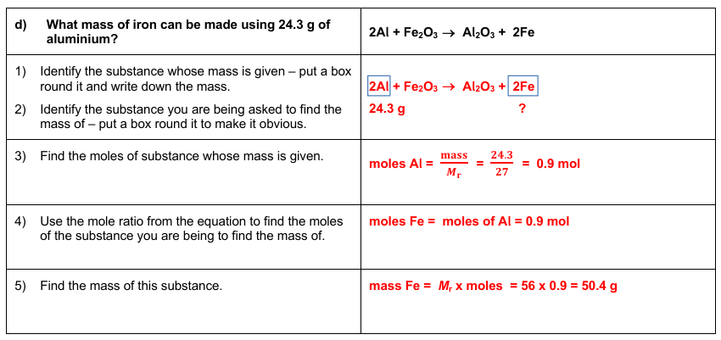

Find out more….
As chemistry can be challenging, it helps to be curious and interested in the subject. You could:
 | Investigate the types of jobs that need chemistry here – there are videos to watch and profiles to read – fancy being an astrochemist or an atmospheric chemist or a fine fragrance evaluator?
 | Follow chemistry on social media - @compoundchem, @chronicleflask, @cenmag, @chemistryworld can be followed on Instagram, tik tok and X.
 | Find out more about important chemists from history at On This Day in Chemistry
 | Subsrcibe to a youtube channel  - The RSC channel has loads of things on it including Chemistry in Your Cupboard demos that you could try at home  - The University of Nottingham have produced lots of Periodic Videos including lots of investigations that you are not advised to try at home!  - The Crash Course chemistry videos will help you find out more and give you a taster of A-level chemistry.
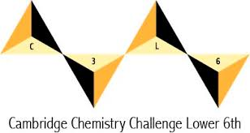 | Find out about the Lower Sixth Cambridge Chemistry Challenge and start training – there is a weekly quiz to try.
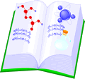 | Read a book. Books that might interest you include Travelling With the Atom, The Science of Cooking, Molecules of Murder and The Disappearing Spoon

Any questions you have before you start then please email Jo Clare, the chemistry course manager joannac@richuish.ac.uk

See you in September

