


CORE MATHS 2026


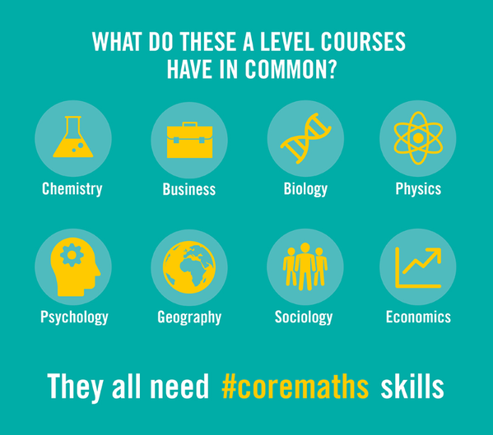
CORE MATHS
What is Core Maths?
https://amsp.org.uk/universities/core-maths

This qualification gives you the mathematical skills to tackle problems in a variety of authentic situations. It enables you to strengthen the mathematical knowledge and skills you learnt at GCSE so you can apply them to the problems you may encounter in further study, life and employment.
“It’s not just skills for the exam.”

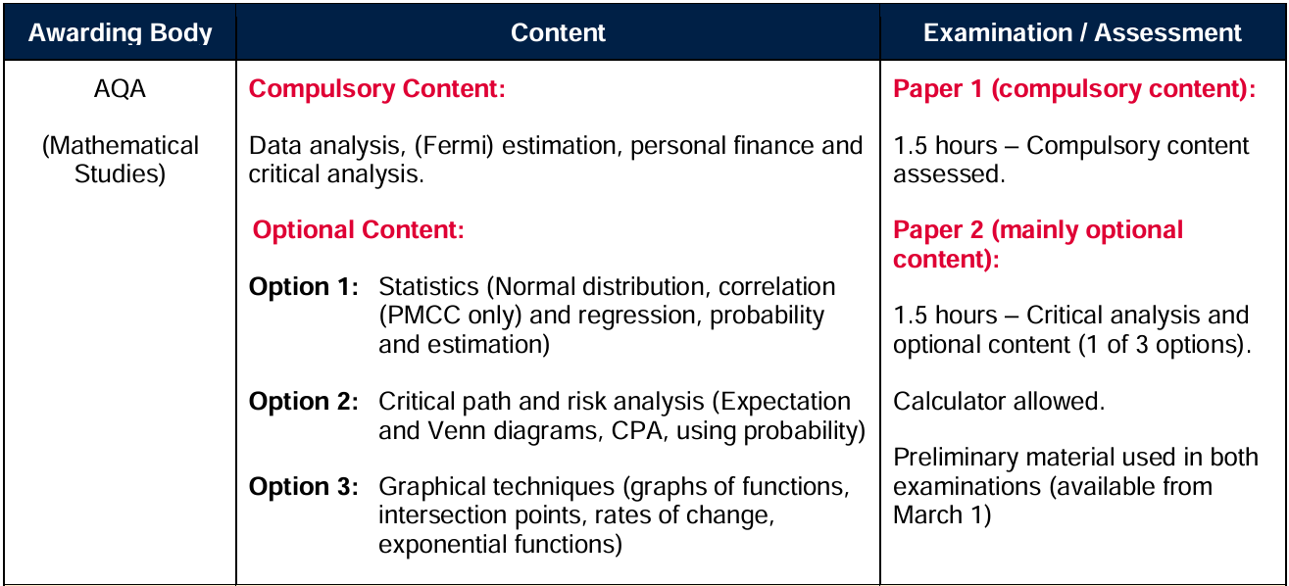
The specification followed at Huish in 2026/2027
https://www.aqa.org.uk/subjects/mathematics/level-three/mathematics-1350/specification
HUISH HEADSTART TASKS
Core Maths at Huish is a 1 year course, usually as a 4th subject alongside 3 A levels. Read through the information and try the TASKS in each section. This will better prepare you for starting Core Maths and/or help you decide if it’s the right course for you.
SECTION A – TASTER QUESTIONS – TASK 1
SECTION B – NUMBERS IS THE NEWS – TASK 2 and 3
SECTION C – GCSE REVISION – TASK 4 and 5

The estimate/suggestion is to spend about 4 hours on these tasks.
If you have any questions, please email loisk@richuish.ac.uk
SECTION A – TASTER QUESTIONS
TASK 1 Classic Core Maths questions to make you think
Have a think about how you would answer these questions. There can be range of answers to Core Maths questions, justifying your decision making process is necessary. Keep all your notes and calculations, be ready to share and compare your ideas in class.
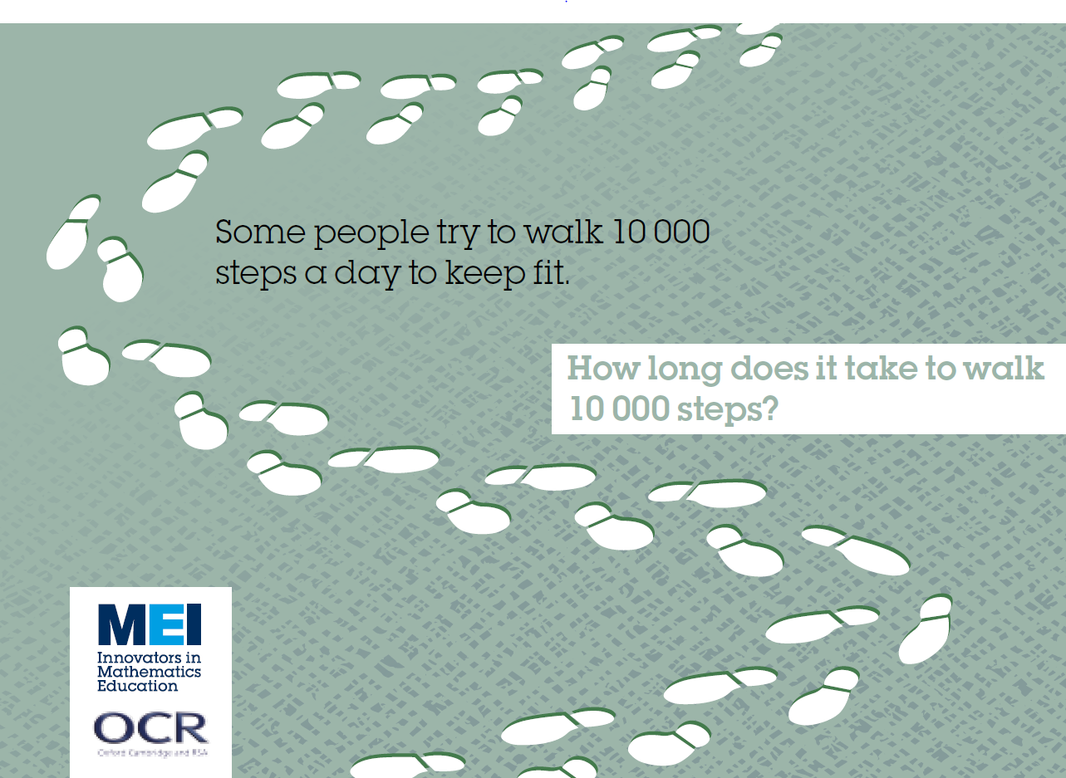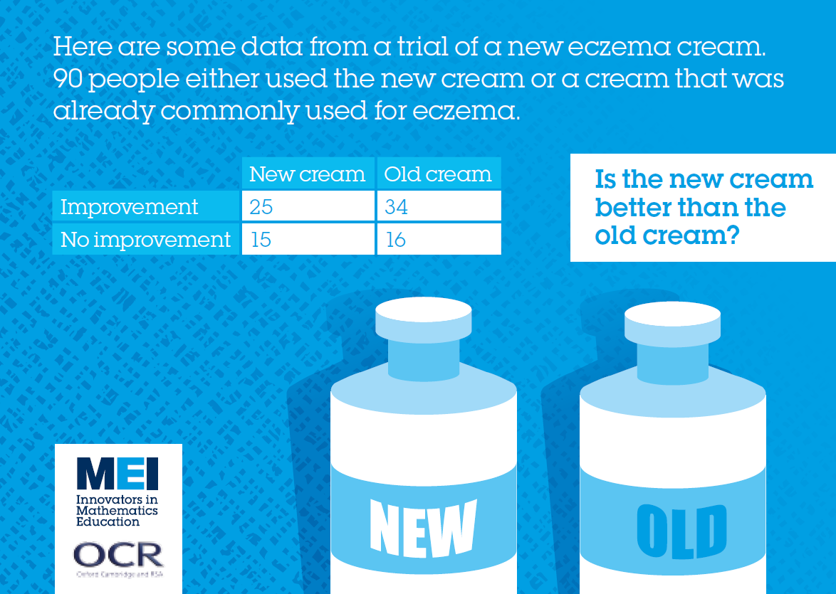
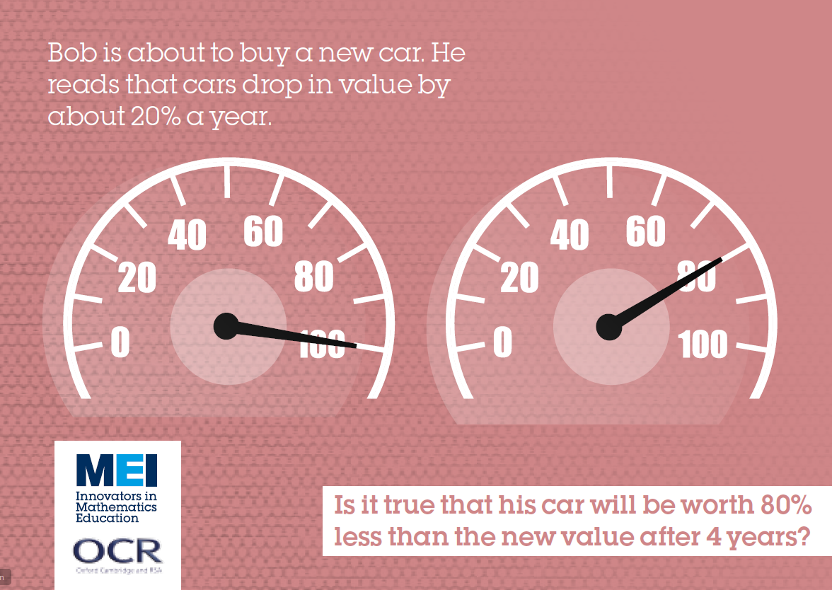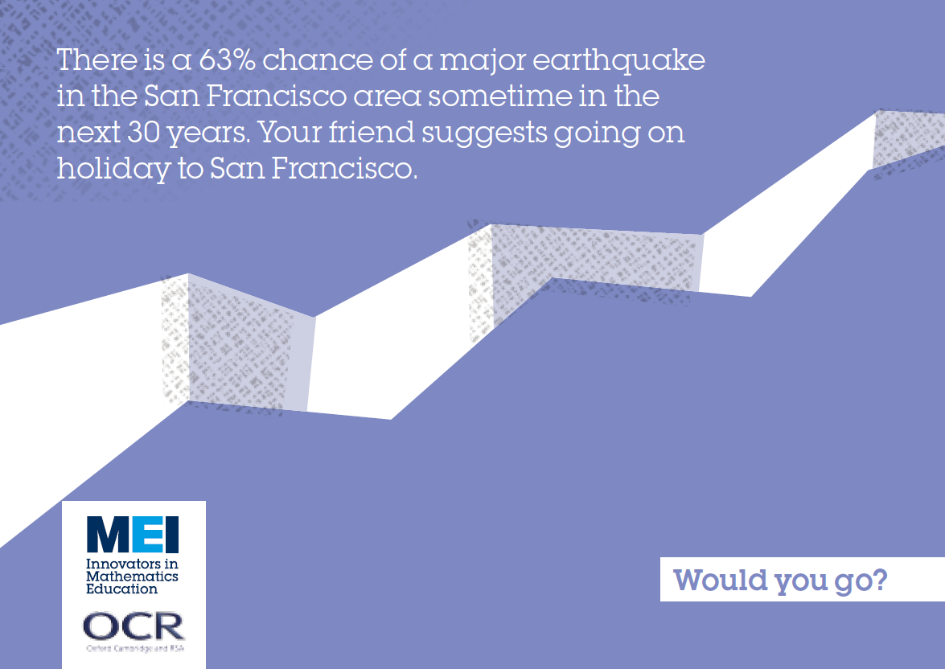
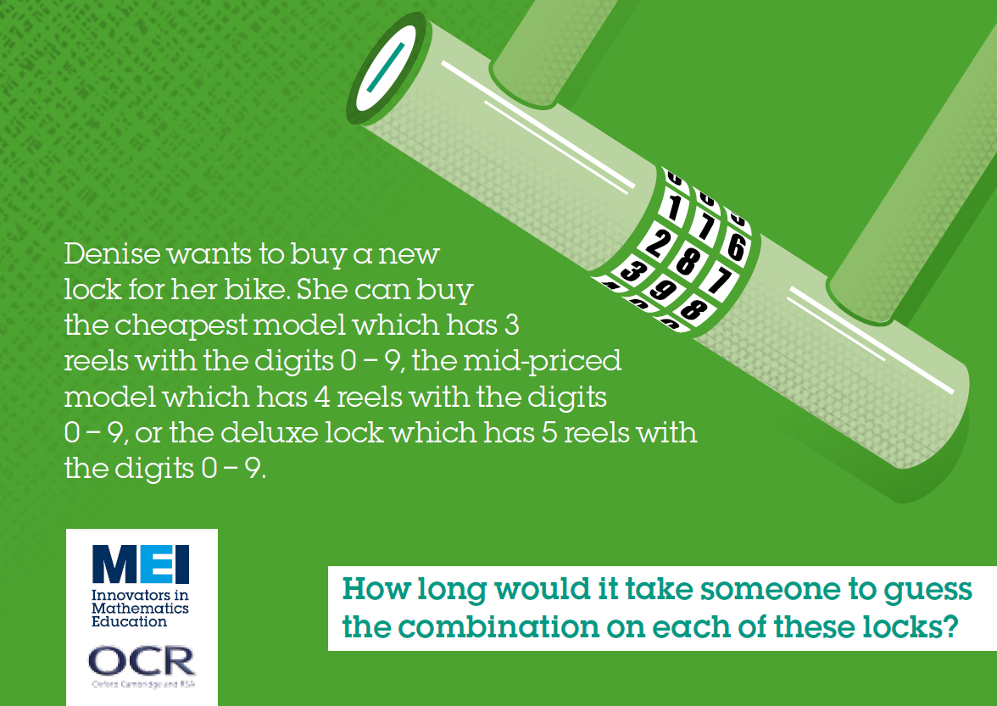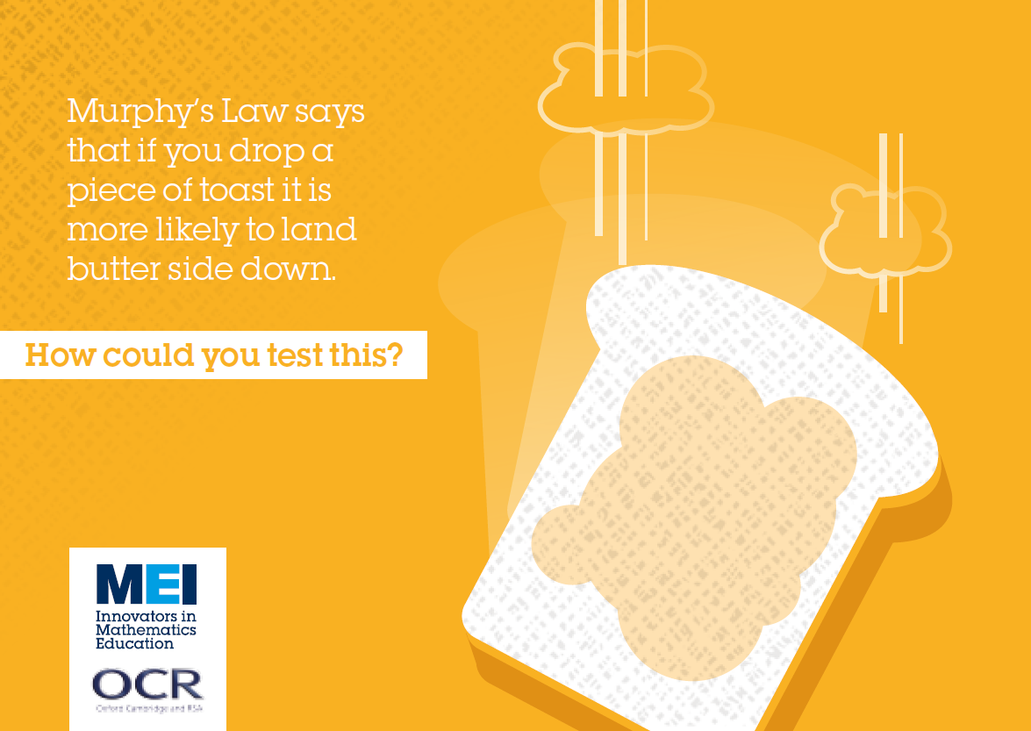

Here is a link to a practice quiz for TASK 1. https://forms.office.com/e/Gsejw9JSSm
At the start of the term I will ask you to complete this quiz again and results will be recorded then.

SECTION B – NUMBERS IN THE NEWS
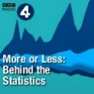
Core Maths is about the maths we see in everyday life. More or Less is an ideal radio programme to improve awareness of the maths and statistics all around us. Tim Harford explains - and sometimes debunks - the numbers and statistics used in political debate, the news and everyday life.
TASK 2
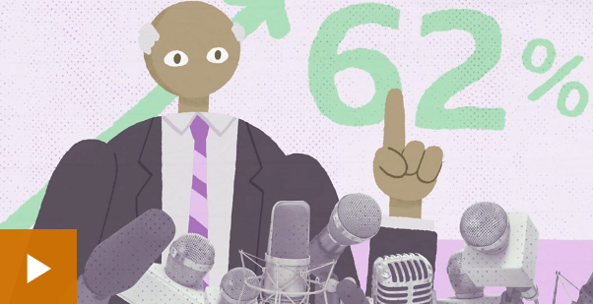
When can you trust statistics?
Watch the video https://www.bbc.co.uk/ideas/videos/when-can-you-trust-statistics/p09l3k0c
TASK 3

Here is an example of a ‘Question inspired by a news story’! Do you trust the numbers in the news? Do you have the maths skills to be able to check the numbers in the news? Try the quiz.
Here is a link to a practice quiz for TASK 2 and TASK 3. https://forms.office.com/e/1JeiAUChFY
At the start of the term I will ask you to complete this quiz again and results will be recorded then.
Cost of pasta and tinned tomatoes jumps as shop prices rise
Work out the missing prices and percentages below.
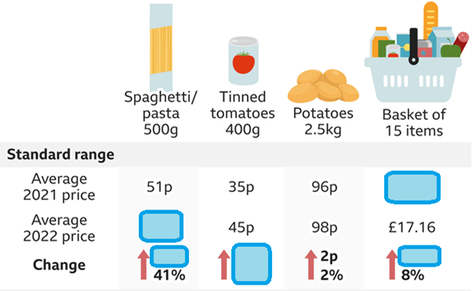
http://quibans.blogspot.com/2022/02/quibans-104-basket-case.html
SECTION C – GCSE REVISION
TASK 4 Topics at GCSE level to know well before starting Core Maths
Thank you to BBC Bitesize for these short online tests. Below are the most relevant and necessary topics to get to grips with before starting Core Maths. Try each test, by clicking on the links below. A calculator is allowed for all questions. Aim for 100%, revise a topic if needed and then try test again.
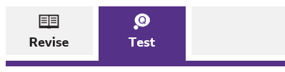 | Done ☑ Scores
Number
Approximation https://www.bbc.co.uk/bitesize/guides/zscq6yc/test
Standard form https://www.bbc.co.uk/bitesize/guides/z8scdxs/test
Financial maths https://www.bbc.co.uk/bitesize/guides/ztkmpbk/test
Algebra
Using and interpreting graphs https://www.bbc.co.uk/bitesize/guides/zpmfgdm/test
Algebraic formulae https://www.bbc.co.uk/bitesize/guides/z36vcj6/test
Ratio, proportion and rates of change
Ratio in context https://www.bbc.co.uk/bitesize/guides/zpxyrwx/test
Percentages https://www.bbc.co.uk/bitesize/guides/z9rjxfr/test
Direct and inverse proportion https://www.bbc.co.uk/bitesize/guides/zqd6srd/test
Geometry and Measure
Units of measure https://www.bbc.co.uk/bitesize/guides/zcwhy4j/test
2-dimensional shapes https://www.bbc.co.uk/bitesize/guides/zgbd2nb/test
3-dimensional shapes https://www.bbc.co.uk/bitesize/guides/zqjhy4j/test
Circles, sectors and arcs https://www.bbc.co.uk/bitesize/guides/zt6vcj6/test
Probability
Probability https://www.bbc.co.uk/bitesize/guides/zsrq6yc/test
Statistics
Representing data https://www.bbc.co.uk/bitesize/guides/zc7sb82/test
Analysing data https://www.bbc.co.uk/bitesize/guides/zwhgk2p/test
Problem solving
Solving ‘number’ problems https://www.bbc.co.uk/bitesize/guides/zwpr8mn/test
Solving ‘graphical’ problems https://www.bbc.co.uk/bitesize/guides/z3jpv9q/test
Solving ‘geometric’ problems https://www.bbc.co.uk/bitesize/guides/z8hgk2p/test
Solving ‘statistical’ problems https://www.bbc.co.uk/bitesize/guides/zydtfcw/test
TASK 5 Optional Extra GCSE Questions
If you are confident with GCSE Maths, wordy questions and enjoy problem solving you are likely to get a high grade in Core Maths. About 30% of Core Maths will be new skills not seen at GCSE. The following GCSE questions look similar to parts of some Core Maths questions. Give them a try and then see the solutions to check.
Try Questions 4, 15, 19, 21 https://ocr.org.uk/Images/563120-question-paper-paper-4.pdf
Solutions https://ocr.org.uk/Images/563142-mark-scheme-paper-4.pdf
Try Questions 5, 7, 9, 11 https://ocr.org.uk/Images/563121-question-paper-paper-5.pdf
Solutions https://ocr.org.uk/Images/563143-mark-scheme-paper-5.pdf
Try Questions 1, 2, 3, 7, 8, 16 https://ocr.org.uk/Images/563122-question-paper-paper-6.pdf
Solutions https://ocr.org.uk/Images/563145-mark-scheme-paper-6.pdf
Be sure to try all of the TASKs, especially if you haven’t done maths for a while. It will help you decide if this course is for you. If you have any questions please email loisk@richuish.ac.uk

