


Vocational Drama

Cambridge Technical Extended Certificate in Performing Arts- Drama
Overview
Year One | Year 2
Proposal for a Commissioning Brief  You will be given the opportunity to develop a community arts project from a given brief. You will consider your creative skills and preferences and think about how these can be utilised in a way that benefits a community or a defined group of participants who may otherwise have little access to the project’s content. You will develop knowledge and understanding of administration and planning as well as the appropriate creative skills and techniques applicable to a project.  ASSESSMENT- Coursework  Influential Performance Practice  You practically will learn about genres, styles and periods, social, cultural and historical influences and significant theatrical/performance developments and practitioners. To help understand the demands of performing a piece of repertoire, you will need to be familiar with the context in which the piece was created and the stylistic conventions of the style or genre into which the piece fits. You will demonstrate the techniques learnt in your own performances.  ASSESSMENT- Coursework and practical work | Performing Repertoire  Repertoire is the collected works of individual practitioners, a canon of work from an art form, the regularly performed pieces of a company or a term that reflects a wider style or genre. You will have an opportunity to work practically within the discipline and demands of a piece of repertoire and be able to put your own mark on the material.  ASSESSMENT- Coursework and practical work  Prepare to Work in the Performing Arts Sector  This unit will give you an understanding of the range and diversity of this industry. You will learn about the jobs and organisations that make up the industry, how it is funded and how companies are supported and regulated. You will perform a monologue that is inspired by the brief along with coursework.  ASSESSMENT- Coursework and practical work  Combined Arts  Few performance companies that you see as part of your course will be exclusively defined by a narrow art form, and some companies positively seek to produce performances which are not easy to define. You will study these historical and contemporary examples to inspire you to make you own piece of combined art.  You will practically explore a range of combined arts during workshops in lessons and then create your own devised work.  ASSESSMENT- Coursework and practical work
Welcome to Huish Drama! Below is a task that will provide valuable information and research skills for when you start the drama course here at Huish.
Please take your time and enjoy researching about these influential practitioners.
I look forward to seeing you in September!
Many thanks
Gemma
Drama Course Manager

TASK 1 (2 hours)
Below is a brief description of three influential practitioners. Some may be familiar to you, but don’t worry if not.
After reading about each one answer the following questions for each practitioner;
1− Give an example where you have either used some of these techniques yourself in a rehearsal/performance and/or seen these techniques being used in a performance (this can include live theatre and TV/film), what was the effect of these techniques?
Example- I used placards in a performance to successfully remind the audience that they were watching a performance/ By ensuring my characterisation was believable I allowed the audience to truly immerse themselves in my performance, creating an emotional response.
2− Create a mind map on each practitioner, you can use the facts given below but also include information from your own independent research.

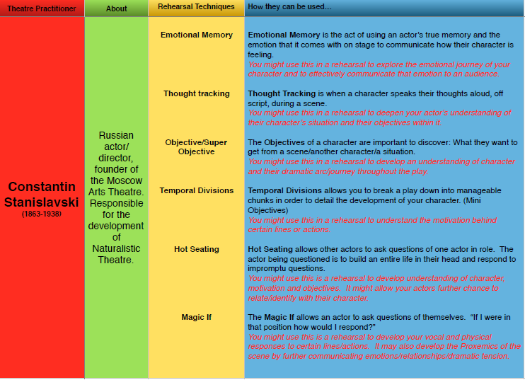

1. Give an example where you have either used some of these techniques yourself in a rehearsal/performance and/or seen these techniques being used in a performance (this can include live theatre and TV/film)

- Give an example where you have either used some of these techniques yourself in a rehearsal/performance and/or seen these techniques being used in a performance (this can include live theatre and TV/film)

- Create a mind map on each practitioner, you can use the facts given above but also include information from your own independent research.

STANISLAVSKI

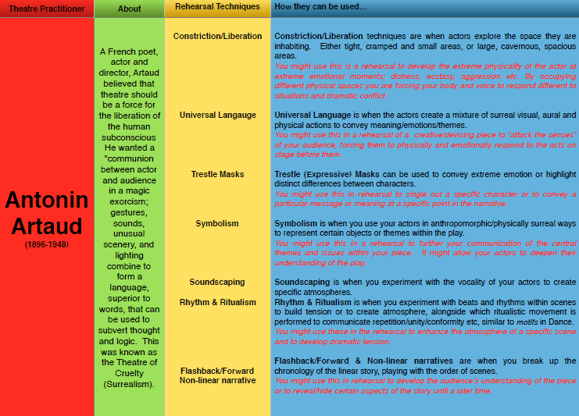

1. Give an example where you have either used some of these techniques yourself in a rehearsal/performance and/or seen these techniques being used in a performance (this can include live theatre and TV/film)

2. Create a mind map on each practitioner , you can use the facts given above but also include information from your own independent research.

ARTAUD

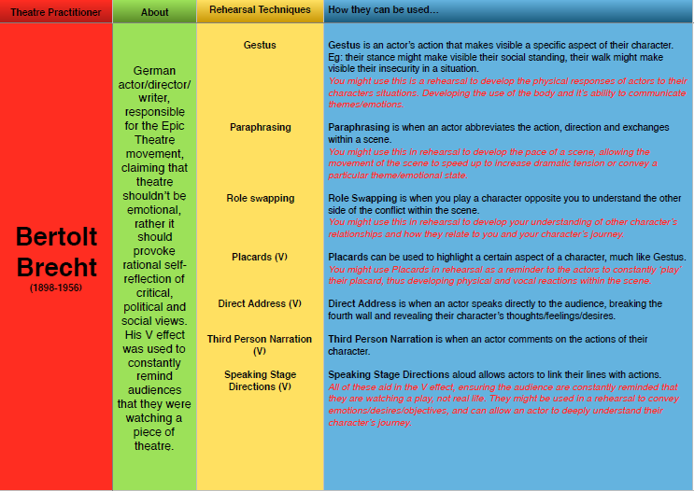

1. Give an example where you have either used some of these techniques yourself in a rehearsal/performance and/or seen these techniques being used in a performance (this can include live theatre and TV/film)

2. Create a mind map on each practitioner , you can use the facts given above but also include information from your own independent research.

BRECHT

TASK 2 (2 hours)
As a part of Unit 2 you will create a commission proposal in response to a brief.
You will need to show understanding of the performing arts industry and the institutions that support it.
Research the following bodies and answer the following questions;
Organisations;
Arts Council Homepage (artscouncil.org.uk)
Equity We are the performing arts and entertainment trade union | Equity
BECTU Bectu
Spotlight Spotlight: The home of casting
Independent theatre council (ITC) Rates of Pay - ITC (itc-arts.org)

Questions to answer;
Who are they?
List 5 key facts about them as an organisation.
What service do they provide?
How do they support the performing arts industry?
What would the impact be if they did not exist?

