


ECONOMICS

WELCOME TO A LEVEL ECONOMICS
There has never been such an interesting time to study Economics. Through A level Economics you will understand the impacts of national and international events, and discuss the ways that the government can overcome the challenges ahead.
Thank you for taking the time to look at the Headstart in A level Economics Booklet. I hope that it will inform you about the content of the course, the skills needed to support your learning, and that it will help to prepare you for the exciting journey ahead.
Have a great summer and I look forward to meeting you,
Liz Voice (Course Manager Economics)

WHAT WILL I STUDY?

MICRO:Individuals, firms, markets and market failure | MACRO: The national and international economy
- Economic methodology and the economic problem  - Individual economic decision making  - Price determination in a competitive market  - Production, costs and revenue  - Perfect competition, imperfectly competitive markets and monopoly  - The labour market  - The distribution of income and wealth: poverty and inequality  - The market mechanism, market failure and government intervention in markets | - The measurement of macroeconomic performance  - How the macro-economy works : the circular flow of income, AD/AS analysis, and related concepts  - Economic performance  - Financial markets and monetary policy  - Fiscal policy and supply-side policies  - The international economy
SUMMER TASKS
- Complete the Initial Numeracy Assessment 1 hour
- Introduction to macro and micro economics. Complete the activities. 2 hours
- Economics in the news – carry out some research, pick 3 articles and produce a short report or mindmap. 2 hours
- Use the context to answer the exam questions. 1 hour
Please bring your numeracy assessment, mindmap and essay to the first Economics lesson.

TASK 1 - INITIAL NUMERACY ASSESSMENT. This should take around 1 hour.
This assessment includes some exam questions (multiple choice).
You may need to use the following formulae to help you:
Fixed costs + variable costs = Total Costs
Revenue – Total costs = Profit
Average costs = total costs / output
Revenue = Price x Quantity
Variable costs are costs that change with output
Fixed costs do not vary with output.

- Simon owns a small juice bar. His two most popular juices are ‘red juice’ and ‘green juice’. Each juice has different ingredients. The cost of ingredients for ‘red juice’ is 60p per juice. The cost of ingredients for ‘green juice’ is 40p per juice. Simon sells 50 ‘red juices’ and 80 ‘green juices’ per day.
Calculate the daily cost of making the red juices.
Show your workings here:

- The price of each juice drink is £2.30. Assuming Simon sells the quantities stated in Q1,

i) Calculate how much revenue Simon earns in one day from selling ‘red juice’ and ‘green juice’. (revenue = price x quantity)
ii) Calculate the profit Simon makes (profit = revenue –costs).
Show your workings here:

- Simon decides to increase the price of his juice drinks by 20%. Sales of ‘red juice’ fall by 10% and sales of ‘green juice’ fall by 5%.
Calculate Simon’s new level of revenue.

- Geoff sells a house for £650,000 in Harrogate. The estate agent is paid 1.5% of the selling price for her services.
Calculate how much she is paid. Show your workings here:

- Geoff buys a new 1-bedroom apartment in London with the proceeds from his house sale in Harrogate. The apartment costs him £500,000 to buy. This time he has to pay Stamp Duty tax on his purchase. Stamp Duty tax at this price is 3%.
How much stamp duty tax does he pay? Show your workings here:

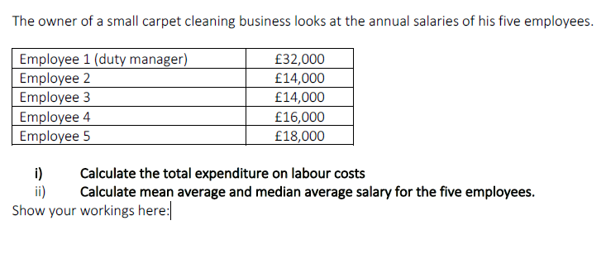

7. The boss hires a sixth employee to the business. The employee is highly experienced and very skilled. As a result, she commands a relatively high salary of £26,000.
i) Calculate the extra cost of the additional employee.
ii) Calculate the change in the mean average salary in the business.
iii) Calculate the new median average salary for the employees of the carpet cleaning business.
Show your workings here:

8.Nomo takes a loan from a payday company. Nomo takes a £300 loan at 0.8% per day.

How much will Nomo owe the lender after a week? Show your workings here:

9. A British-made car costs £20,000. The current exchange rate is £1 (UK pound) to $1.30 (US dollars). 6 months ago, the exchange rate was £1 to $1.50.
Calculate how much the £20,000 car costs in US dollars i) now and ii) 6 months ago.
Show your workings here:

10. Canada has a population of 36.2 million people. Canada has a total national income of $1.6 billion. Calculate the average income per person.
Show your workings here:

11.
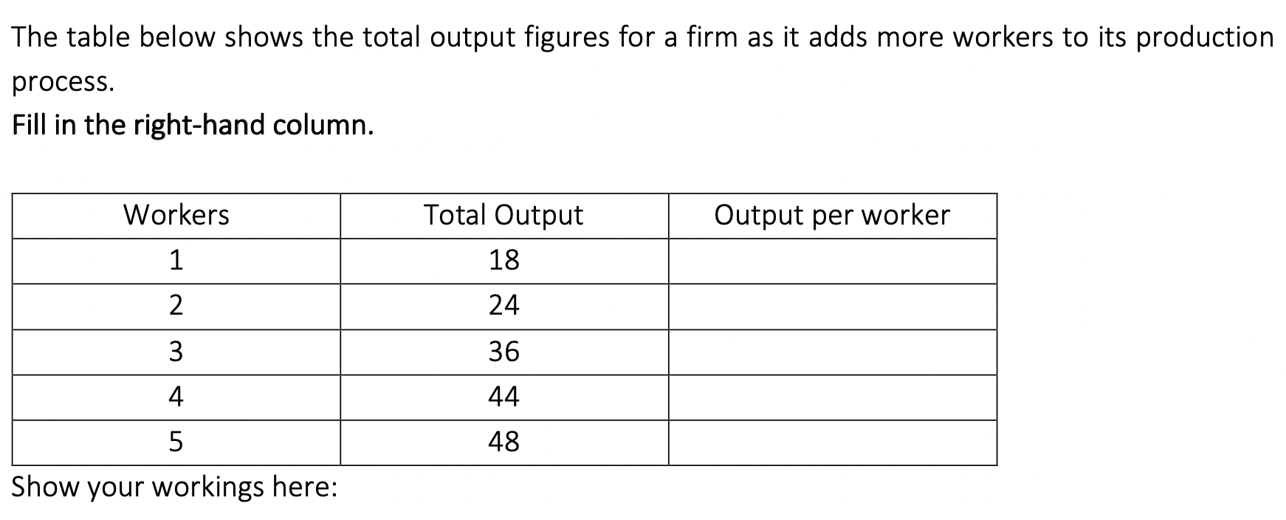

12. 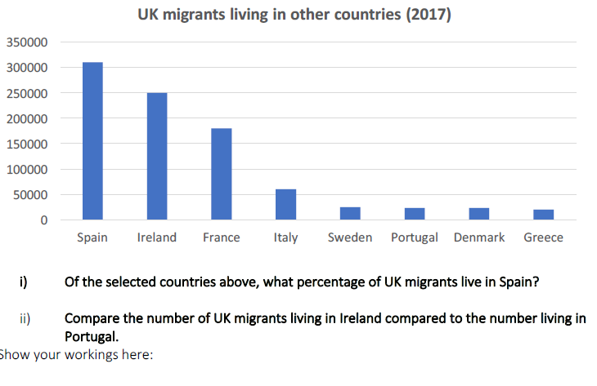

13. Antonio sells ice creams in the local park. In a typical week, he sells 500 ice creams at £2 each and his total costs are £700. One week he does not work, so he sells no ice creams but his total costs are £200.
What are his variable costs in a typical week?

A | £200
B | £300
C | £500
D | £700

14. The table below shows the total cost at different output levels for a firm.

Output (units) | Total cost (£)
1 | 10
2 | 16
3 | 21
4 | 24
What is the average cost of 3 units of output?

A | 3
B | 5
C | 7
D | 63
15. Ben owns a small business that makes hand-made guitars.
One year he sells 160 guitars, his total revenue is £78 400, and his total costs are £59 200.
The average profit that Ben earns on each guitar is

A | £120
B | £370
C | £490
D | £860

16. Claire’s sweet stall in Chorley market sells sweets in 100g bags. She has the following costs of production:

Stall rental | £25 per day
Sales assistant’s wages | £32 per day
Various varieties of sweets | £0.26 per 100g
Paper bags | £0.01 per bag
Assuming Claire sells 100 bags of sweets per day, what is the average cost of a bag of sweets?

A | £0.57
B | £0.59
C | £0.83
D | £0.84

17. A firm manufactures and sells fresh fruit drinks. The firm sells 200 bottles of fruit drink each week; its weekly total costs are £540, which includes £300 of fixed costs. The drink is sold at £4 a bottle.
A rival firm drops out of the market and sales increase to 250 bottles a week. Other things remaining the same, profit per week increases by

A | £65
B | £125
C | £140
D | £400

18. One week, a business has to pay £80 interest for its loan, £95 for raw materials and £210 on rent. If the business has no other costs, what are its fixed costs for that week?

A | £210
B | £290
C | £305
D | £385

TASK 2 – Watch the videos on economics, and complete the student activities.
You will need to use the link below to access the videos and student activities on- line.
This should take around 2 hours.

https://www.tutor2u.net/economics/reference/head-start-economics-introduction-to-macroeconomics

What is the Difference between Micro and Macroeconomics?
What is the difference between micro and macroeconomics? This short video explains the difference for all students just about to begin their studies of Economics
Microeconomics considers the economics of everyday life, the decisions that we as households take and the impact of businesses in different and often related industries.
Macroeconomics is the study of the economy as a whole and it also analyses the global (international) economic system.

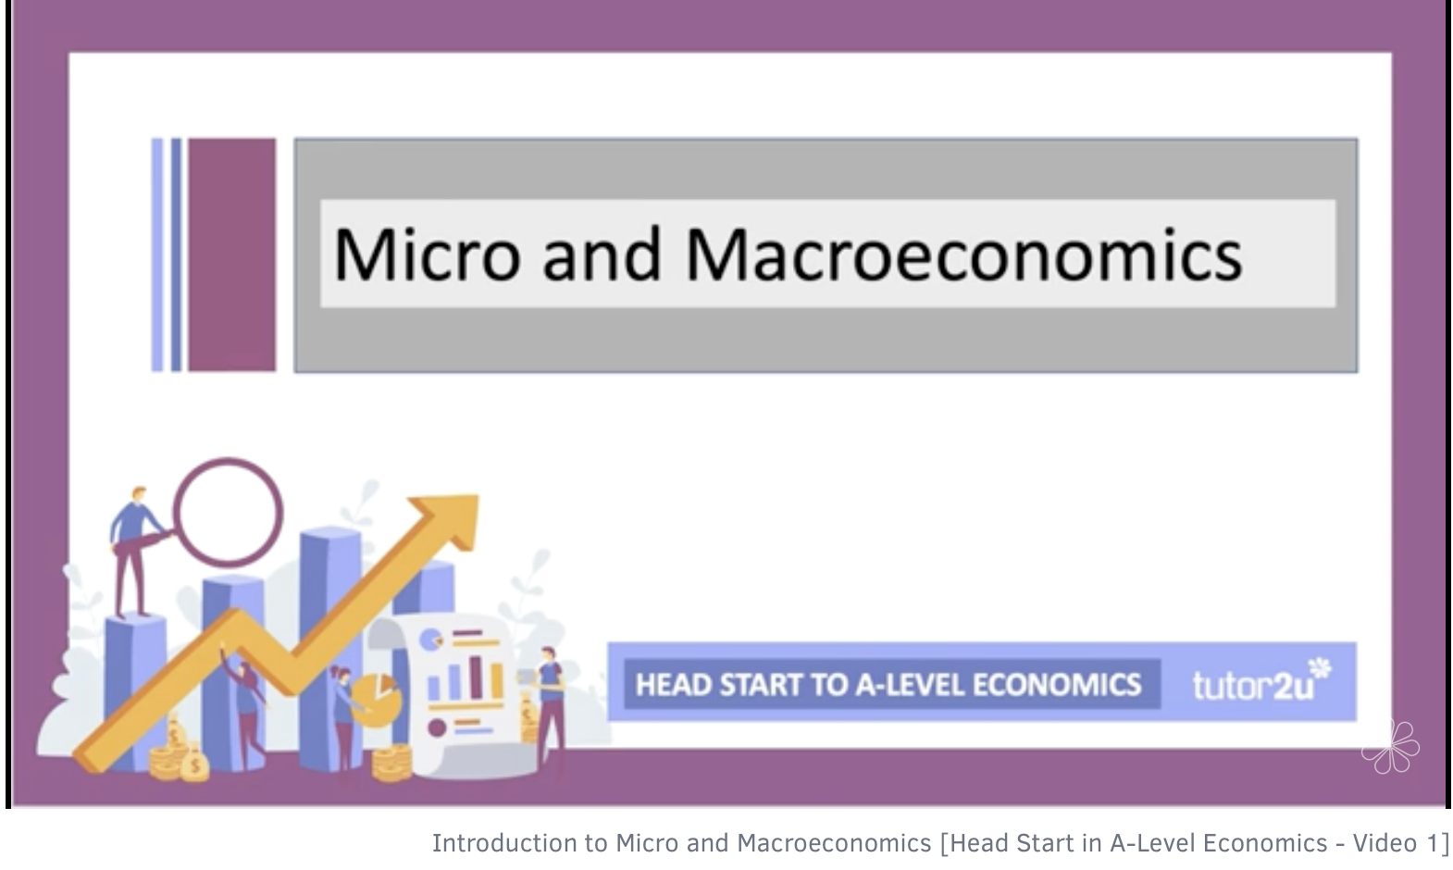

Measuring Economic Activity - Gross Domestic Product
In this second introductory video, we introduce a key concept – gross domestic product – a measure of economic activity.
Gross domestic product measures the monetary value of a country’s output of goods and services. GDP remains an important indicator for many including the financial markets. GDP as a concept that dates from the second world war and the Great Depression when politicians wanted to have a measure that set out what was happening to the economy as a whole.
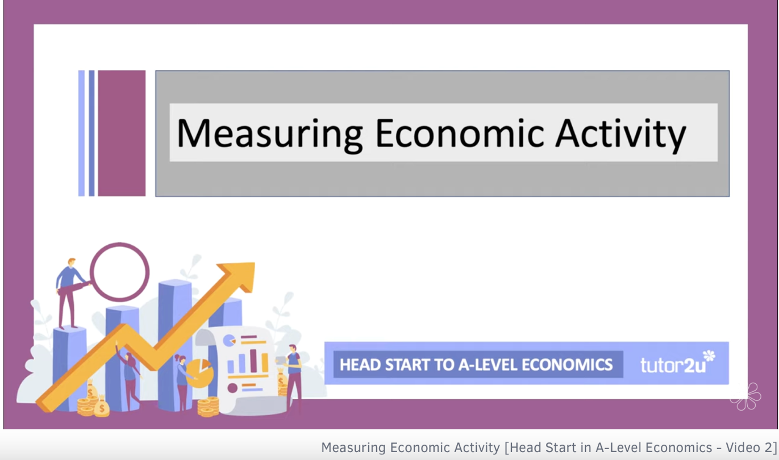

Try an Activity!
Can you get five in a row? You will be given five countries and have to decide whether their per capita national income is higher or lower than the preceding country! Good luck!
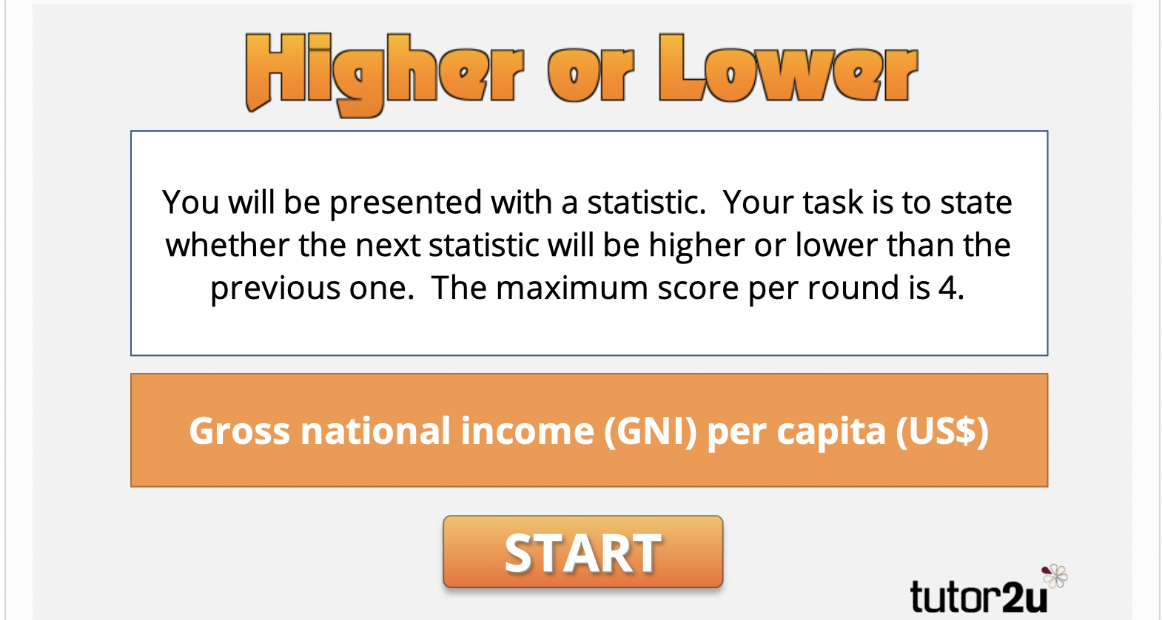
The Changing World Economy
In this video we build on our initial introduction to GDP (gross domestic product) to look at the largest economies in the world. We rank which countries are the richest and poorest in the world using GDP per capita as a guide. Finally we also explore how the balance of world national output is changing.
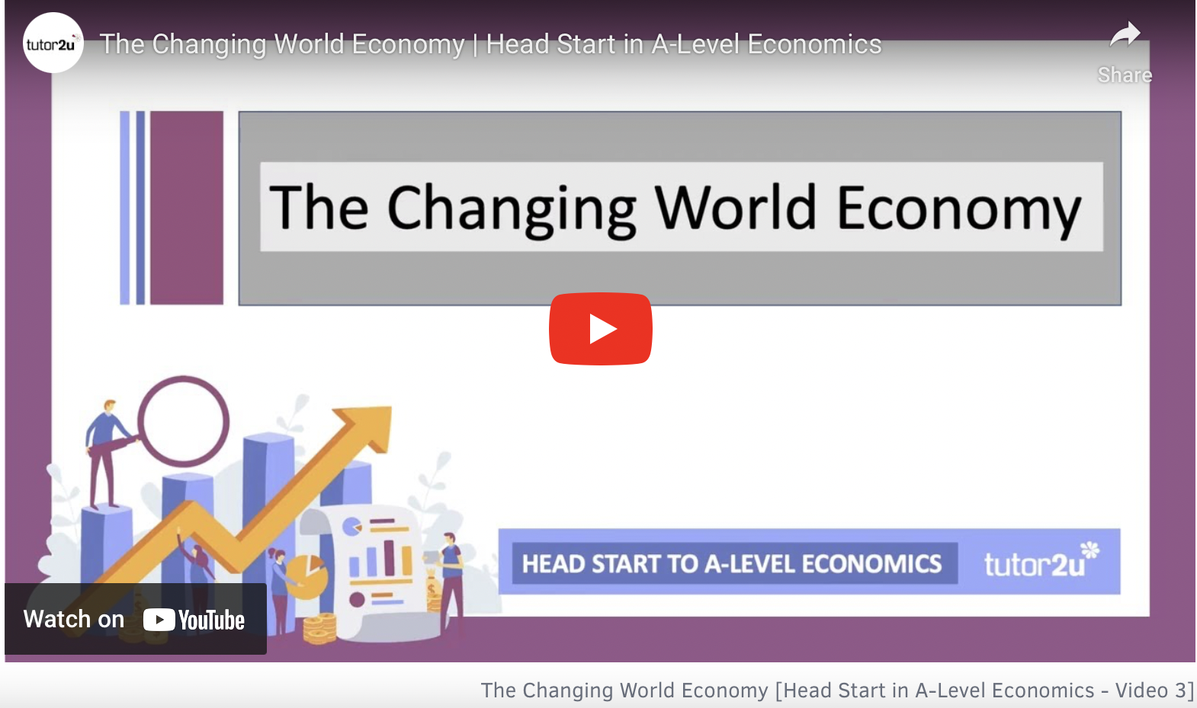


TASK 3 – Economics in the News Research Activity.
Use the following link to research Economics in the news.
https://www.bbc.co.uk/news/business/economy
Choose 3 articles and use them to produce either a short report or a mindmap explaining the key issues. Bring this to your first Economics lesson. This should take around 2 hours.
Examples of articles include:


TASK 4 – Use the context to answer the exam questions.
ESSAY STRUCTURE FOR THE 25 MARK ESSAY
INTRODUCTION – include a brief explanation of the question – who gets a bus pass and who funds it?
YES ARGUMENTS– use the context to identify reasons why free bus travel to all or some elderly people is important. How will the individuals or the economy benefit?
NO ARGUMENT – use the context to identify reasons why free bus travel should not be given to all elderly people.
CONCLUSION – answer the question and justify it – should free buss travel be given to all, some or no elderly people? Why have you made this decision ? What might it depends on?
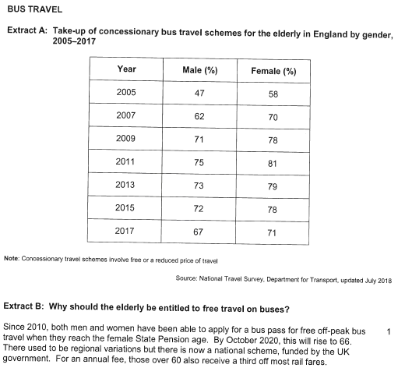
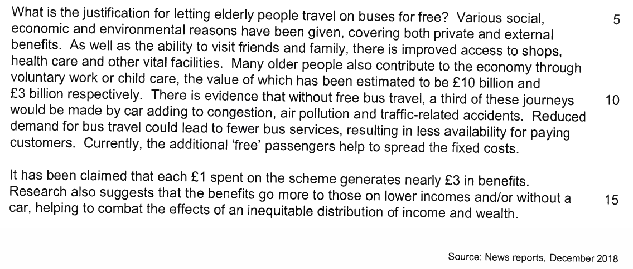

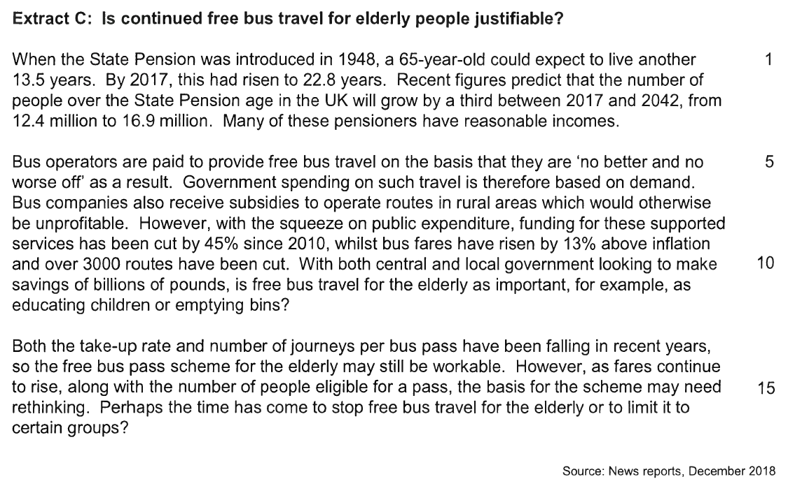
QUESTIONS

