


Further Mathematics

FURTHER MATHEMATICS

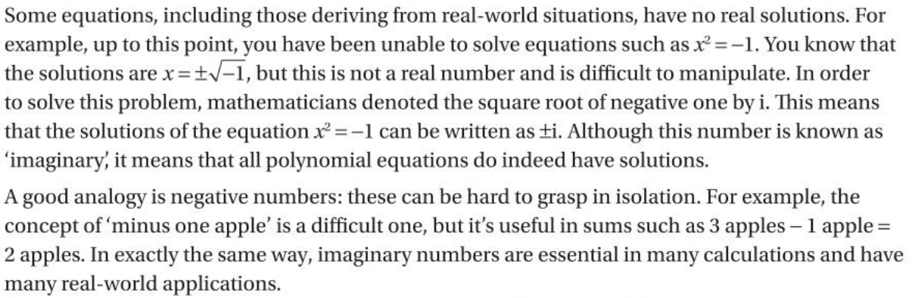
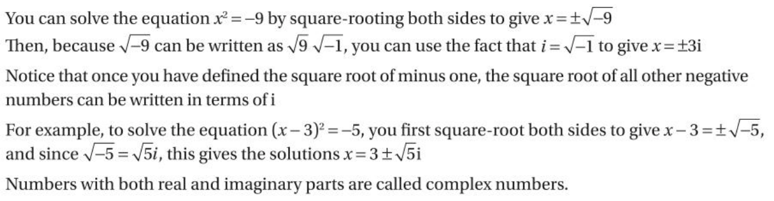

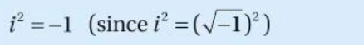
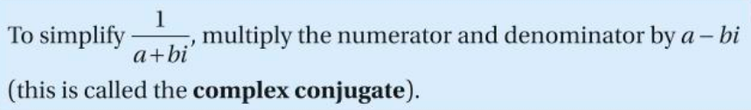
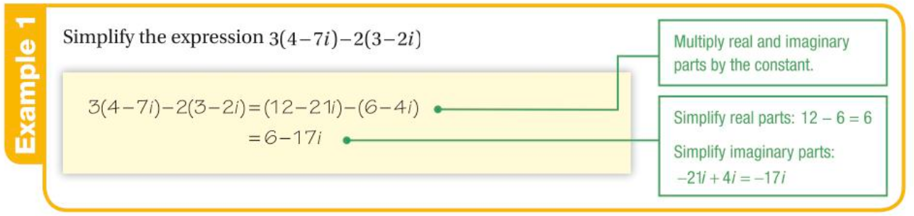
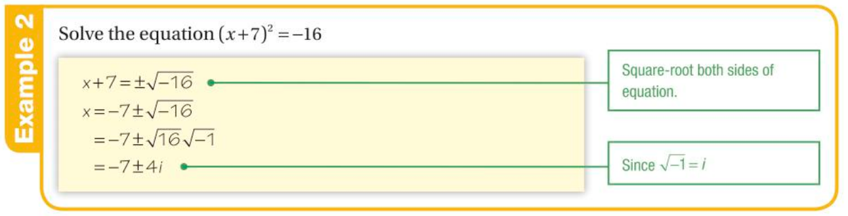

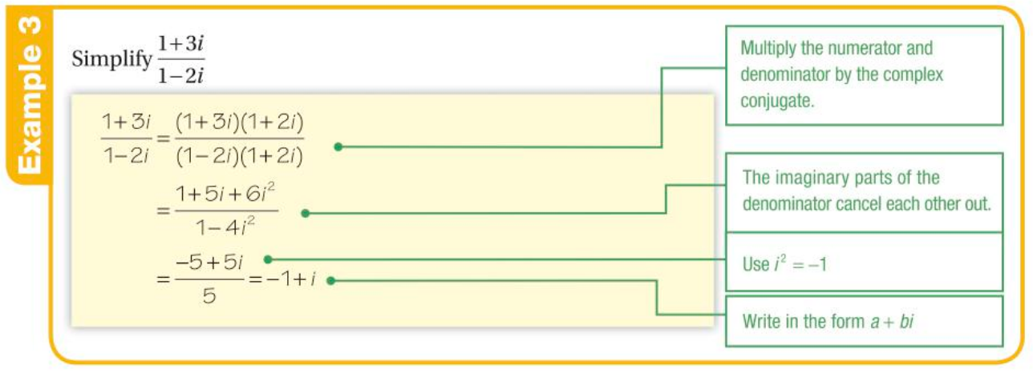

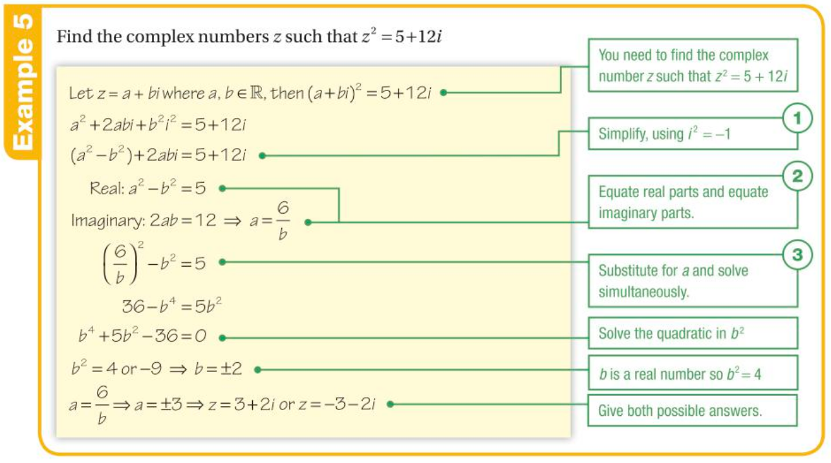

You can watch the following videos to help you with the exercise:
Real and imaginary numbers - ExamSolutions | Further-Core-Maths-A-Level | A-Level | AQA
Addition, subtraction and multiplying complex numbers and simplifying powers of i - ExamSolutions | Further-Core-Maths-A-Level | A-Level | AQA
Complex conjugates - ExamSolutions | Further-Core-Maths-A-Level | A-Level | AQA
Division of a complex number by a complex number - ExamSolutions | Further-Core-Maths-A-Level | A-Level | AQA

Consolidation example
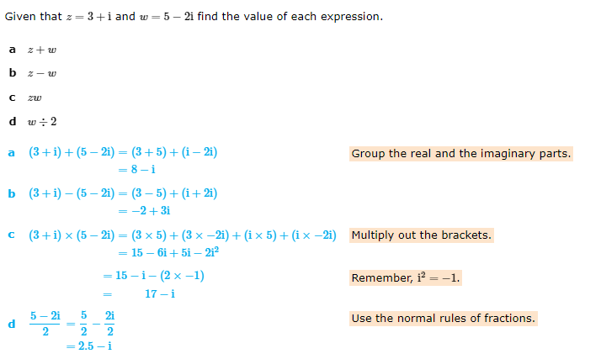

Exercise. (Please show your workings).

1. Simplify expression:
(a)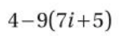

(b)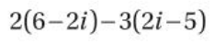

(c)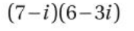

2. Solve equations:

(a) 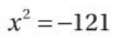

(b) 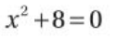

(c) 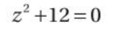

3.
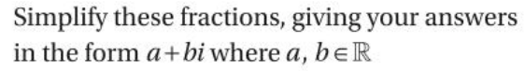
(a) 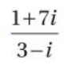

(b) 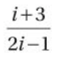

(c) 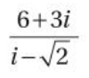

4.
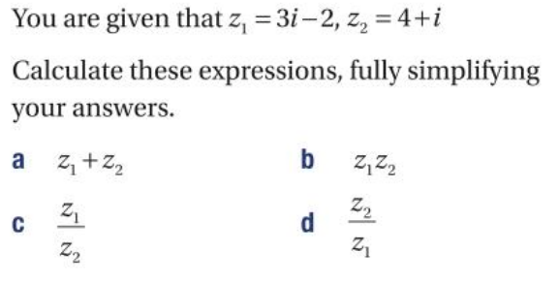

5. (Challenge)
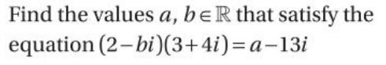

Answers:

1. (a) 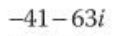; (b) 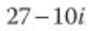; (c) 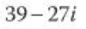
2. (a) ; (b) 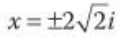; (c) 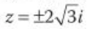
3. (a) 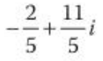; (b) 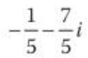; (c) 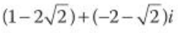
4.
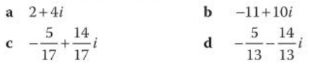
5. 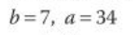

Assignment

1.
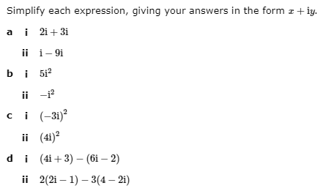

2.
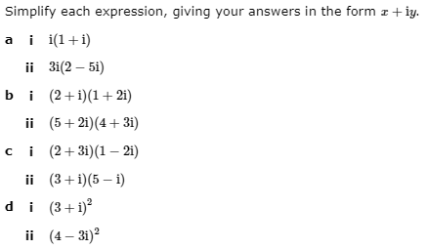

3.
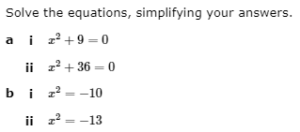

4.
