
GEOLOGY
Exam board is EDUQAS

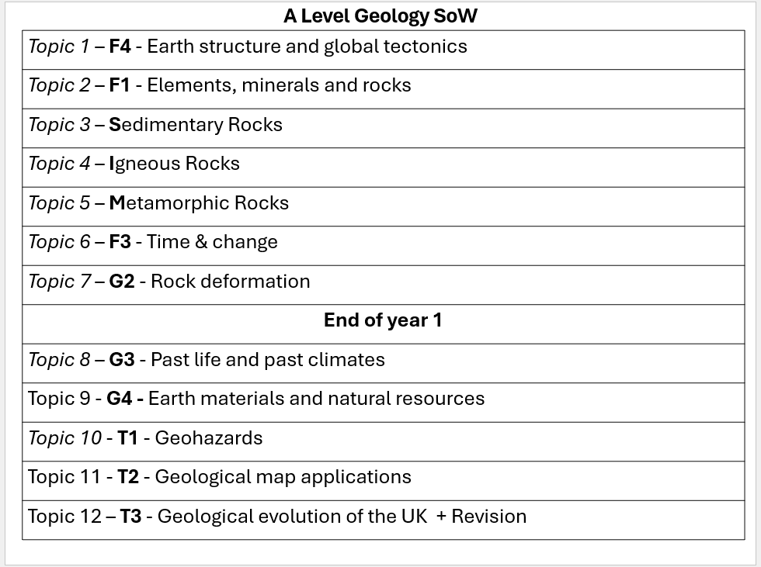
Overview of the A level = 3 exams

1 = Component 1: Geological Investigation. Practical examination with specimens and cross section map construction. Written examination: 2 hour 15 minutes. 35% of qualification

2 = Component 2: Geological Principles & Processes. Written examination: 1 hour 45 minutes. 30% of qualification. Wide range of questions all based around a resource (map, diagram, graph etc).

3 = Component 3: Geological Applications. Section A: Geohazards. Section B: Geological map applications. An investigation of the geology of an area shown on a Geological Survey map extract using stimulus response question. Section C: Learners answer questions on one option from a choice of three. Each comprises three questions requiring short, structured and extended answers. • Geological Evolution of Britain. Written examination: 2 hours. 30% of qualification.

FAQs

- You do not need to have done GCSE Geography? It will be helpful but not essential
- There is maths in geology? It is a science A level so 10% of the A level exam questions will be maths based.
- How will Iearn? Practically where possible. No coursework! No essays! Lots of resources to help in the exams. 5 fieldtrips over 2 years!

Welcome to Huish – Geology Summer study

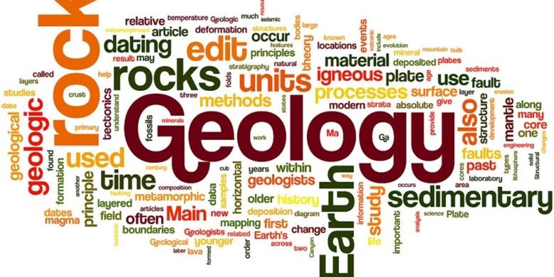

Task 1 – Learn the geological periods of time.
- Time - 3 lots of 20 minutes of learning. This is called spaced learning.
- How? - You need to learn the mnemonic for the periods then devise you own way of learning the Eons and Era’s. I want to see evidence of quizzing your self – this is going to be a feature of the course. It is an important part of learning.
You do not need to know the dates!
- To hand in – I would like to see evidence of learning – hand-written notes showing repetitive learning and quizzing of yourself. There will be a quick test in the first couple of lessons!
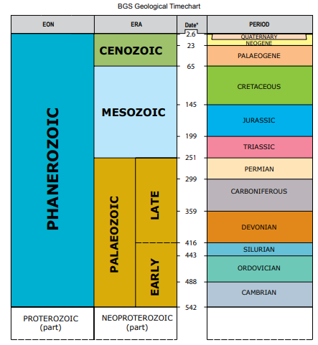
Quietly – Quaternary
Too – Tertiary (name for Palaeogene + Neogene)
Creak – Cretaceous
Joints – Jurassic
Their – Triassic
Perhaps - Permian
Carefully – Carboniferous
Down – Devonian
Sit – Silurian
Often –
Ordovician

Camels – Cambrian
Pregnant – Precambrian
Pre Cambrian

Read upward

Task 2 – Mini Project – The history and evidence of plate tectonics.
- Time – 2 hours
- How? – Once you have examined the resources below to collect information you are to produce an infographic (posh poster) with the title - The history and evidence of plate tectonics. This can be done hand written or digitally.
What to write up / subheadings
History of the theory – Geosyncline model à continental drift à passive plates / active plates à Sea floor spreading
Evidence for plate tectonics à Continental fit (jigsaw) à Rock types à Fossils à Mountain ranges à Glaciation à GPS
- To hand in – Criteria for success = summary of the information.
I would like to mark the infographic – hand-written notes / images / print offs that are annotated.
Resources
1 - Watch the film = The Development of Plate Tectonics – Professor Dave Explains = 9mins14
2 – Read info
a) Click on each ‘Pioneer’ to understand more The Geological Society (geolsoc.org.uk)
b) Dynamic Planet/Tectonics - Wiki - Scioly.org
c) Chapter 2 - 2 Plate Tectonics – An Introduction to Geology (opengeology.org)

Task 3 – Produce a response to the podcast – The infinite Monkey Cage podcast series – Series 23 – The History of Rock - Here is the link.
- Time – 2 hours
- How? – Once you have listened to the podcast (you will need a BBc account – this is free to sign up) produce a response
- To hand in – Criteria for success = Effort - I would like to mark your response so get it ready to hand in
By response I mean anything you want!
Comic strip?
Annotated doodles?
Poster?
Mind blurt?
Flow diagram?
Painting? Set of illustrations?

