


Late Modern History

Preparing for A Level History (Late Modern course).
This booklet should take approximately 4 hours to complete. You do not need to print this booklet.






Is Late Modern History for you? Would you like to:
- Explore sources and interpretations of the past?
- Understand more about the modern world?
- Enjoy learning about people, ideas and structural forces?
- Develop the Higher Order Thinking Skills (HOTS) that employers and universities value, such as: critical thinking, coherent communication, collaboration and creative problem solving?
What do we study?
- a breadth study of the British Empire c1857-1967 (examined)
- a depth study of the Cold War c1945-1991 (examined)
- Non-Examined Assessment on c100 years of history
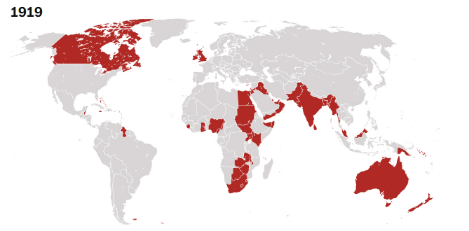
British Empire c1919
Our first unit is The British Empire c1857-1967:
Activity 1 – Find a fact about each of these places when they were part of the British Empire:
- Dublin
- Calcutta
- Cape Colony
- Sierra Leone
- Singapore
- Columbo
- Hong Kong
- Cairo
Activity 2 -Read this overview and answer the following questions:
In 1857, Great Britain possessed a vast territorial empire which was spread across all continents of the world. Britain's possessions had eclipsed those of its former rivals — the Portuguese, Spanish and Dutch, who had dropped out of the competition for overseas colonies, and France, whose possessions were limited to Algeria and some islands in the Pacific. Germany, a country that was to become a rival in the 1890s, did not even exist as a united country in Europe until 1871. At its greatest extent, the British Empire comprised over 13 million square miles and covered nearly a quarter of the earth's land-surface. It ranged from tiny islands to large land masses and was connected by an elaborate system of trade-routes and 'coaling stations'.
Although the British Crown and Parliament exercised ultimate authority over the Empire, the actual business of governing varied. A representative system, with a royal governor and a local assembly, had been established in Britain's older West Indian colonies and in Canada, Australia, New Zealand
and on the South African Cape. These 'colonies of settlement' were so- named because they were peopled by white settlers who had usually gone to the colonies in search of land. From around the middle of the nineteenth century, these areas (although not the West Indies) moved to 'responsible
government'. This meant that they had their own government ministers who were answerable to their individual elected parliaments, in a system of government similar to that in Britain itself. Around the turn of the twentieth century these internally self-governing colonies became known as Dominions. British authority over them was finally removed between 1926 and 1931, although the
title "Dominion' continued until after 1945.
Much of the remainder of the Empire was made up of Crown colonies. In 1857, these included areas which had been developed for trading purposes, such as Trinidad, Ceylon, various Pacific islands and parts of West Africa, and places like Gibraltar, Malta, Hong Kong and Singapore, which were naval bases or ports along the world's trade routes. The number of Crown colonies was set to expand in the later years of the nineteenth century as more of the African continent fell into British hands. The population in the Crown colonies was overwhelmingly non-European and therefore, to the nineteenth-century mind, incapable of self-rule. These colonies were administered directly by a
governor appointed by the British Crown. It was only in the twentieth century that local legislative (law-making) councils were gradually established; most of these colonies gained full independence after the Second World War.
There were also territories in 1857 that were influenced by the British, even if not ruled directly by them. In these, British traders, backed by the powerful British Navy, which was the largest in the world, had established bases through conquest or advantageous deals with local rulers. Thus, much of Malaya had come to be controlled from Singapore and long stretches of the Chinese coast
from Hong Kong. These areas are sometimes referred to as 'informal empire' although in the later nineteenth century the term 'protectorate' came into use for areas where rulers kept their own sovereignty but were 'protected' by the British Crown. Thus the lands of the Malay sultans became a 'Protectorate' in 1895; and Egypt, which Britain 'occupied' from 1882, was made a formal
protectorate between 1914 and 1922.
There was yet another type of rule added to the complex pattern of empire in the aftermath of the First World War. Some of the former provinces and imperial possessions of the defeated Turks and Germans were transferred, under the auspices of the peace-keeping body, the League of Nations, to
Britain as 'mandates'. These included 'Transjordan and Iraq, which were treated as protectorates, and Palestine and the German African colonies, which became Crown colonies.
Finally, there was India — 'the brightest jewel in the Crown' according to Disraeli in 1876, which had eclipsed the West Indies as the most important of Britain's possessions by the mid-nineteenth century. India stood apart from the rest of the Empire, not only because of its size, importance for trade, riches and immense population (expanded with the acquisition of the Punjab in 1849 and Lower Burma in 1852), but also because it had its own unique system of rule. Until 1858, India was governed by a trading company (the East India Company) on behalf of the Crown, and large parts of it (the Princely States) had been bound to the British Crown by treaties and thus were 'protected' in return. However, from 1858, the Crown assumed direct control — although the Princely States retained their status. India became known as the Raj and from 1876, British monarchs took the title Empress or Emperor of India. India was granted a limited form of representative government, but in practice, the British retained a firm grip until internal movements for independence forced change in the twentieth century. India and Pakistan gained independence in 1947.
While the British Empire was a confusing mix of self-governing dominions, Crown colonies, protectorates, mandates, the Raj and 'informal empire', its establishment and growth nevertheless led to the spread of British influence throughout the globe and helped to shape the world around us today. At its height, Britain was responsible for ruling 500 million people — more than a fifth of the world's population — and this position was retained until the Second World War. No country could experience such pre-eminence without being itself changed by the experience. Britain's interaction with its empire affected the British nation, economically, politically and culturally. Even after changed world circumstances and the rise of nationalism forced a period of decolonisation between 1947 and 1967, the imperial legacy remained a potent force.


- Identify 3 different types of British rule within the Empire:

- Identify one similarity in the nature of British rule:

- Suggest 3 ways that the British gained from controlling the Empire:

- Suggest 3 words to characterise the British Empire:

Activity 3. Causes of expansion.
- Link the territory to a key reason behind British control -
- Calcutta | 1) Naval port and trading base for the East India Company established by Stamford Raffles
- Rhodesia | 2) occupied by the British from 1882 to protect financial investments and the Suez Canal
c) Singapore | 3) East India Company base in India established by Robert Clive
d) Hong Kong | 4) established by Cecil Rhodes and his company, the BSACo, using mercenaries to seize land from tribal leaders
e) Iraq | 5) rented to Britain by China from 1842 after their defeat in the 1st Opium War. Important trading and naval base
f) Egypt | 6) handed to Britain after victory in WWI
b) From the information above, suggest 3 factors driving the expansion of the British Empire:


Key Skills: Research, Reading, and Note-taking.
Activity 4:
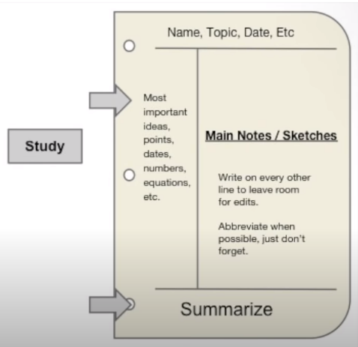
Taking accurate and useful notes is an essential part of being a successful student, there are different methods to practise to improve this skill. Try to experiment with different formats. Use the following links for ideas on:
Cornell note taking: https://www.youtube.com/watch?reload=9&v=ErSjc1PEGKE
Dual-coding https://www.learningscientists.org/dual-coding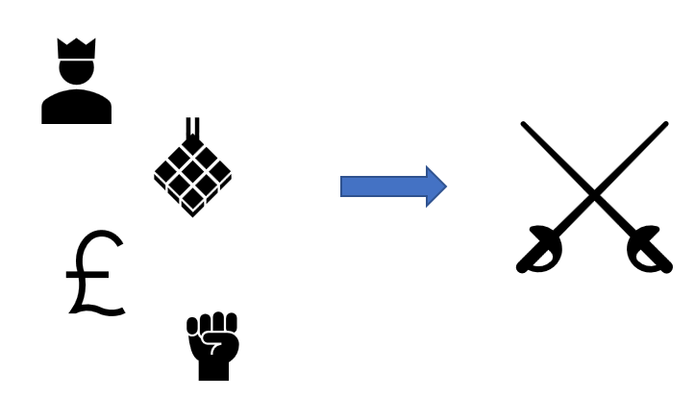
Mind-mapping https://app.mindmapmaker.org/#m:new
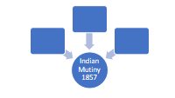
Use one of these techniques, or combine them, , to create notes to answer the following question:
- Watch History KS3: Conflict and Mutiny - BBC Teach
- Read Indian Mutiny, 1857 - 58 (britishempire.co.uk)
- Create notes to identify 3 causes of the Indian Mutiny/First War of Independence

- Extension activities – Try watching/listening to/reading one or more of the following and practice your note-taking ( eg Cornell, dual-coding, mind-mapping)
Ferguson documentary https://youtu.be/moZN2UZ1k60


Empire Podcast


Olusoga article David Olusoga: ‘There’s a dark side to British history, and we saw a flash of it this summer’ | History books | The Guardian


British Empire article The Presence that Changed the World (britishempire.co.uk)


To do list:
- Activity 1 – complete the map task pages3-4
- Activity 2 – check you understand the extract and answer all the questions pages 4-6
- Activity 3 – match the territories to the causes of expansion and answer the question page 6
- Activity 4 – consider different note-taking techniques and complete the question on the Indian Mutiny, 1857.page 7
- Optional – extension activities, page 8
- Optional – watch/listen to the news/current affairs programmes to make links with the legacies of the British Empire eg
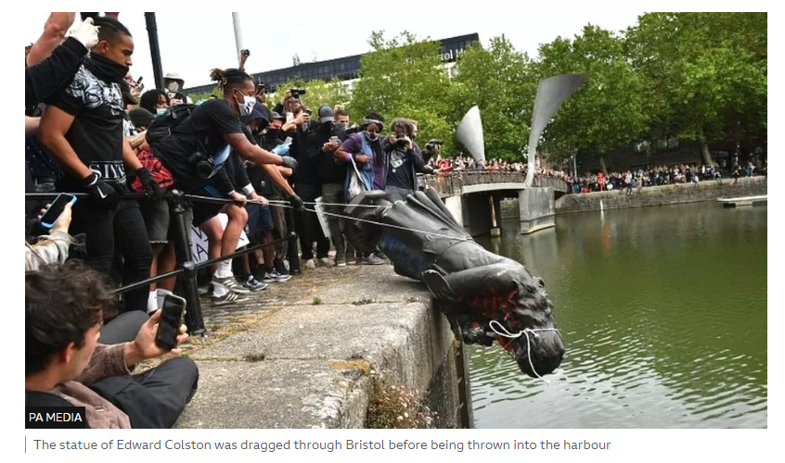
Edward Colston: Bristol slave trader statue 'was an affront' - BBC News
Resources

- The list of resources for finding out about The British Empire is endless, so look out for podcasts and websites, documentaries and films, and also fiction set in or about the Empire. Please share any interesting resources you find.

Please bring a paper copy of your work to your first lessons.

