




A-Level Law

Contents –
01 Introduction
02 Course content overview
03 Textbooks
04 Summer Homework
05 Extension ideas
06 What our students go on to study

01. Introduction –
Studying A-Level Law will give you an understanding of the role of Law in today’s society and raise your awareness of the rights and responsibilities of individuals. You will learn how legal rules apply in real life, you will also develop your analytical ability, decision making, critical thinking and problem-solving skills. All these skills are highly sought after by higher education and employers. Over the two years we will focus on the English Legal System, Criminal Law, Tort Law and Contract Law. If you need more information please contact RowenaM@richuish.ac.uk

The awarding body for this qualification is AQA and you can access their website by following the link: https://www.aqa.org.uk/subjects/law/as-and-a-level/law-7162
02 Course Content Overview:
Year 1 | Year 2
English Legal System/Concepts | English Legal System / Concepts
Criminal Law | Tort Law
 | Contract Law
Breakdown of Year 1 Topics:
TOPIC – English Legal System
Sentencing & Criminal Courts
Juries
Magistrates and Judges
Barristers and Solicitors
Law Making – statutory interpretation & precedent
Law Reform & Access to Justice
Concepts – Morality, Fault, Justice and Theory of Crime

TOPIC – Criminal Law
1. Basic Principles in Criminal Law | Actus Reus
1. Basic Principles in Criminal Law | Causation
1. Basic Principles in Criminal Law | Mens Rea
1. Basic Principles in Criminal Law | Strict Liability
2. Non-fatal Offences (OAPA 1861) | Assault and battery
2. Non-fatal Offences (OAPA 1861) | ABH S.47
2. Non-fatal Offences (OAPA 1861) | GBH S.20
2. Non-fatal Offences (OAPA 1861) | GBH S.18
3. Fatal Offences  - Voluntary Manslaughter  - Involuntary Manslaughter | Murder
 | Diminished Responsibility – partial defence
 | Loss of Control – Partial defence
 | Unlawful Act Manslaughter
 | Gross Negligence Manslaughter
4. Property Offences | Theft
4. Property Offences | Robbery
5. Inchoate Offences (attempts) | Attempts
6. Defences | Self-defence & Prevention of Crime
6. Defences | Insanity
6. Defences | Automatism
6. Defences | Intoxication
6. Defences | Duress

Expectations:

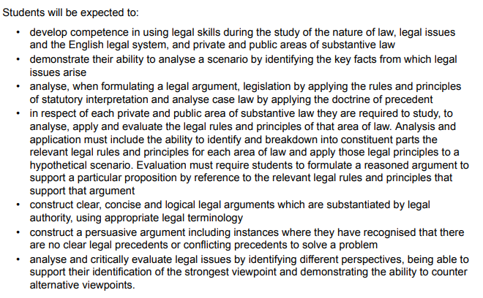

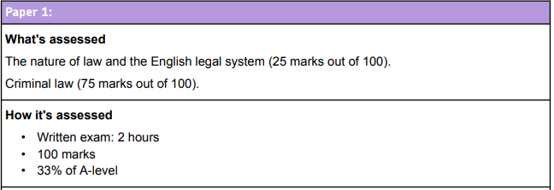
Assessment: This is a two-year linear course, and you will therefore sit three, two-hour examination papers at the end of your second year. The questions are a combination of multiple choice, short answers and extended writing answers

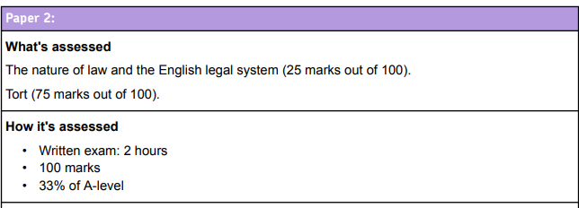
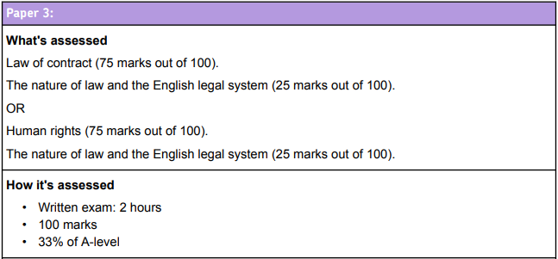

Skills in A-Level Law – Assessment objectives are the areas that AQA will be marking you on – these are AO1, AO2 & AO3.
AO1 | Demonstrate knowledge and understanding of the English Legal System and legal rules and principles.
AO2 | Apply legal rules and principles in given scenarios in order to present a legal argument using appropriate legal terminology.
AO3 | Analyse and evaluate legal rules, principles and concepts.

03.Textbooks and online resources:
Textbooks are available in the Learning Centre for you to hire. You will also be given FREE online access to the e-textbook for law. We DO NOT advise that you buy both course textbook to support your studies. There is also a useful revision guide available. HOWEVER if you wish to purchase a textbook please see recommendation below
Picture | Title | Year | Author (s)
A | AQA A Level Law – Book 1 | 2017 | Jacqueline Martin and Nicholas Price
B | AQA A Level Law – Book 2 | 2018 | Jacqueline Martin and Nicholas Price
C | AQA A Level Law – My Revision Notes | 2018 | Claire Wilson and Craig Beauman
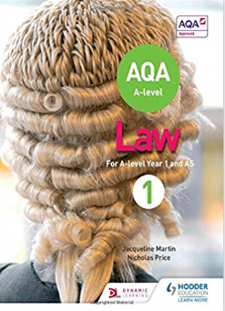
C
A
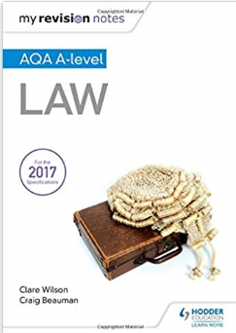
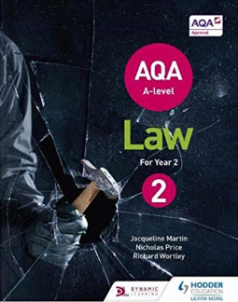
B

Online materials: You will have access to the Law Teams site, which will contain your lesson materials. Below are some useful websites for you to use in your independent study:
Law | tutor2u
The Law Teacher - YouTube
Try to download the Microsoft teams app ready for use in September. WE USE THIS FOR ALL COURSE RESOURCES, UPLOADING OF HOMEWORK (Huish30) AND ASSESSMENT.
Flipped Law – the college subscribe to this resource and we use it throughout the programme
FlippedLaw - HOME | Flipped Law
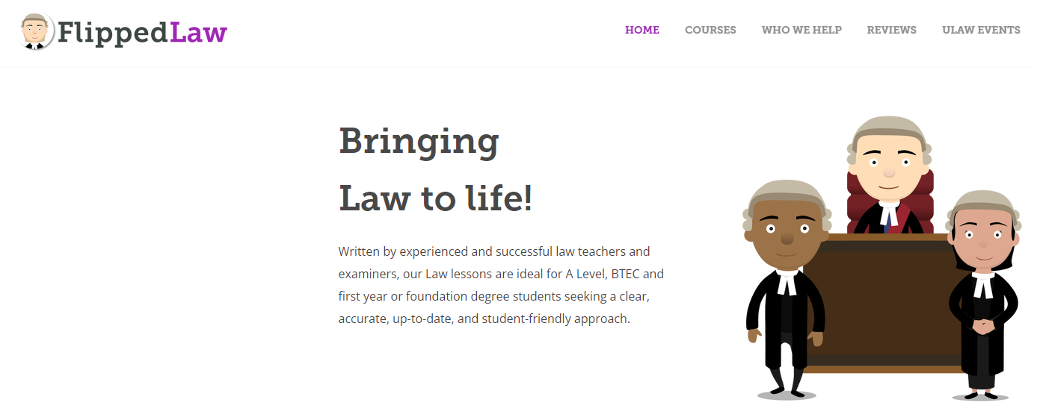Username:

04. Summer head-start homework
Task 1 – Introduction to law tasks – Guidance time – 1 hour
We will be looking at the courts and specific legal cases over the duration of A Level Law. Therefore, it is important to understand some key legal terms.
Task 1(a) is to define the following legal terms. (You can use a dictionary or internet to help, but you should not use Wikipedia)
Legal Term | Definition
Claimant

Defendant

Judge

Law Report

Statute

Jury

Kings Counsel

Recorder

Law

Royal Assent

Evidence

Witness

Prosecution

Task 1(b)
It is important to understand the structure of the Courts in England and Wales. Add the names of the courts to the hierarchy below.
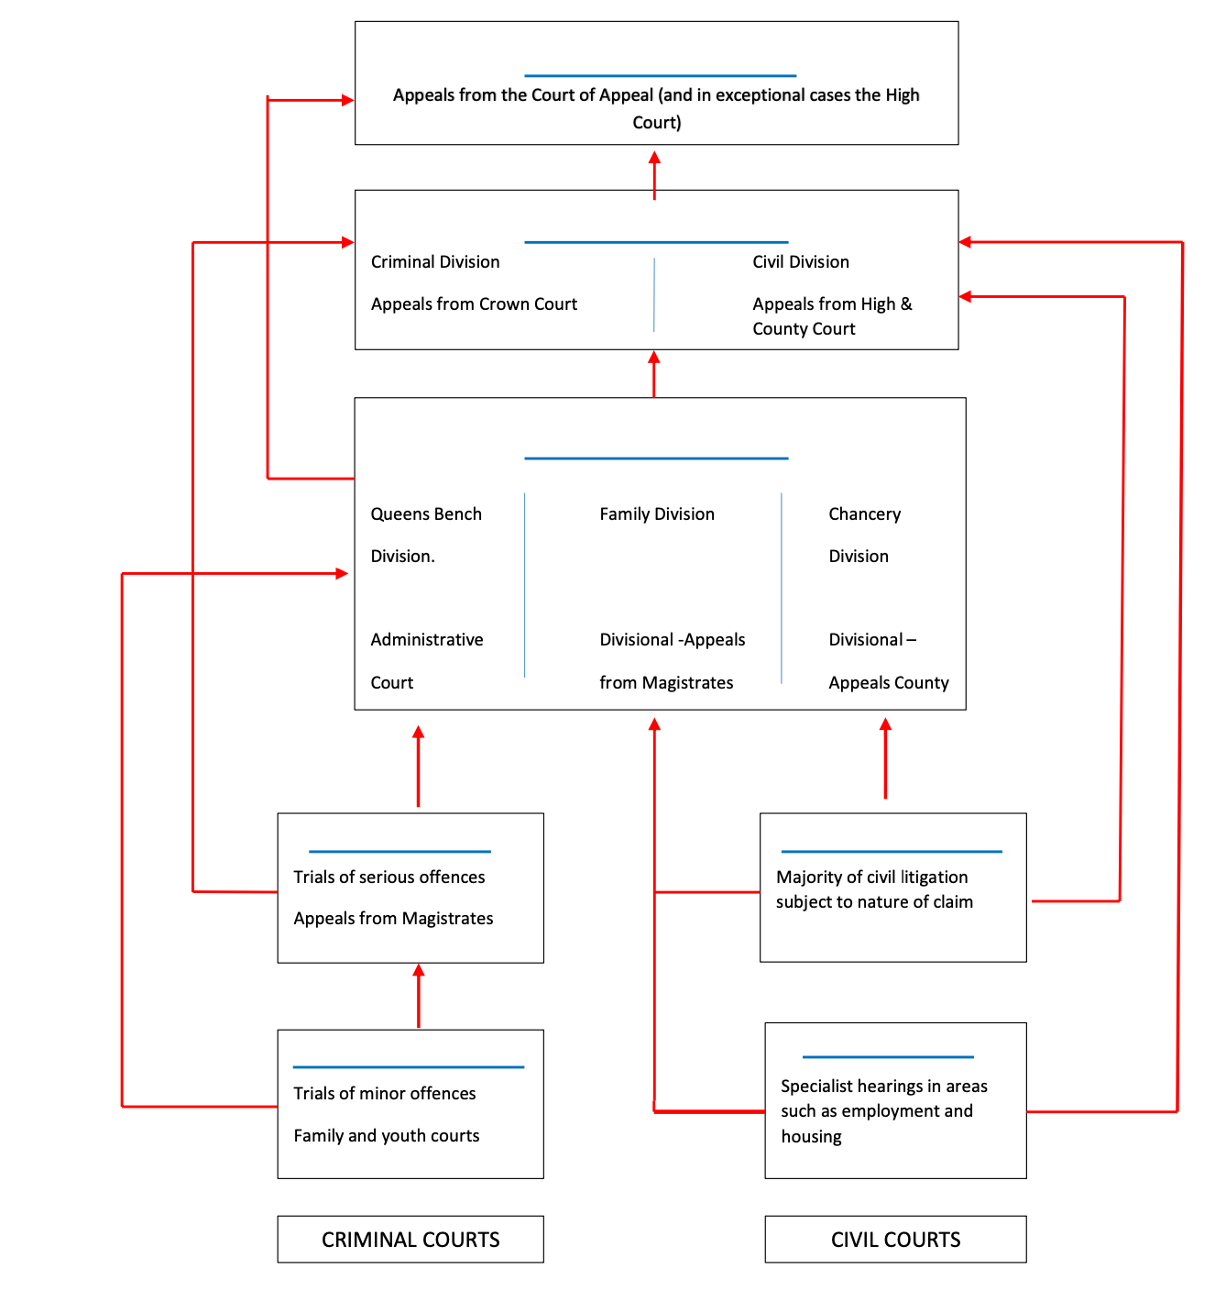
Kings Bench

Task 1c Find out the role of these legal professionals in court
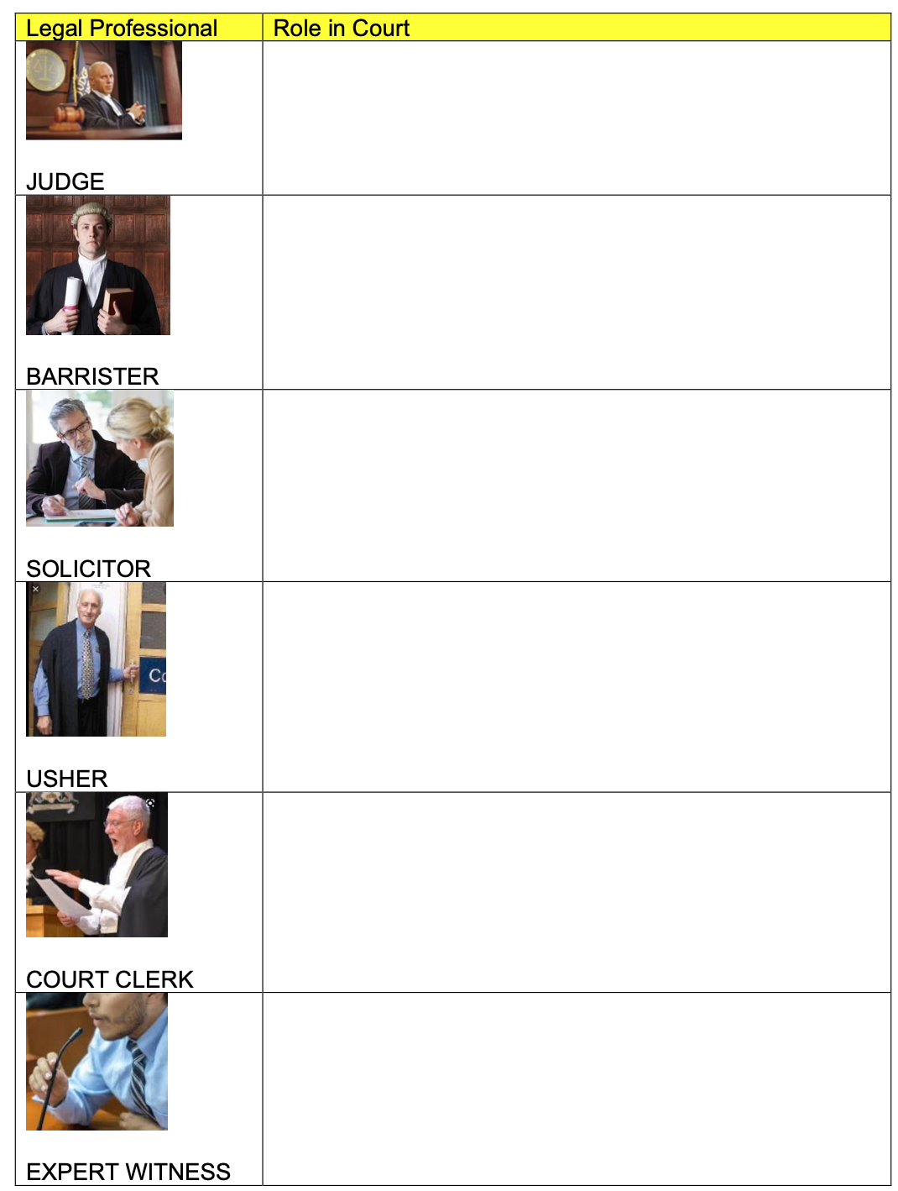

Task 2 – Criminal Law: Guidance time = 1 hours and 30 minutes.
Read the stories below and answer the questions.
Peanut curry death: Restaurant owner Mohammed Zaman jailed

A "reckless" restaurant owner has been jailed for six years for the manslaughter of a customer who had an allergic reaction to a curry. Paul Wilson, 38, suffered a severe anaphylactic shock in January 2014 after eating a takeaway containing peanuts from the Indian Garden in Easingwold, North Yorkshire Mohammed Zaman, 52, was found guilty at Teesside Crown Court. The court heard he cut corners by using cheaper ingredients containing peanuts.
In what is thought to be a landmark trial, Zaman, of Aylesham Court, Huntington, denied he was responsible but a jury was told he switched almond powder for a cheaper ground nut mix, which contained peanuts. Mr Wilson, a bar manager from Helperby, North Yorkshire, specified "no nuts" when he ordered a chicken tikka masala - an instruction which was written on his order and on the lid of his takeaway, the court heard.
'Cavalier attitude'
He died three weeks after a different customer with a peanut allergy bought a meal from one of Mr Zaman's six restaurants and had a reaction requiring hospital treatment. The restaurateur had a "reckless and cavalier attitude to risk" and "put profit before safety" at all his outlets, the jury was told. Zaman was almost £300,000 in debt and cut costs by using the cheaper nut powder and by employing untrained, illegal workers, the court heard. Sentencing him, Judge Simon Bourne-Arton, the Recorder of Middlesbrough, said Zaman had remained "in complete and utter denial" and ignored warnings from officials after 17-year-old Ruby Scott suffered a reaction to a curry, three weeks before Mr Wilson's death. He said he had thrown away his successful business and property portfolio worth £2m "in pursuit of profit".
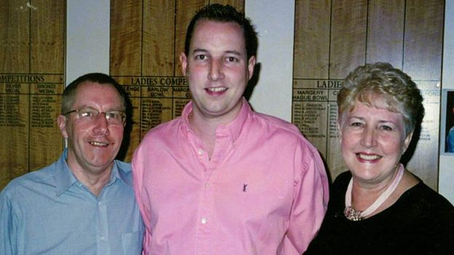
Paul Wilson's parents Margaret and Keith said he loved curry but was always clear with staff about his allergy, asking for his meals not to contain any peanuts "You have done so in such a manner as to bring about the death of another individual", said the judge. "Paul Wilson was in the prime of his life. "He, like you, worked in the catering trade. He, unlike you, was a careful man."
But the judge acknowledged Zaman was of "good character" and the sentence would have an impact on his wife and four children. In a statement read out in court, Mr Wilson's parents, Margaret and Keith, from Sheffield, said they felt "numb, shock and disbelief" over their son's death. "I feel robbed that I won't share the rest of my life with Paul"," Keith Wilson said.
'Totally avoidable.' Mrs Wilson said her son was "meticulous" about dealing with peanuts after a reaction to a chocolate bar at the age of seven. She said the smell of peanuts, or accidentally drinking from the same glass as someone who was eating them, could trigger a reaction.

[1] What was the offence that the defendant was charged with and in which court was the case heard?

[2] For a defendant to be convicted of Gross Negligence Manslaughter the jury must decide if the defendant has met the requirements set out in a case called Adomako and recently updated in R v Broughton. Find out what happened in BOTH cases and the requirements set out for a Gross Negligence Manslaughter conviction.
Facts – ADOMAKO

Facts – R v BROUGHTON

Requirements for the offence as decided in R v Broughton–

1.

2.

3.

4.

5.

6.

[3] What sentence did the defendant receive (in the Zaman case) and do you think it was fair?
[4] A recent case that covered similar territory was following the death of Megan Lee. Why did the Court of appeal quash the conviction of one of the defendants in this case. https://www.telegraph.co.uk/news/2019/05/16/takeaway-boss-has-two-year-manslaughter-sentence-overturned/

Task 3 – Criminal Law: Guidance time = 1 hours and 30 minutes.
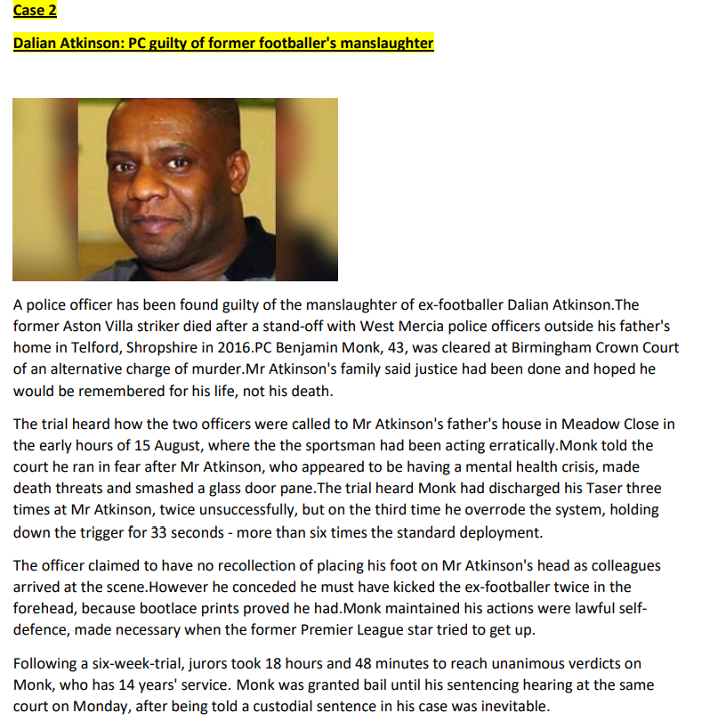
- What were the 2 offences the police officer was charged with?
- What defence did he raise and why?

- The offence that the police officer was convicted of was Unlawful Act Manslaughter. If you google the case of DPP v Newbury and Jones you can find the 4 elements of the offence.

- What sentence did the D receive?

Further Extension activities if you wish to do more law! THIS IS OPTIONAL
The following are some suggestions for activities that might be worth doing over the summer.
Reading
The following are a couple of books that are quite an easy read. They are normally available quite cheaply on the usual sites and The Secret Barrister is free with a trial of Amazon Audible.

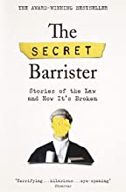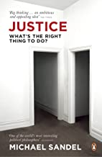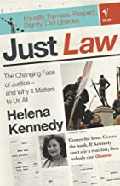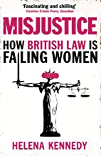

Watching
[a] Michael Sandel: What is the right thing to do. There are a whole series of lectures on you tube. They are fairly academic but well done. The link is to the first one.
https://www.youtube.com/watch?v=kBdfcR-8hEY
[b] Neflix. For those who have Netflix we recommend all of the following. They are mainly from the US but are quite good in showing the format of criminal trials or raise issues about miscarriages of justice.
[i] The people v OJ Simpson
[ii] The Staircase
[iii] Making of a murderer
[iv] When they see us
Listening
There is a big archive of old editions of Law IN Action on Radio 4. You can search and there are interesting episodes about the Law of Murder, Magna Carta and the legal changes caused by Covid 19 amongst many others.
Open Learning
There are some open learning introductions to law courses. Some of the material is heavy going but if you have time, they introduce some key ideas. The links below are to free Open University material.
https://www.open.edu/openlearn/society-politics-law/starting-law/content-section-0?active-tab=description-tab
https://www.open.edu/openlearn/society-politics-law/judges-and-the-law/content-section-0?active-tab=description-tab

06 What our students do next
[a] Law degrees
Last year as is typical over 30 of our students went on to study Law at Degree Level. Amongst the Universities that our students have gone on to in recent years are: Cambridge, Oxford ‘Bristol’ Durham, Kings College London, Bristol , Manchester, Warwick, Reading, Cardiff, Kent Newcastle Exeter, Southampton , Sheffield , Nottingham , Leeds and many more.
[b] Other degrees
Many students go on to do other degrees and in recent years this has included Medicine, English , History , Economics , Psychology, Nursing, Food Science , Sociology and many more subjects.
[c] Employment
An increasing number of students are looking at higher level apprenticeships and this has included working at the BBC and prestigious national Law Firms.

