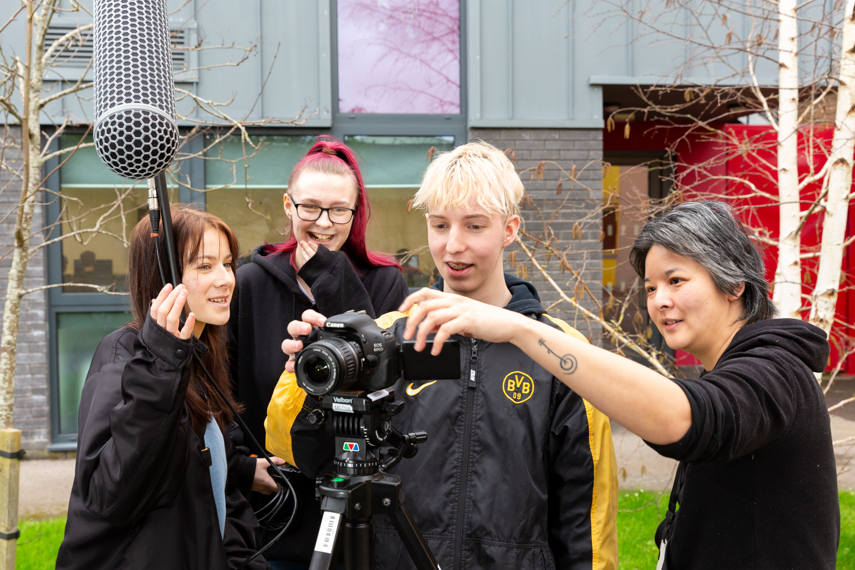
VOCATIONAL MEDIA
EXTENDED DIPLOMA
YEAR 11 BOOKLET



Course: Cambridge Technical Level 3 Digital Media
Time: 8–9 hours total
Theme: Media, Identity, Culture & Creativity

Overview
This project prepares you for the course by developing:
- Media literacy and critical thinking
- Understanding of audiences and representation
- Awareness of global media and social platforms
- Practical creative skills (photography)
- Planning and pre-production
- Subject-specific terminology

Task 1: My Media World (Media Literacy Audit)
⏱️ 60 mins
Track your media use over one full day.

Record:
- Platforms used
- Time spent
- Purpose (entertainment, communication, information)

Reflect:
- Which media dominates your day? Why?
- How do platforms keep your attention (algorithms, autoplay, notifications)?
- Who is the target audience for your favourite content?
- How might media influence your identity or opinions?

Task 2: Representation & Cultural Capital
⏱️ 60 mins
Choose one media text (film, TV, advert, influencer content).

Analyse:
- Who is represented?
- Are stereotypes present?
- What messages are created about people or lifestyles?
- Who is the intended audience?

Reflect:
- What media has shaped your interests?
- Which genres do you know best?
- Which do you rarely engage with?
- How might your background shape your interpretations?

Task 3: Genre Research
⏱️ 60 mins
Choose your favourite genre.

Watch 2 clips and analyse:
Feature | Your Genre
Settings
Sound
Camera
Lighting
Characters

Then:
- Identify 5 conventions
- Explain appeal to audiences
- Describe emotional impact

Task 4: Film Extract Planning
⏱️ 75 mins
Plan a 1–2 minute film extract.

Include:
- Title + logline
- Target audience
- Narrative structure
- Mise-en-scène (location, props, costume, lighting)

Storyboard:
Draw 12 frames with:
- Shot types
- Action
- Sound

Task 5: Media Terminology
⏱️ 45 mins
Define:
- Audience
- Target audience
- Genre
- Convention
- Representation
- Stereotype
- Narrative
- Mise-en-scène
- Camerawork
- Editing
- Diegetic / non-diegetic sound

Apply:
Analyse one media text using at least 5 terms

Task 6: Practical Photography Task
⏱️ 90 mins
Use your phone camera to take 8–10 photos demonstrating composition techniques.

You MUST include:
- ✅ Rule of Thirds (at least 2 photos)
- ✅ Leading Lines (at least 2 photos)
- ✅ Golden Ratio / Spiral (at least 1 attempt)
- ✅ Depth (foreground, midground, background)
- ✅ Framing (shooting through objects)

Step 1: Take Photos
Subjects can include:
- People
- Urban environments
- Nature
- Objects

Step 2: Select Your Best 5 Photos

Step 3: Analyse Your Photos
For each photo, write a short paragraph:
- What technique did you use?
- How did you frame the shot?
- What is the effect on the audience?
- What works well?
- What would you improve?
👉 Use terminology like:
- Composition
- Framing
- Focus
- Perspective
- Lighting

Task 7: Social Media Campaign Analysis
⏱️ 75–90 mins
Choose a real social media campaign:
- Brand (Nike, Apple, McDonalds etc.)
- Influencer campaign
- Charity campaign
- Film/game promotion

Step 1: Describe the Campaign
- What platform(s) are used? (TikTok, Instagram, YouTube etc.)
- What is being promoted?

Step 2: Audience & Purpose
- Who is the target audience?
- What is the goal? (sell, inform, entertain, promote)

Step 3: Analyse Techniques
Consider:
- Visual style (colour, imagery, branding)
- Language/tone
- Use of hashtags or trends
- Posting style (short videos, reels, ads etc.)

Step 4: Global & Social Context
Write about:
- How the campaign could appeal globally
- Whether cultural differences may affect how it is received
- How social media helps spread the message

Step 5: Terminology Use
Use at least 6 terms, for example:
- Target audience
- Engagement
- Platform
- Brand identity
- Representation
- Global audience
- Digital distribution

Task 8: Personal Reflection & Skills Audit
⏱️ 45 mins
Reflect on the whole project:
- Which task did you enjoy most?
- What skills did you develop?
- What was most challenging?
- What do you want to improve when the course starts?

Final Question:
- What makes effective media in your opinion?

Submission Options
- PowerPoint
- Word (use this document)
- PDF
- Handwritten (photographed)/Mixed media (images + writing)

