

Mental Health: Individuals and Society
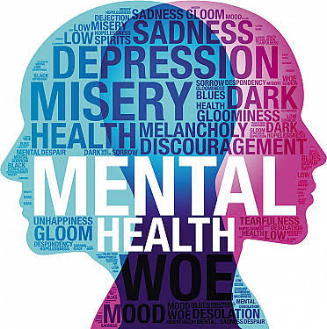

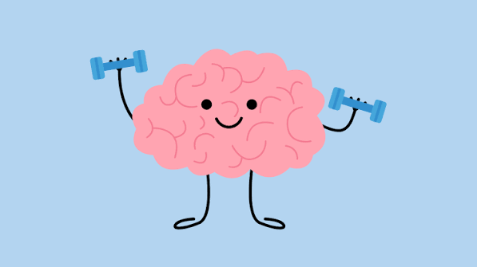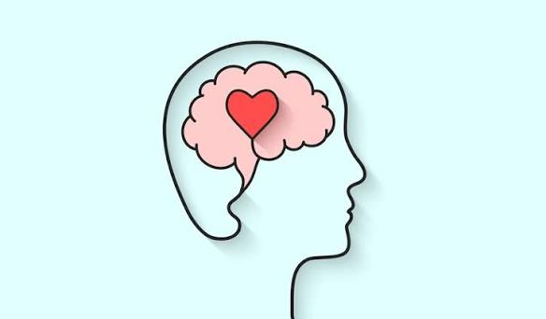

The OCR Alternative Academic Qualification (AAQ) in Mental Health: Individuals and Society is designed to provide you with a broad understanding of mental health from both a personal and societal perspective. It is particularly suited to you if you are interested in careers in health, social care, childcare, education, or community support roles.

Key Aims of the Course
- Develop knowledge of mental health conditions and wellbeing
- Explore how mental health is experienced at both the individual level and within wider society
- Build awareness of factors affecting mental health, including biological, psychological, and social influences
- Encourage empathy, understanding, and reduction of stigma
- Support the development of research, analysis, and communication skills

Core Areas of Study

1. Understanding Mental Health

2. Factors Affecting Mental Health

3. Individuals’ Experiences

4. Society and Mental Health

5. Support and Interventions

Studying this AAQ will help you to develop skills in:
- Research and investigation
- Critical thinking and evaluation
- Communication and discussion of sensitive topics
- Applying knowledge to real-life contexts

Important Content Warning

This course includes discussion of mental health conditions and personal experiences, which may be sensitive or emotionally challenging for some learners.
Topics may include:
- Mental illness and distress
- Trauma and adverse experiences
- Stigma and discrimination
- Case studies based on real-life situations

While the course is delivered in a supportive and educational context, you should be aware that some content may be upsetting.
Throughout the study programme you will be encouraged to speak to your teacher or tutor if necessary and make use of available wellbeing support within the college

Understanding Mental Health

Task 1: What is Mental Health and Wellbeing?
Write a definition for both:
Mental health

Wellbeing

List:
- 3 characteristics of good mental health
- 3 characteristics of poor mental health

Explain the difference between mental health and mental illness.

Task 2: Knowledge Check
True or False:
1. Mental health only refers to illness
2. Stress is always harmful
3. Mental health changes over time
4. Sleep affects wellbeing
5. Anxiety is a disorder

Explain two answers:

Task 3: Wellbeing Leaflet
Create a leaflet with:
2 physical strategies to support positive wellbeing
2 emotional strategies to support positive wellbeing
2 social strategies to support positive wellbeing
Explain why each works and when to use it

Task 4: Celebrity Mental Health Investigation


Part A: Background Information
1. Choose one of the celebrities?

2. What is their job/career?

Part B: Mental Health Challenges
3. What mental health difficulties have they experienced?
(e.g. anxiety, depression, addiction)

4. When did these challenges occur?

Part C: Risk Factors
5. Identify at least THREE factors that may have contributed to their mental health difficulties:
- ☐ Trauma or loss
- ☐ Social media pressure
- ☐ Work stress
- ☐ Body image issues
- ☐ Relationships
- ☐ Substance misuse
- ☐ Other: __________________________
Explain your answers:

Part D: Protective Factors
6. What helped them cope or recover?
(e.g. therapy, family support, time off, speaking out)

Part E: Impact
7. How did their mental health affect their life?
Career:

Personal life:

Public awareness:

Reflection
8. What have you learned from this celebrity’s experience?

9. Identify TWO factors that can affect mental health eg. Traumatic events:
1.

2.

Extension Task
Write a short paragraph explaining how factors influence mental health using this celebrity as an example:

