



A Level
Physical Education


Welcome

It is excellent that you are interested in A Level PE! We would like to give you more of a flavour of the course, hopefully inspire you and help you to develop skills to support your learning to get a ‘head start’ for September.

We have created activities for you to do to get you thinking about the subject, so you are more prepared when the course officially begins in September. These activities should be completed throughout the remainder of the summer term and over the Summer Holidays. A suggested time for completion is included in brackets for all tasks.

PAGE | ACTIVITIES
Folder System
Please invest in an A4 lever arch folder, complete with 5 dividers labelled:
- Component 1
- Component 2
- Component 3
- Past Exam Papers
- Component 5&6
3 – 4 | Course Overview (15mins)  This introduces you to the exam board website and structure of the course.
5 | Practical Performance Sport (15mins)  This shows you all the activities available and gives you tasks based on your initial sport choice.
6 | Logbook & Video Evidence for your coursework (30mins+ (depending on your sport and season)  This is to make a start on Part 1 of your coursework, which is to provide video and logbook evidence of your performance or coaching levels in 1 sport from the OCR A Level PE Specification list.
7 – 10 | Component 1 Tasks (60mins)  Tasks to introduce the Physiology section of the course. Print these 4 sheets out and add to Component 1 section of new A Level PE folder. We will use these in lessons.
11 | Component 2 & 3 Tasks (120mins)  Tasks to introduce the Psychology & Socio-cultural sections of the course. Add this work to the respective Component 2 or 3 section of your new A Level PE folder.
12 | Analysis of Performance (EAPI) Task (30mins)  The 2nd part of your coursework is to analyse the strengths and weaknesses of another performer in your sport, and verbally feed these back, whilst also creating a plan for how to improve their greatest weakness and also apply your A Level theory knowledge to these comments. This task is the first step to preparing for this coursework.
13 | Course textbook Information  Some students like to buy their textbooks… this tells you what we use. There is no expectation for you to do this as we will provide you with access to these.
14 – 15 | Book Recommendations  Want to improve your knowledge of sport? Try these inspiring reads!
16 – 17 | Film/Movie Recommendations  Want to improve your knowledge of sport? Try these inspiring films!
Course Overview

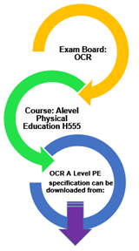

- Click on the hyperlink to take you to the OCR website for PE

http://www.ocr.org.uk/qualifications/as-a-level-gce-physical-education-h155-h555-from-2016/

2. Download the A level
Specification
- Use this to complete the missing facts in the table on the next page
COURSE STRUCTURE: Assessment Breakdown

Content Overview | Assessment Overview
Content Overview | Marks | Duration | % Overall Mark
H555/01 Physiological Factors Affecting Performance:
- 1.1 Applied Anatomy & Physiology
- 1.2 Exercise Physiology
- 1.3 Biomechanics
H555/02 Psychological Factors Affecting Performance:
2.1 Skill Acquisition
2.2 Sports Psychology
H555/03 Socio-cultural Issues in Physical Activity & Sport:
3.1 Sport & Society
3.2 Contemporary Issues
H555/05 Practical Performance
- Performance
or
- Coaching
H555/06 Evaluating & Analysing Performance for Improvement (EAPI):
- Verbal performance analysis looking at strengths and weaknesses of a performance, designing of a development plan and application of theoretical knowledge.

Print this table out, put it in a plastic wallet and add to front of your new A Level PE folder.
Practical Performance

You need to start to think about which ONE sport you will choose as your practical activity. This will count as 15% of your final A Level PE grade.

- Go back to the OCR website
http://www.ocr.org.uk/qualifications/as-a-level-gce-physical-education-h155-h555-from-2016/

- Click on the ‘Guide to non-exam assessment’ link
- Scroll down to activities for assessment.

What sport will you choose?

- Scroll to page 38 (Skills Criteria for Practical Activities) and it will give you the page number for the criteria of your sport Assessment.
- Read and select the sport you think you will submit. Write this sport on the dotted line below:

………………………………………………………………………………………………………………………………………..

- Will you be assessed as a performer or coach? Please highlight which one.
- Print out a copy of the specification for your chosen activity, put it in a plastic wallet and slot this into the C5&6 (Practical section of your folder).


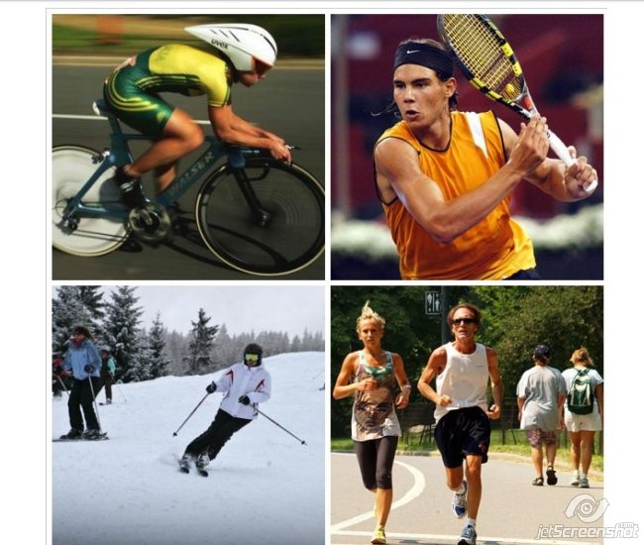

Logbook & Video Coursework Evidence Collection

Tasks:

- Complete the following details, which will go into your logbook which we will share electronically with you when you join the course:

- Sport being assessed in:

- Performer or Coach?:

- If performer, details, e.g. position you play? Event you compete in? Clubs you play for? Level you perform at/represent?:

Details:

- If you are performing in your sport, you have to film your video evidence from competitions. You have 2 seasons from which to film this evidence. You will be expected to upload an example of evidence as soon as you join the course in September. Therefore consider:
  - If you are playing a seasonal sport (one that is played over the summer months, e.g. cricket, golf, athletics, etc.) then you must film these competitions over the summer between finishing Year 11 and joining us. All video evidence must be from competition. If you are a summer sport student, then you must FILM EVERY PERFORMANCE over the summer and save this somewhere safe, ready to be used in September when you join the course.
  - If your playing season starts more traditionally around September, you will be expected to have filmed some pre-season footage.

- If you are coaching, please write down the details of the team/performers/club at which you will complete a minimum of 20 sessions of minimum 40mins duration each, when you start the course:

Details:

You will also be expected to upload video evidence of a coaching session you have completed, when you join in September.

Component 1: Physiological Factors Affecting Performance

This section is all about the physical workings of the human body, and how this relates to sporting performance.

Complete the following 2 tasks, which will highlight for you the key differences between GCSE/Level 2 and A Level (Level 3) PE (it does not matter if you did not previously study GCSE PE). It will be hugely beneficial to you if you begin this course with a basic knowledge of the bones, circulatory system and lung structure; the ‘full’ names of specific muscles will be something we will work on together!

Task 1 – Bones & Muscles: Label all the bones and muscles required for GCSE PE in blue and then label all the new bones and muscles in RED (required for A’ Level):
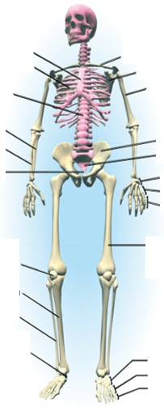

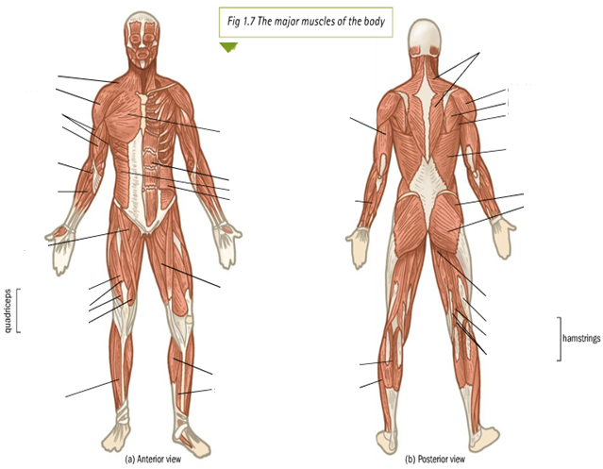
Component 1: Physiological Factors Affecting Performance

Task 2 – Heart & Lungs: Label the following diagrams:

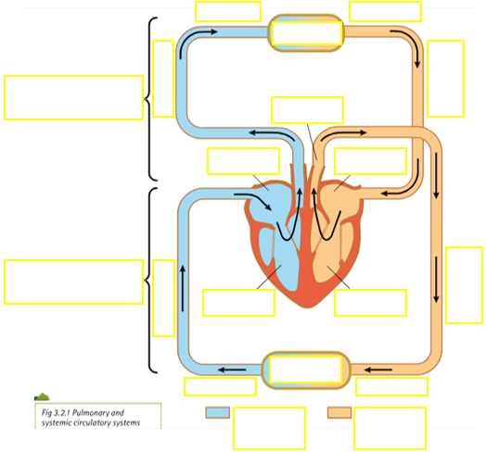
Component 1: Physiological Factors Affecting Performance

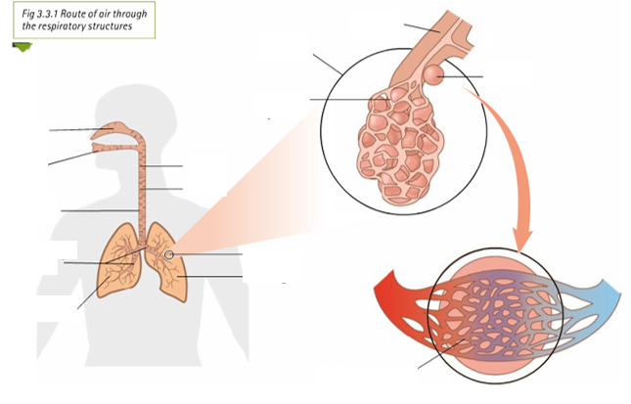

Component 2: Psychological Factors Affecting Performance

Sports psychology is concerned with the mind and how it functions in a sporting and competition situation.

Read the article entitled: ‘THE RELATIONSHIP BETWEEN MOTIVATION, SELF- CONFIDENCE AND ANXIETY’
https://believeperform.com/the-relationship-between-motivation-self-confidence-and-anxiety/

Answer the following questions –
- What are the two types of motivation?
- Which one is deemed the most important for sustained success?
- According to Feltz, what is ‘self-confidence’?
- What often happens to performers experiencing high levels of anxiety?
- What is the issue with setting unrealistic goals?

How about you – Motivation
- Make a list of all the reasons you play/participate/compete in your current sport.
- Using the answer to question 1 above, highlight against each reason which type of motivation it is – Are you motivated by one type in particular? (You will need to have read the article!)
- Please give a personal example where you have used a type of motivation to achieve success in your sport.
- Do you have any current goals or aspirations in your sport?


Component 3: Socio-cultural Issues in Physical Activity & Sport

The key to this area of the exam is to immerse yourself in contemporary sporting issues both past and present; examples are the key to success.

Task – Research Task.
Over the coming months please take a moment to read/collect/log articles relating to the following areas:

Modern Olympic Games
- A brief history.
- Why do countries want to host a games?
- Positive and negatives implications of hosting a modern Olympic Games.
- In your opinion, was Paris 2024 a success? Justify your answer.

World Cup 2026
- With a critical eye, discuss the decision to host the football world cup in North America, Canada and Mexico.

Make observations and look at the media’s response to
- Human Rights Concerns (e.g. Migrant workers; LGBTI+ Rights; Freedom of Press)
- Political Interference & Corruption (e.g. Trump’s involvement; potential boycotts)
- Logistical Challenges (e.g. multiple host nations; state laws; security)
- FIFA’s role (e.g. new format; human rights responsibilities)

Analysis of Performance (EAPI) Coursework Task

Tasks:

For your main sport, list the following:

- The main skills/technical aspects of your sport.

  - E.g. football, not just passing: short passing, long passing, driven pass, lofted pass, chip pass, volley, half volley, curled pass, etc.

  - E.g. swimming – starts, turns, head-to-toe technique of the stroke, etc.

- Key tactical elements (or choreography for dance, gymnastics, etc.)

  - E.g. in games: decisions, positioning, application of rules, etc.

  - E.g. in choreography: tariff choices – set vs. voluntary routines, etc.

- 8 key fitness components needed for your sport, in rank order most important to least

  - E.g. Aerobic Capacity, Explosive Strength, Dynamic Flexibility, etc.

This should take approximately 30mins.

Core Books for the Course and Book Recommendations
The core text book we use in the classroom: when needed we provide one for your use. For independent study we have an EBook version.
The revision guide: we recommend that you purchase your own copy so you can make notes and highlight on the pages. You are able for the 2nd year of the course to loan a copy from the learning centre but you cannot annotate it.
Core Text:

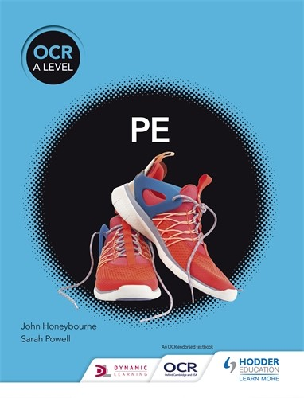

John Honeybourne Sarah Powell

ISBN: 9781510473317

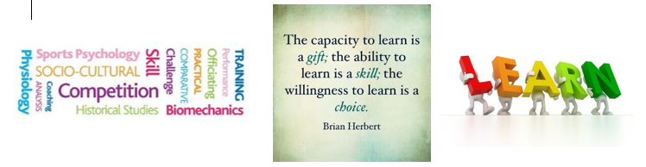
Keri Moorhouse

ISBN: 9781510405219
Revision Guide:

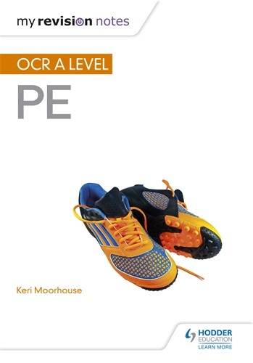
Book Recommendations

Kick back this summer with a good read.
The books below are all popular sport books and great for extending your understanding of Sport.
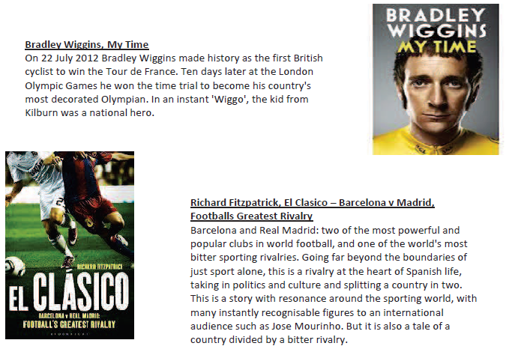
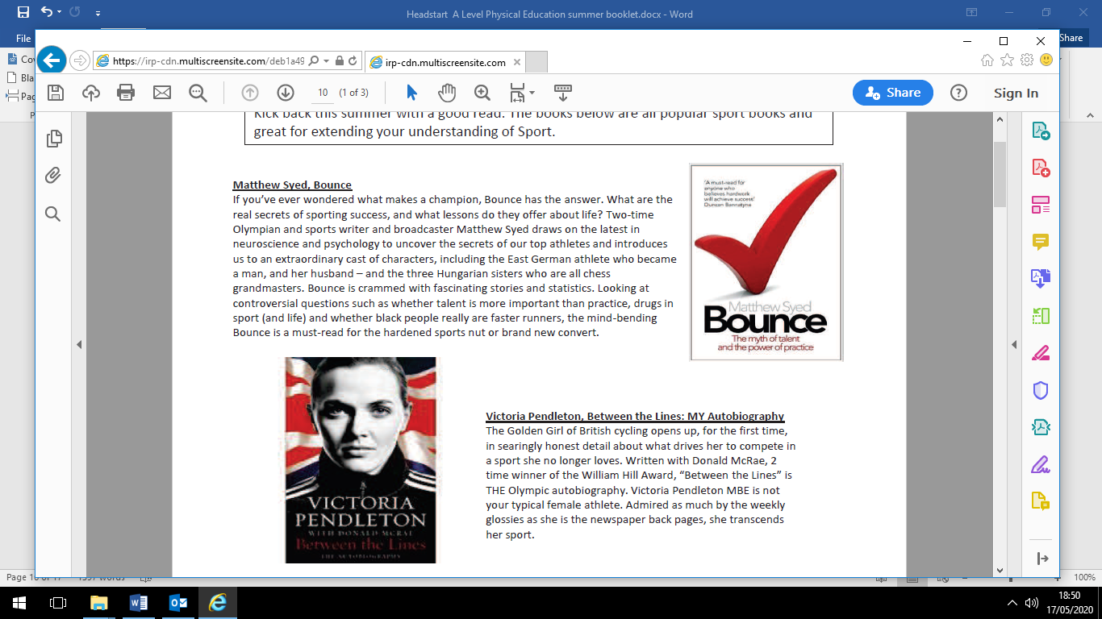

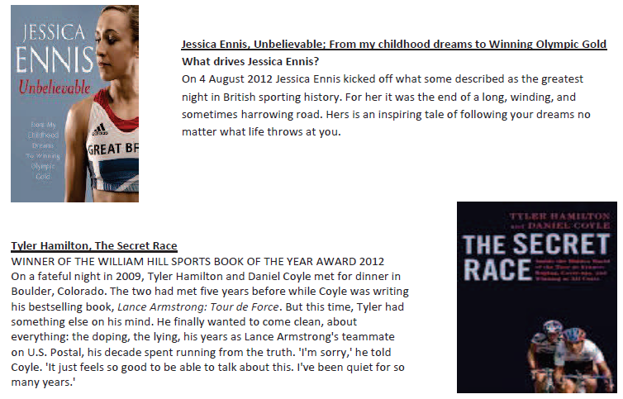
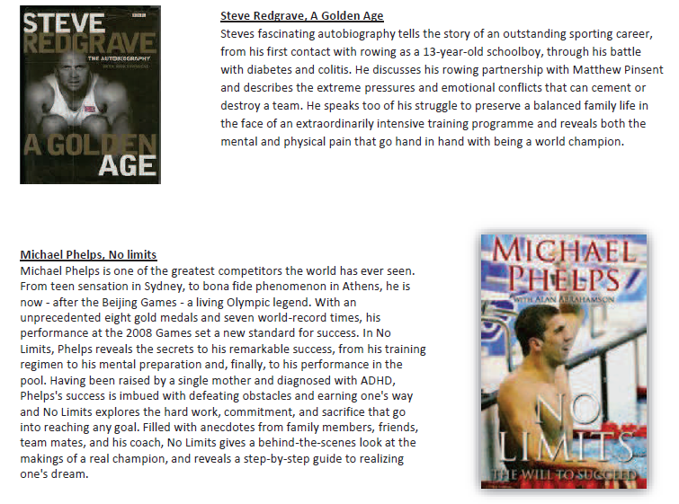

Film Recommendations

Everyone loves a good story and everyone loves some great science. Here are some of the
picks of the best films based on real life scientists and discoveries. You won’t find Jurassic Park
on this list, we’ve looked back over the last 50 years to give you our top 5 films you might not
have seen before. Great watching for a rainy day.
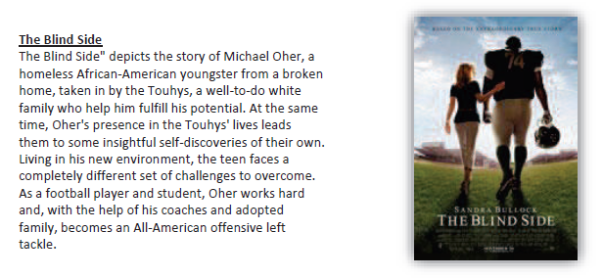
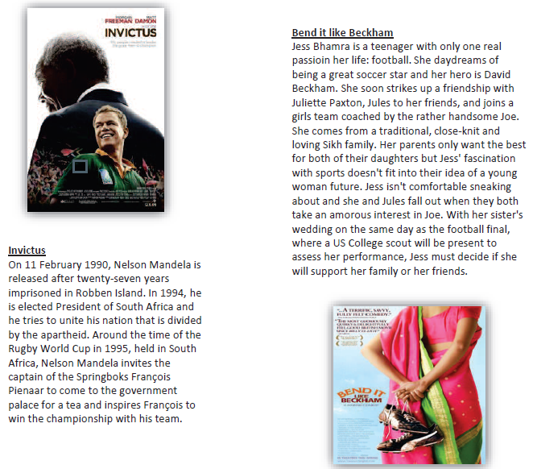

WHAT'S THE STORY?


Concussion
In CONCUSSION, Dr. Bennet Omalu is a caring, thorough doctor at the Pittsburgh medical examiner's office who's baffled by his latest case: local football legend Mike Webster, who had deteriorated seemingly dies for no obvious reason. Eventually Omalu realizes that Webster's brain is damaged, the result of years of hits to the head playing football -- and many, many other players are at risk of the same fate. By identifying the condition that comes to be called chronic traumatic encephalopathy (CTE), Omalu offering a strong example of integrity and perseverance, goes up against the powerful NFL, which has no interest in admitting the sport is dangerous to players and does everything it can to discredit the doctor. This David-vs.-Goliath story has plenty of violent football scenes that often leave players dazed or unconscious, as well as some intense moments when retired players succumb to fits of rage.

Remember the Titans
Remember the Titans tells the inspirational true story about the struggles and victories of a newly-integrated high school football team in 1971 Alexandria, Virginia. As such, the film reflects the divisive nature of the times -- the film begins with a near-riot scene between African-Americans and whites on the street separated by the police as bottles and windows break. The racial tensions of the town -- segregation in restaurants, racial slurs, fist fights in the high school -- are shown to highlight the backdrop in which the Titans must learn to get along and play together as a team.
It's important to know for REMEMBER THE TITANS that it wasn't until 1971, 17 years after the Brown v. Board of Education decision, that black students came to T.C. Williams High School in Alexandria, Va. Every other team in that football-loving district was still segregated. But the white T.C. Williams players were confronted with not only a whole new set of black players, but a black coach, Herman Boone In a matter of a few weeks,
Boone has to make them into a team -- and it has to be a winning team, because the school board is looking for any reason to fire him so they can reinstate Coach Yoast now demoted to assistant. Boone takes the boys to a college near Gettysburg for training. It's impossible to say which is the tougher workout for the team -- the physical challenges of drills and practices or the emotional challenge of overcoming a lifetime of anger and prejudice. Like all great coaches, Boone and Yoast teach the team that they have it within themselves to be great as well. And they realize that they get as much from the boys as the boys get from them.
Ultimately, Remember the Titans is a deeply moving film about the courage of individuals and the power of sports to transcend perceived and ingrained differences. It demonstrates most psychology theories of leadership and the power of group cohesion
