


A Level Physics



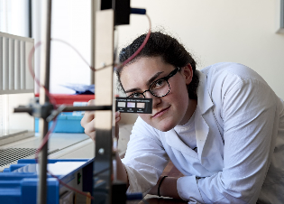
Preparing for A level Physics
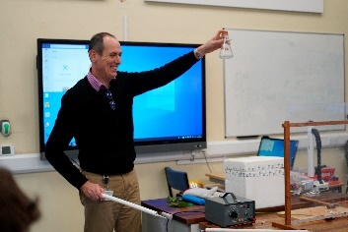
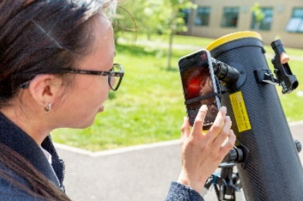
Physics is the science which seeks to understand everything around us, from the tiniest particles through to the (possibly) infinite universe. Fundamentally physicists are problem solvers who, when presented with a puzzle, use the skills that they have developed to solve a huge variety of problems, from the philosophical how the universe might have begun, to the practical building of more efficient solar panels to solve the world's energy crisis, and the latest mobile devices that use some of that energy.

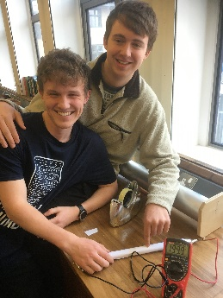
Physicists cross all the boundaries of science from medical physics and biophysics to materials science and product and technology engineering.
Furthermore, understanding problem solving within physics also provides transferable skills and training for many other professions such as law, accountancy, banking, management consultancy, software development, science journalism....

But Physics isn’t finished yet! There are a huge number of unsolved problems.
Maybe you can help find the answers?

Welcome to Huish Physics. Here are some activities you can do to prepare for A Level.
If you have any questions over the summer, email Barrie Hall, Course Manager Physics: barrieh@richuish.ac.uk

We follow the AQA Physics specification, and we start by looking at making accurate measurements necessary at all levels of physics…
Webb telescope helps refine Hubble constant, suggesting resolution to long-standing expansion rate debate
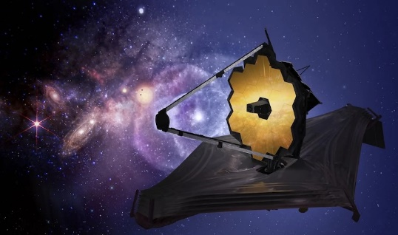
For the past decade, scientists have been trying to get to the bottom of what seemed like a major inconsistency in the universe. The universe expands over time, but how fast it's expanding has seemed to differ depending on whether you looked early in the universe's history or the present day. If true, this would have presented a major problem to the gold-standard model that represents our best understanding of the universe.
But thanks to the new James Webb Space Telescope, scientists from the University of Chicago have been able to take new and better data—suggesting there may be no conflict after all.
"This new evidence is suggesting that our Standard Model of the universe is holding up," said Chicago Prof. Wendy Freedman, a leading figure in the debate over this rate of expansion, known as the Hubble constant.
"It doesn't mean we won't find things in the future that are inconsistent with the model, but at the moment the Hubble constant doesn't seem to be it," she said.
Taken from an article from Phys.org (full article here: Webb telescope helps refine Hubble constant, suggesting resolution to long-standing expansion rate debate)
OPTIONAL TASKS
What is the average loss in life expectancy due to the ionising radiation exposure from a flight from London to New York? Which is longer: a Hubble or a shake? Use this link to find answers to the above questions and more: Stories from physics booklet 1: Weird units and wonderful measures | IOPSpark
Download phyphox from the App Store and use your phone’s sensors to measure the Earth’s magnetic field, atmospheric pressure, your GPS location, altitude and acceleration due to gravity!
Compulsory Physics Summer Holiday Task - due for 3 September 2026
As part of your preparation, we would like you to complete some questions that will give you practice before starting your Physics A-Level course. We are using a website called Isaac Physics, which contains resources including physics problems which you can attempt online. This should take no more than a couple of hours. Please follow the instructions below:
1. Go to https://isaacphysics.org/login
2. Click ‘sign up’ and follow the instructions. You will need a valid email address and will be asked to set up a password. Please make sure that you remember these as you will need them throughout your time at Huish.
So we can see your progress, please enter the following code into the ‘Teacher Connections’ tab at the top of the ‘My Account Settings’ page.
98T2FD
This will enrol you in the group ‘Huish Headstart Physics 2026’

3. We would like you to complete the following assignments:
• Nuclear: 51 Atomic number and nomenclature
• Mechanics: 8A Additional speed, distance and time questions
• Electricity: 23 Current and voltage – circuit rules
• Waves: 38A Additional Wave properties and basic equations questions
These 4 sections are listed in your assignments (click on ‘Menu’)
To help you answer the problems read: https://isaacphysics.org/solving_problems
This page gives a guide to solving the problems on the site. It also gives information about the notation and conventions used by the makers of the site, and those that you should use when giving answers.
Optional Extension: explore more questions on the site and dip into A Level topics: A Level Resources — Isaac Physics
Any problems email barrieh@richuish.ac.uk

Is there life beyond A Level Physics?
Physics is a “facilitating subject”, meaning that it’s highly regarded whatever degree or career path you choose. It’s considered essential for science and engineering courses, so it keeps a lot of doors open for you.
If you enjoy studying physics but aren’t sure how it could help your job prospects, we have good news. Employers across a huge range of industries are crying out for people with physics skills right now. These are just a few of your options:
Where physics could take you: Career paths | Institute of Physics (iop.org)

Optional pre-course reading

We’ll give you a course textbook on loan for use during the course, and to prepare over the summer you could get a copy of Head Start to A-level Physics (CGP A-Level Physics) ISBN 1782942815. Working through it will help you to be fully prepared to start your A Level study!

There are many great Physics books out there, but here are just three recent ones that you could read over the summer:
The World According to Physics – Jim Al Khalili
Universal: A Guide to the Cosmos – Brian Cox and Jeff Forshaw
Brief Answers to the Big Questions – Stephen Hawking

Finally, which elementary particle best fits your personality? We’ll start the course by learning all about these wonderful particles:
Click Particle Identities | S'Cool LAB (cern.ch)

