


Vocational Sport

Well done on completing your GCSE’s!

You will find below a number of tasks to complete before you start with us in September. They are split into the following sections:
- Career opportunities in the sports industry
- My sporting background
- Anatomy
- Fitness Training & Programming

Complete each task in a different document as you will need to submit them separately to different people! We will explain how to submit the work in class in September. If you do not have access to IT at home don’t panic just hand write it.
Section: | Evidence Format:
Career opportunities in the sports industry | PowerPoint
My sporting background | Word document
Anatomy | Word document
Fitness Training & Programming | Word document

Understand the career and job opportunities in the sports industry
Task 1.
Pick a job role that interests you in sport (for example Coach, PE teacher, Physiotherapist, Personal Trainer, S&C Coach)
Create a powerpoint with your name and chosen job role on the front slide. Tasks 2 to 7 will be the content of your powerpoint.

Task 2.
Explain what your chosen job role is, what do they do? Use the link below as an example of the information. Good practice here is to make sure you copy the link so you reference this work.
https://www.prospects.ac.uk/job-profiles/sports-coach

Task 3.
Explain 3 responsibilities of the job role you have chosen:
Two examples of what a sports coach would be responsible for could be:
- assessing strengths and weaknesses in a participant's performance and identifying areas for further development
- communicating instructions and commands using clear, simple language

Task 4.
Explain 3 skills your job will need
Two examples for a sports coach could be:
- enthusiasm, flexibility and patience
- a strong interest in maintaining professional skills and knowledge.
Task 5.
Safeguarding children and vulnerable adults is extremely important in many roles in sport.
What is a DBS and do you need one in your role?

Task 6.
What would you expect the salary to be in your chosen job?

Task 7.
Explain and discuss the difference between the public sector and private sector. They both play a part in sport organisation.
What is an NGB?
Explain the role of an NGB within your sport. As an example in Rugby Union the NGB is the RFU. https://www.premiershiprugby.com/about-premiership-rugby/about-us/who-we-work-with/the-rfu/
Have a look at the link and in 100 words briefly explain what they do and what they are responsible for. Of course if rugby is not your sport investigate the NGB for your sport https://network.streetgames.org/our-work-changing-sport/national-governing-bodies
NGB’s for other sports could be The Football Association, The Lawn Tennis Association and England Athletics.
If you do more research make sure you add in and reference where you got the information from.

Your Sporting Background
Task:

Write an essay on your sporting background. It is a chance for you to show us your writing and presentation skills, and it also allows us to get to know a little more about you.

Your essay should include all of the following areas:

This work will be uploaded onto Teams during your induction lesson in September.

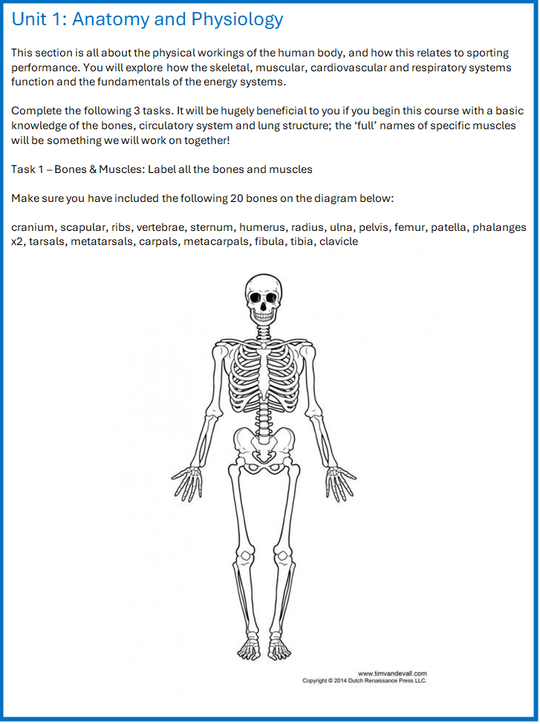

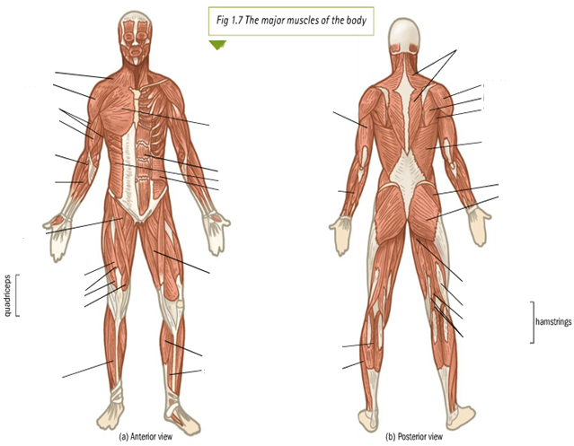
Unit 1: Anatomy and physiology

Task 2 – Heart & Lungs: Label the following diagram:

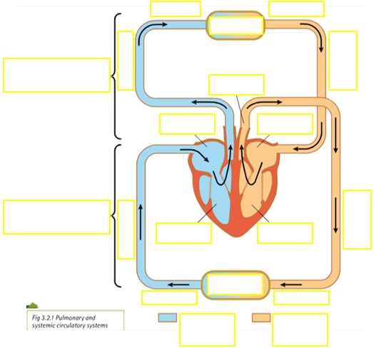
Unit 1: Anatomy and physiology
Task 3 – Respiratory system: Label the following diagram:

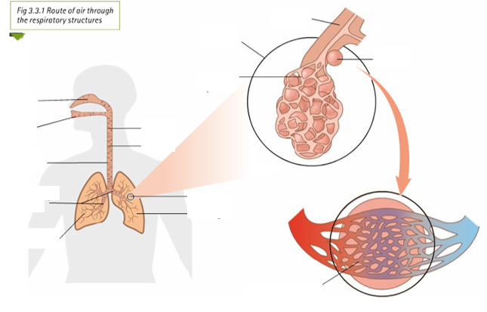
Fitness Training & Programming
Let us introduce you to Christine!

Christine is a 48-year-old female. She works as a personal assistant for the managing director of a large company. Christine drives 2.5 miles to work every day. This takes an average of 30 minutes because of the heavy traffic.

Christine’s workload has increased a lot and she also has some problems in her personal life. She has started to lose her appetite and she often doesn’t have breakfast. This is having a negative effect on her health and wellbeing. Recently Christine has started to feel both physically and mentally ill. She has needed to have a lot of time off work.

Christine has decided to get some advice and guidance about her lifestyle. She is also going to go to her doctor for a health assessment. Christine knows that her lifestyle is not healthy and that she needs to make some important changes. She would like to maintain a healthy work-life balance and to improve her general health and wellbeing.

Below is a Physical Activity Readiness Questionnaire that was completed when Christine went for her health assessment.

Read it through and using all of the information about Christine have a go at the tasks. Again, write your answers in a word document if possible but you can do it by hand. Good luck!

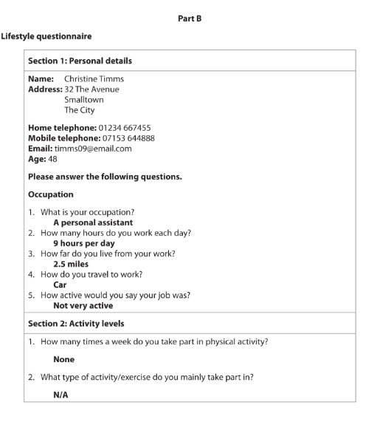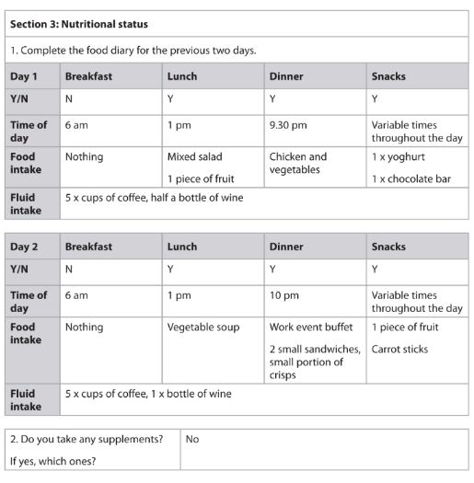

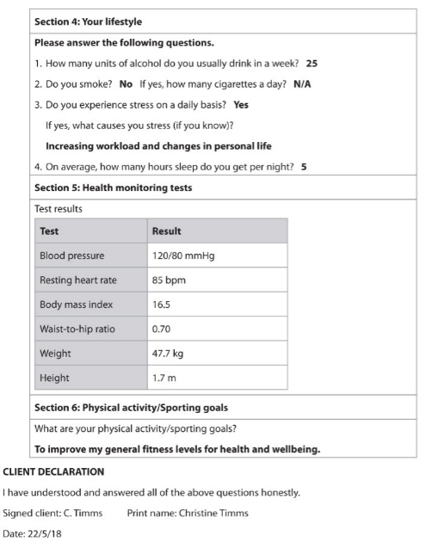

Task 1
List the positive and negative aspects of Christines lifestyle

Positive | Negative

Task 2
Research the national norm ranges for Blood Pressure, Resting Heart Rate, BMI and Waist to Hip Ratio

Task 3
Compare Christine’s results for each test to the norms. What do the test results suggest about her health?

Task 4
What changes could Christine make to improve her lifestyle?
Describe a number of strategies to help increase exercise, lower stress, reduce alcohol and promote better sleep.

Task 5
Plan a better diet for Christine:

Day 1 | Breakfast | Lunch | Dinner | Snacks
Time
Food Intake
Fluid Intake

Day 2 | Breakfast | Lunch | Dinner | Snacks
Time
Food Intake
Fluid Intake

